Ref: ATCPL/24-25/SOP/20

Date: 06/04/2024

**Warehouse Management System**

**Login Page:** Click on  for new user

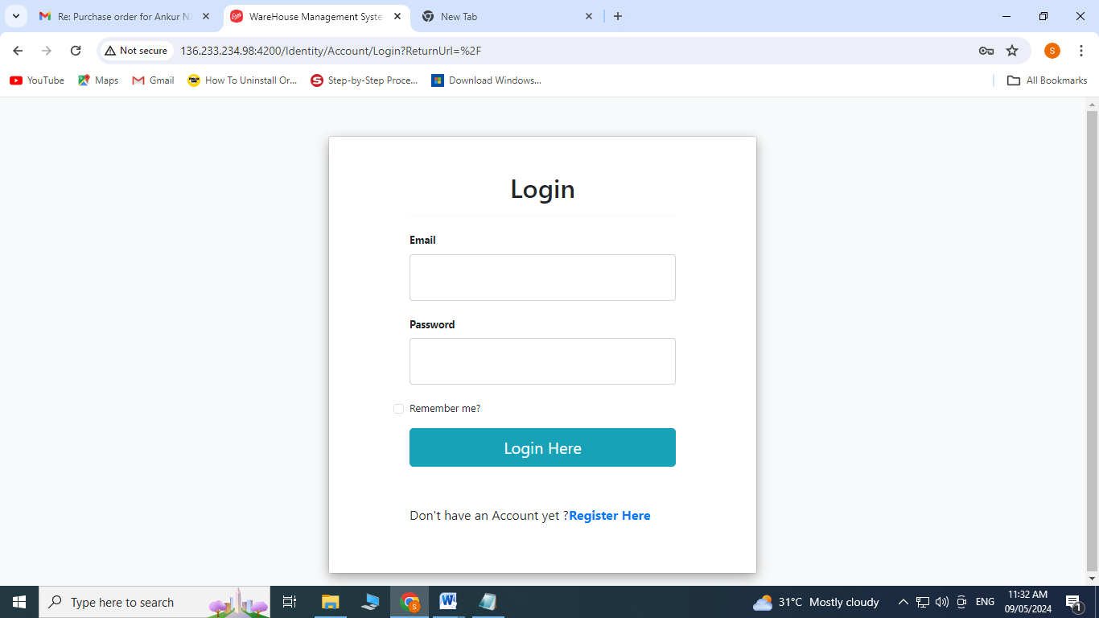

Enter first name and last name

Enter email ID

Enter password and confirm password

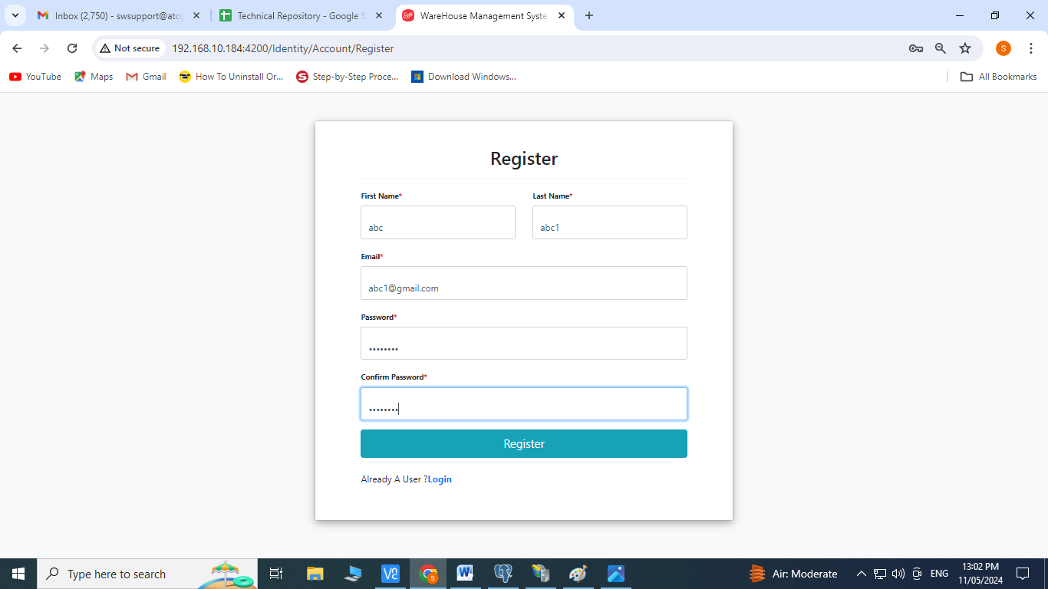

Admin user from his login will provide access to the pages for a particular user

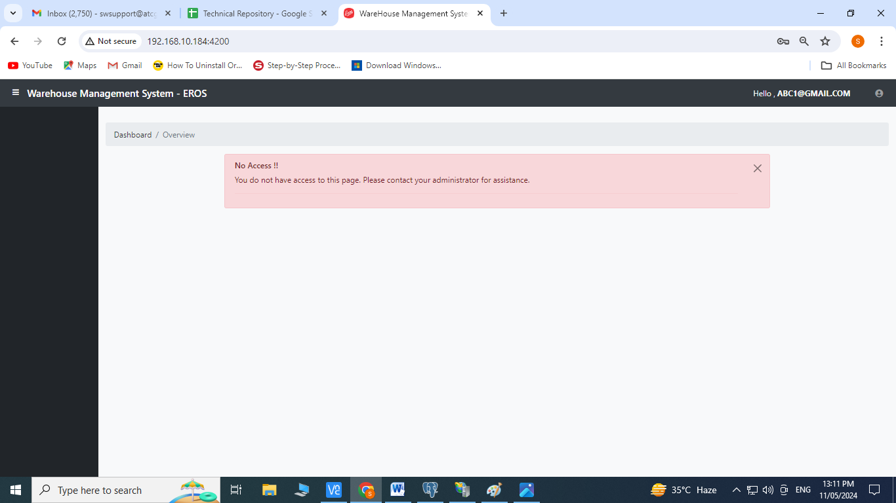

**User Management**

For Admin user—Click on user management

Click on  of the username

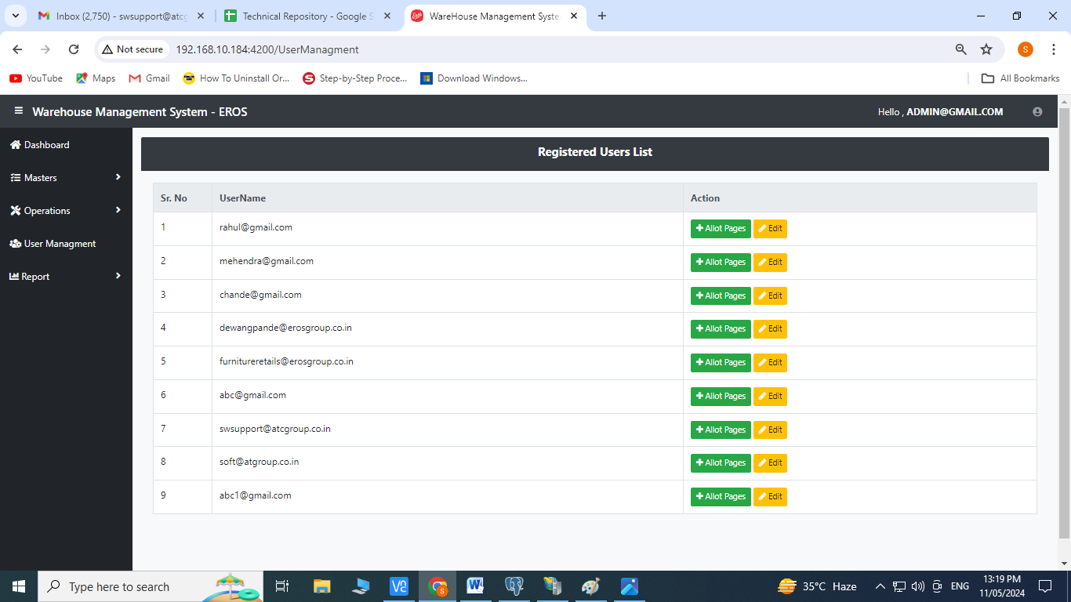

Select Role, Admin, Masters Operations, Reports from the dropdown menu

Click on save

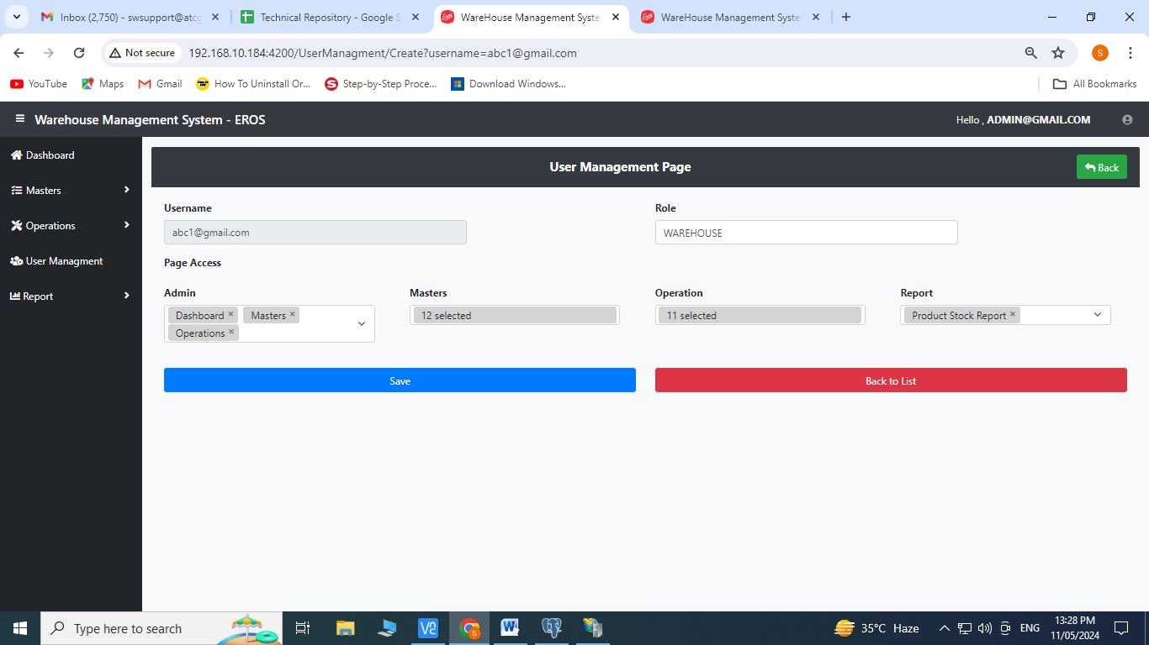

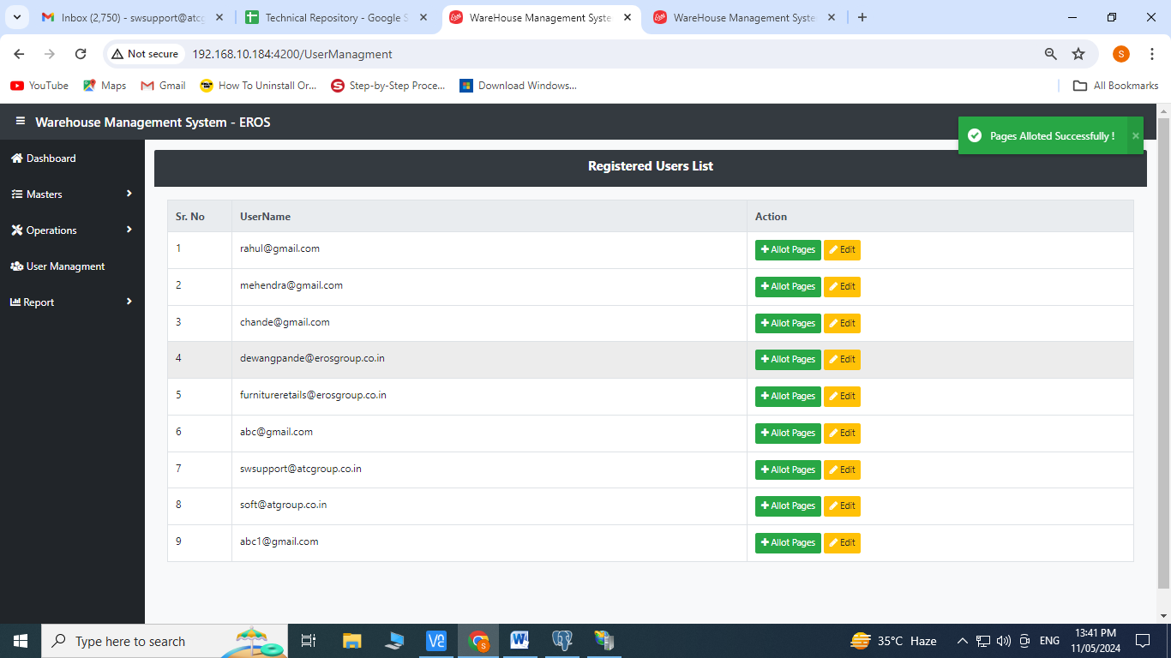

Edit Operation:

Click on  to edit

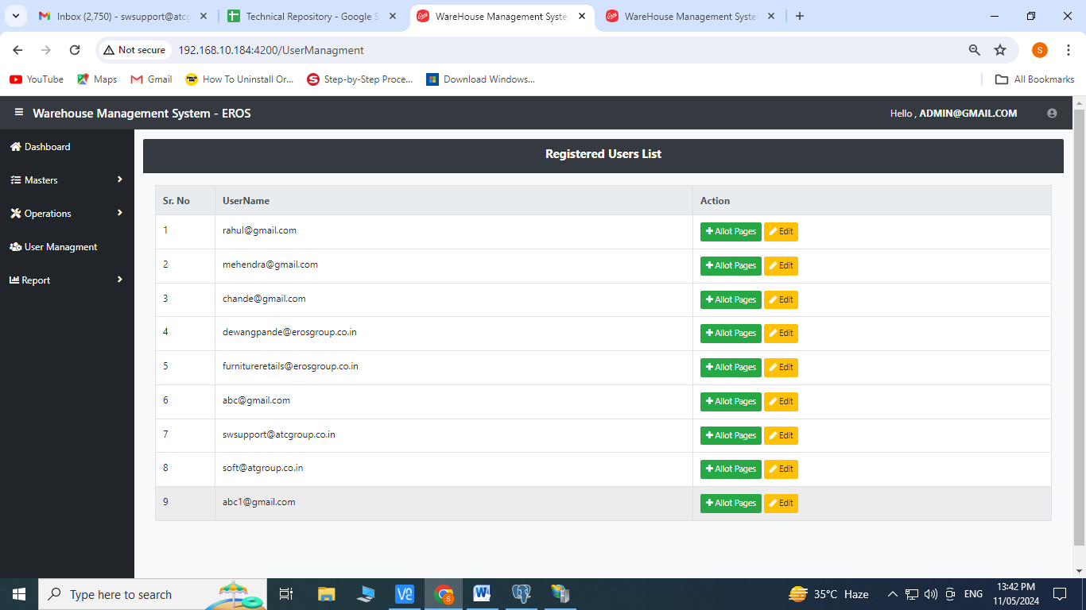

Select Role, Admin, Masters Operations, Reports from the dropdown menu

Click on save

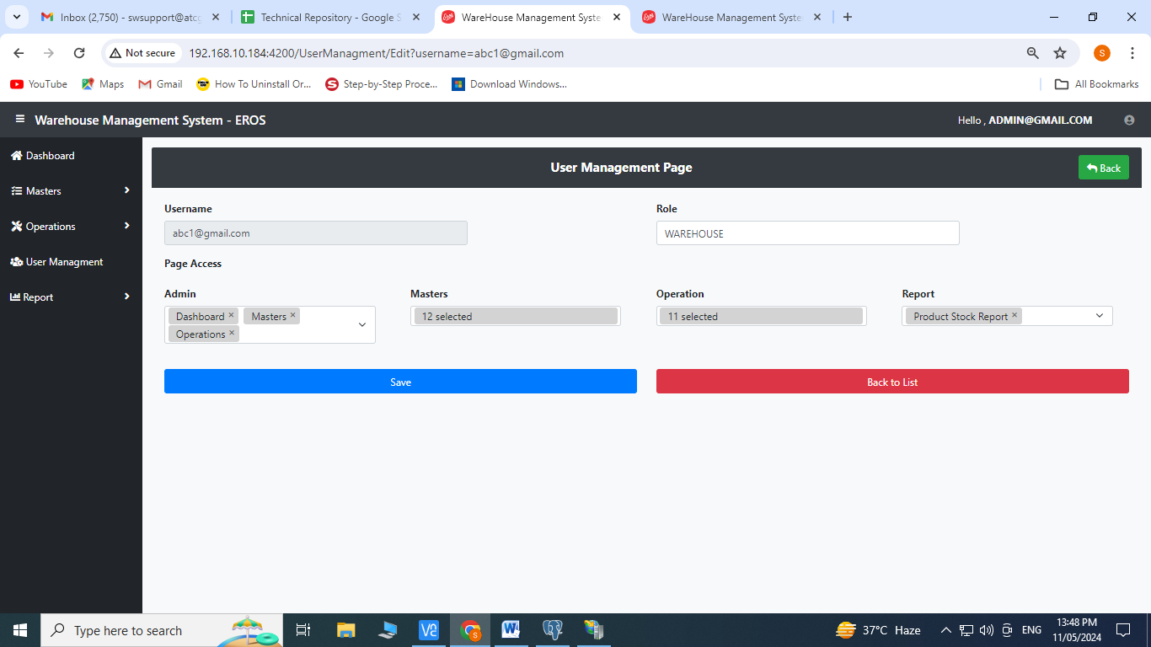

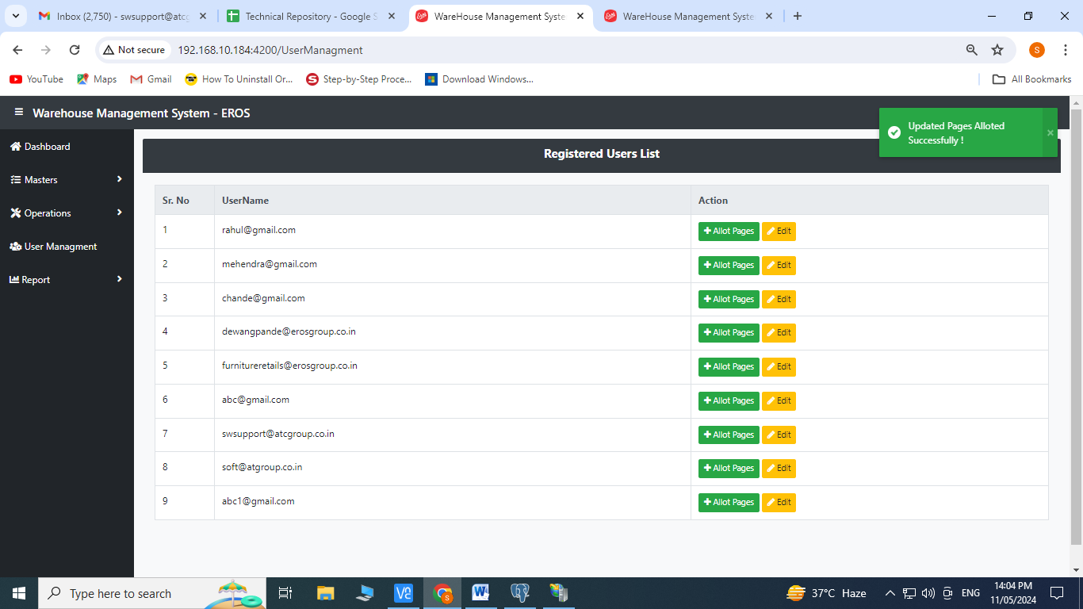

Now, the new user can login with their email ID and password and then click on 

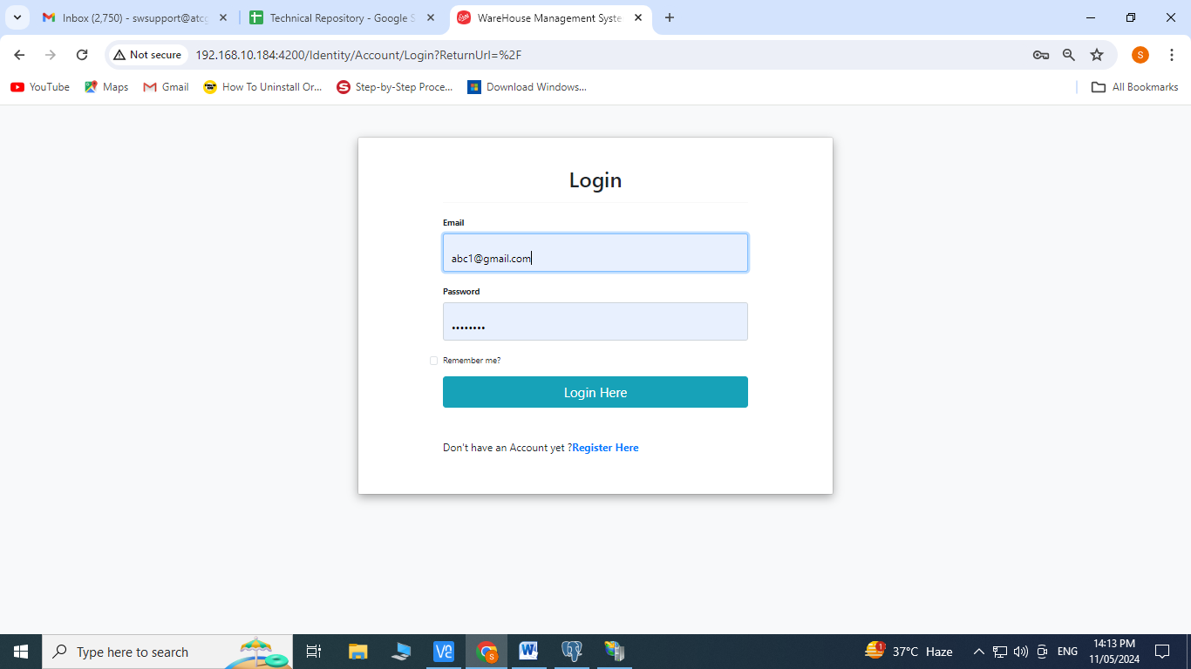

1. **Dashboard:**

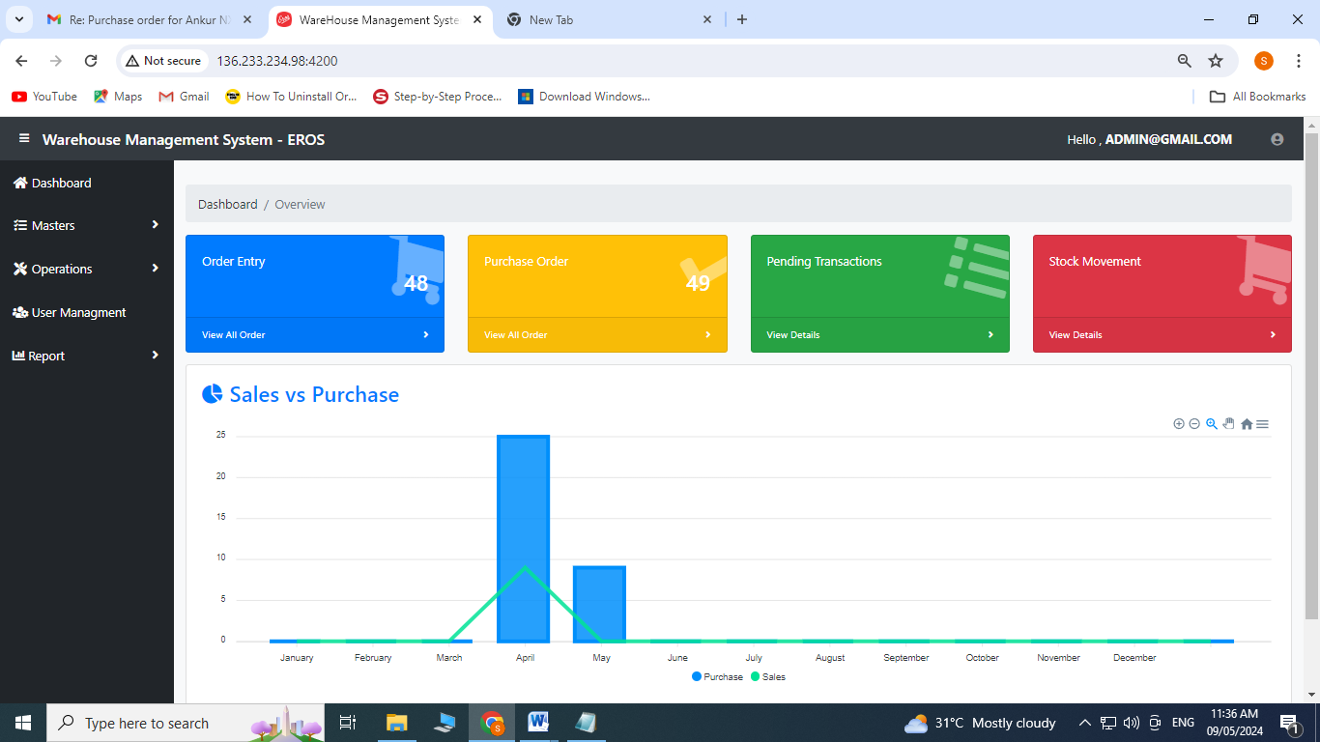

**Master Modules**

1. **Customer Master:** Click on customer from Master’s Menu

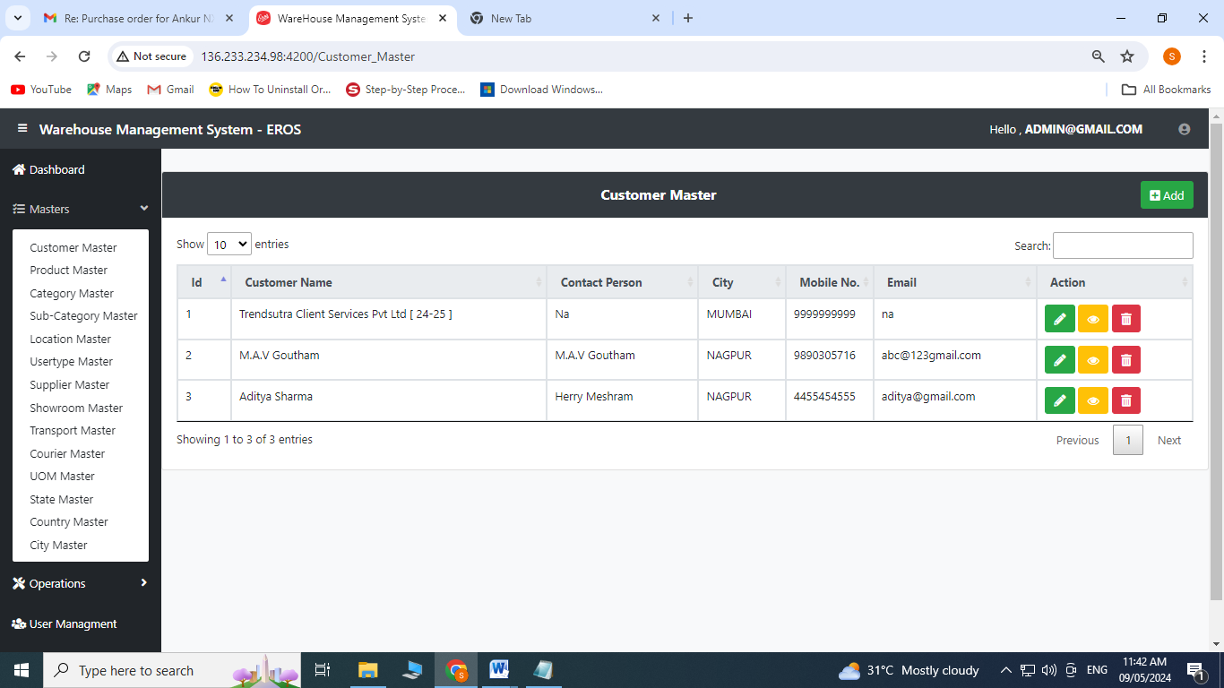

Create Operation:

Click on 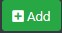to add

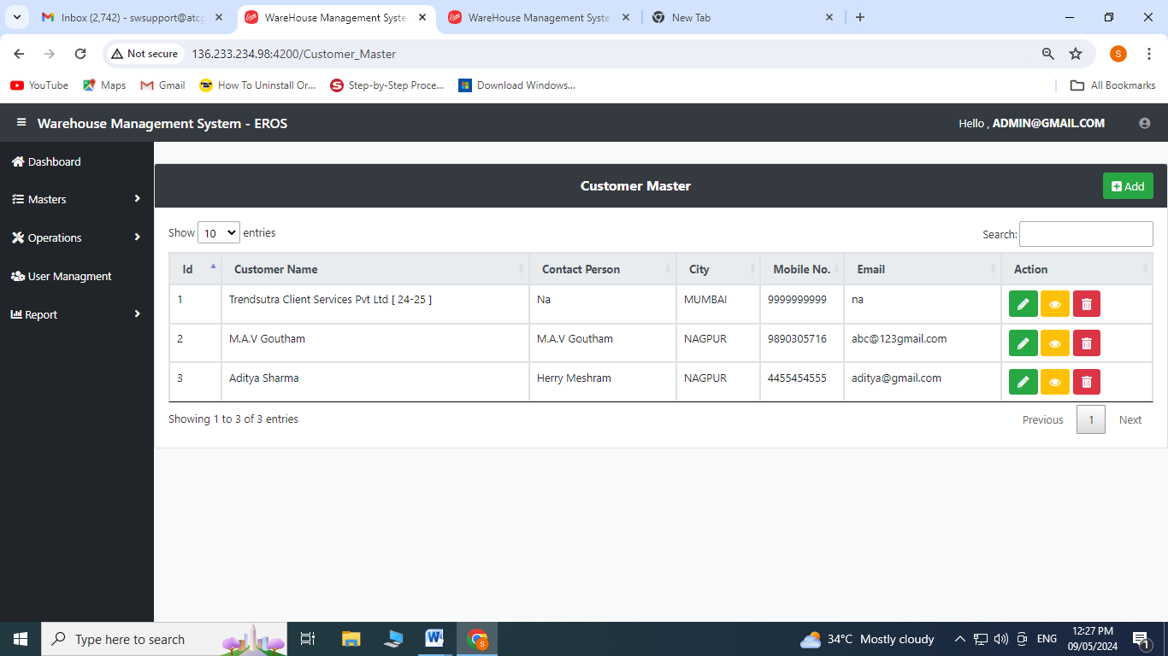

1. Enter Customer Name
2. Enter Contact Person
3. Enter Address
4. Select Country from the dropdown menu
5. Select State from the dropdown menu
6. Select City from the dropdown menu
7. Enter Pincode, mobile no., email, GST no.
8. Enter Consignee Name, Consignee Contact No. , Consignee Contact Person, address, email, city, state and pincode **(Note: This part is optional and multiple consignee details can be added by clicking on the**  **button)**
9. Click on save

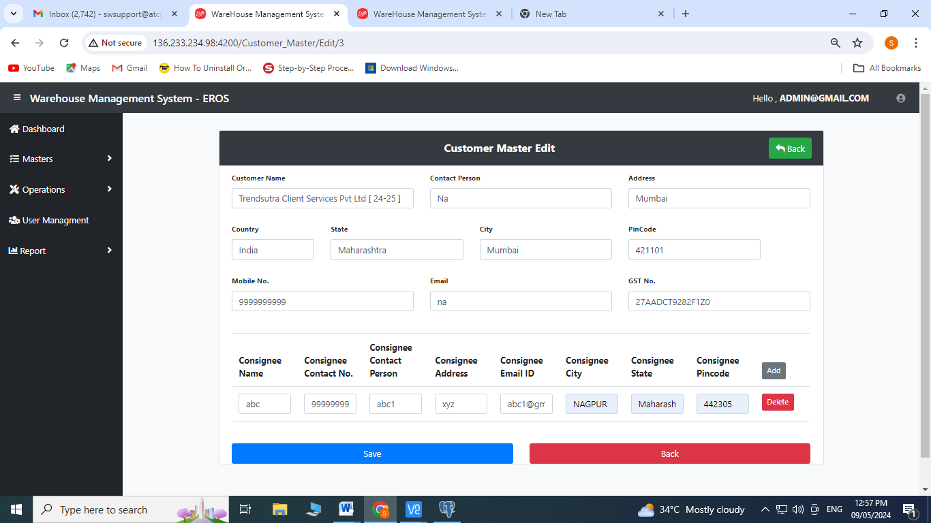

Edit Operation:

Click on  to edit

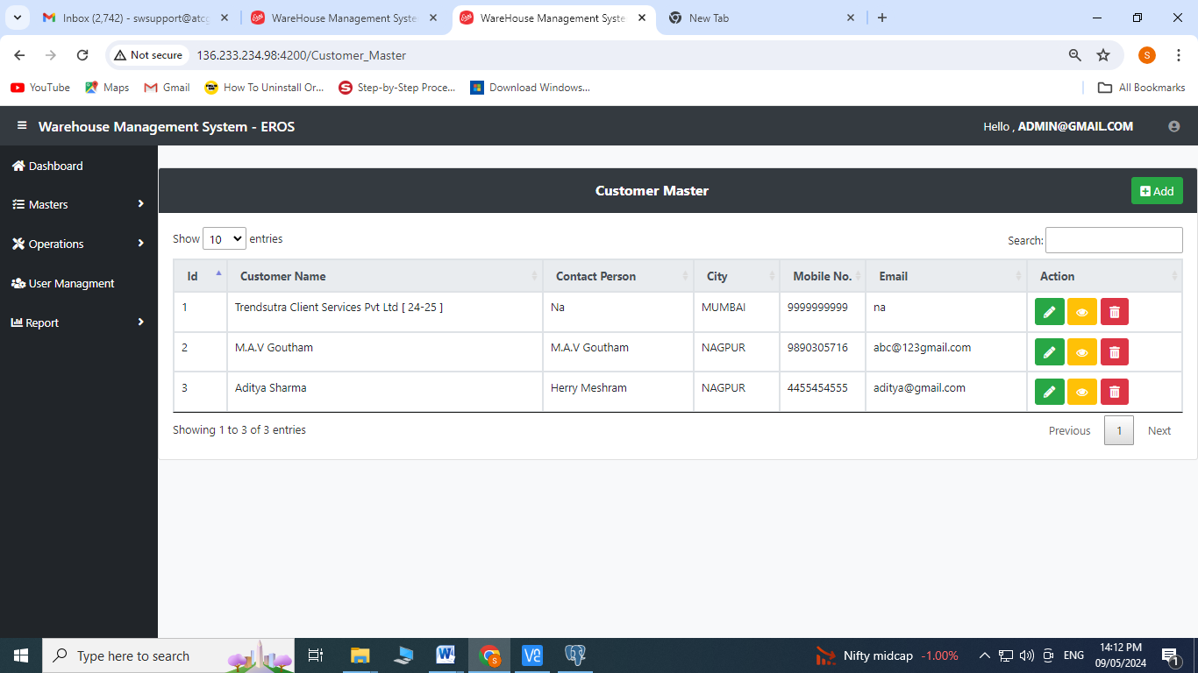

1. All the fields can be edited
2. Click on save

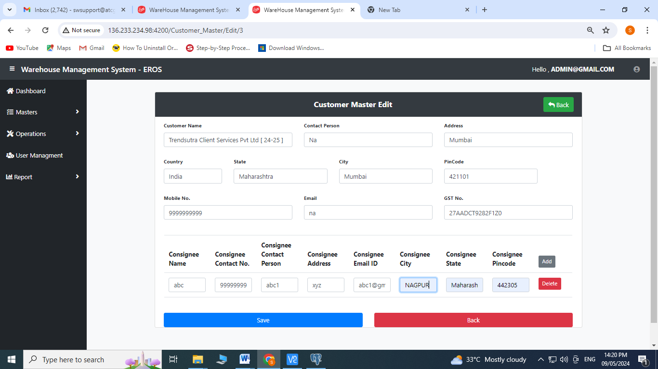

1. **Product Master:** Click on Product Master from Master’s Menu

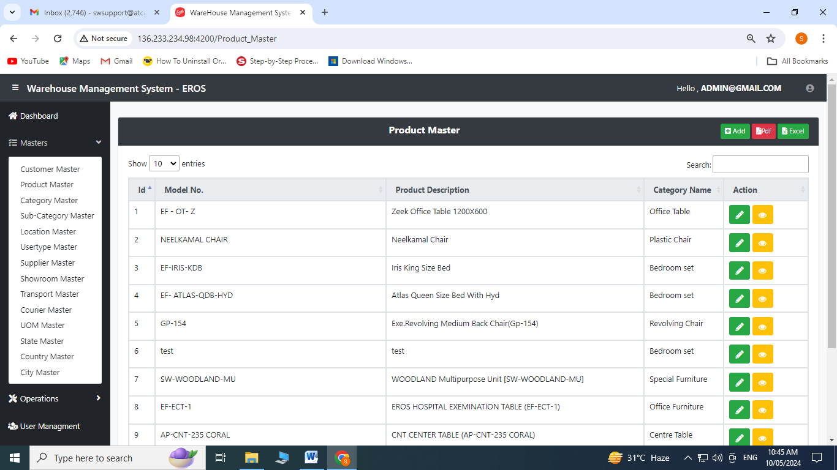

Create Operation:

1. Click on to add

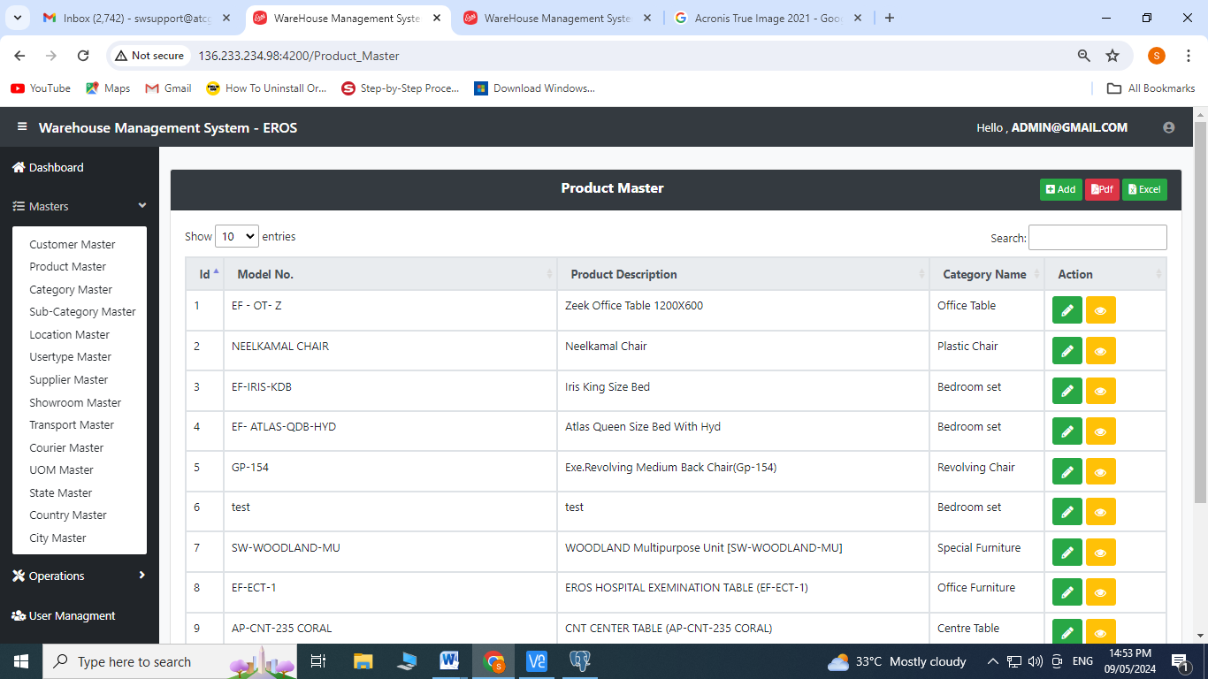

In case of Individual Product

1. Enter Category Name and Sub-category, Model No., Product Description, Brand Name, HSN
2. Enter UOM from the dropdown menu
3. Select the type of product as individual for individual product
4. Click on Save

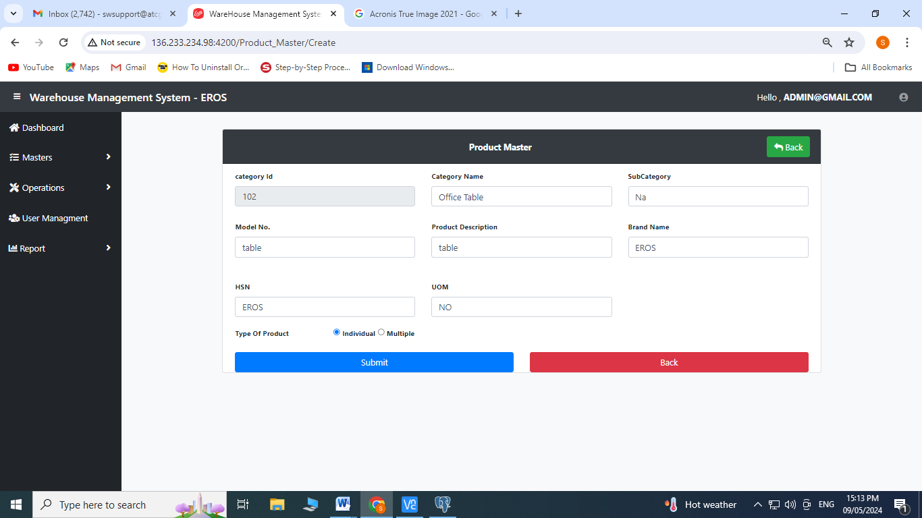

In case of Multiple Products

1. Enter Category Name and Sub-category, Model No., Product Description, Brand Name, HSN
2. Enter UOM from the dropdown menu
3. Select the type of product as individual for individual product
4. Click on Save

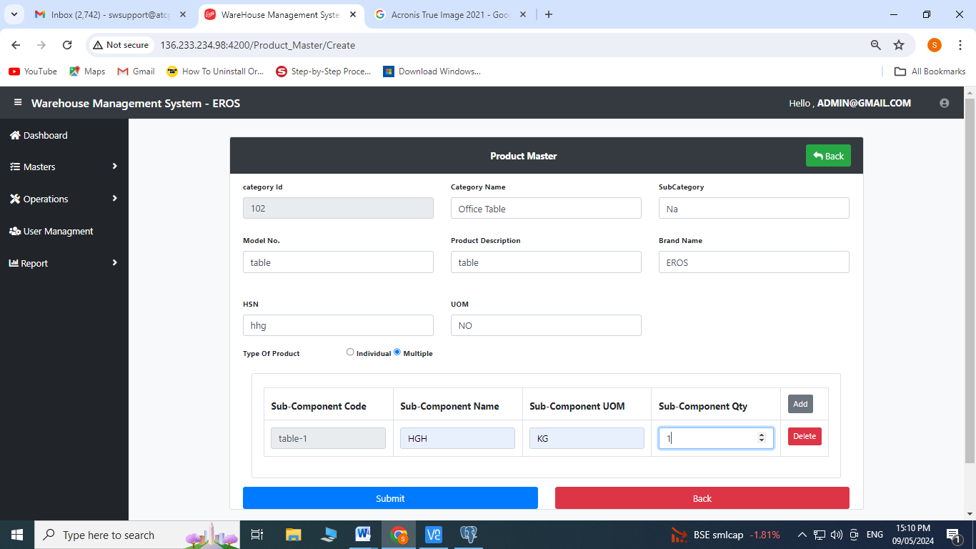

Edit Operation:

1. Click on  to edit

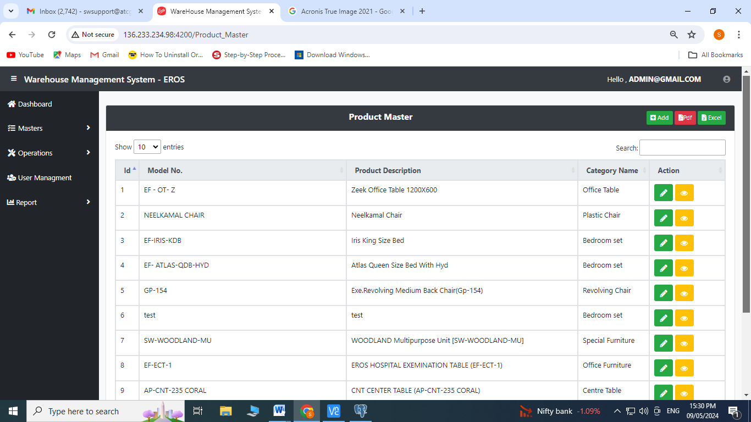

1. Enter Category Name and Sub-category, Model No., Product Description, Brand Name, HSN
2. Enter UOM from the dropdown menu
3. Select the type of product as individual
4. Click on save

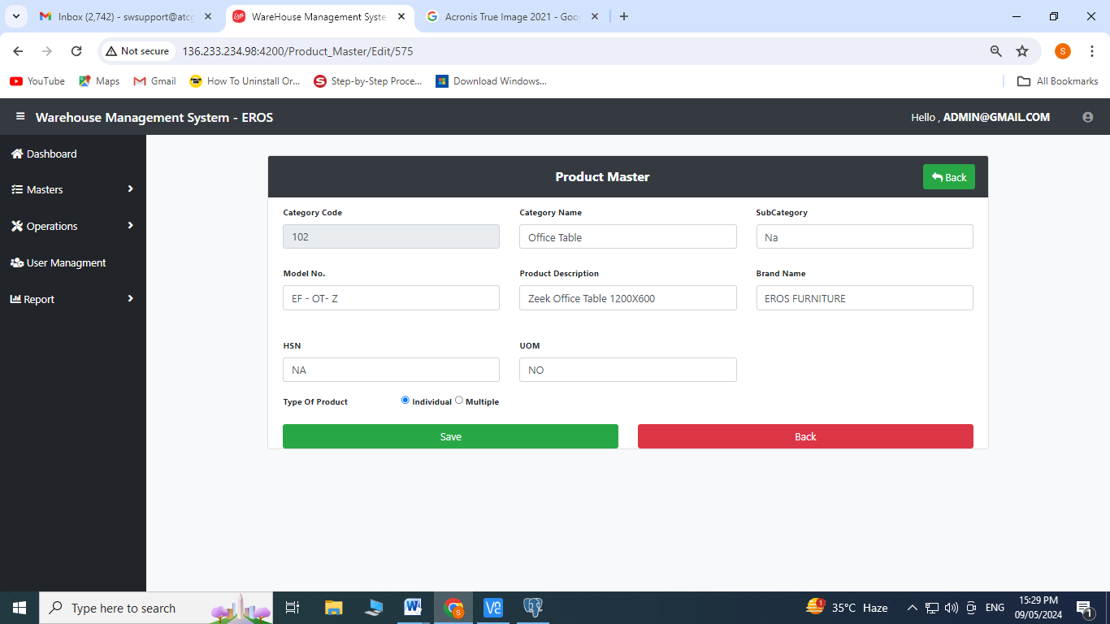

1. **Category Master:** Click on Category Master from Master’s Menu

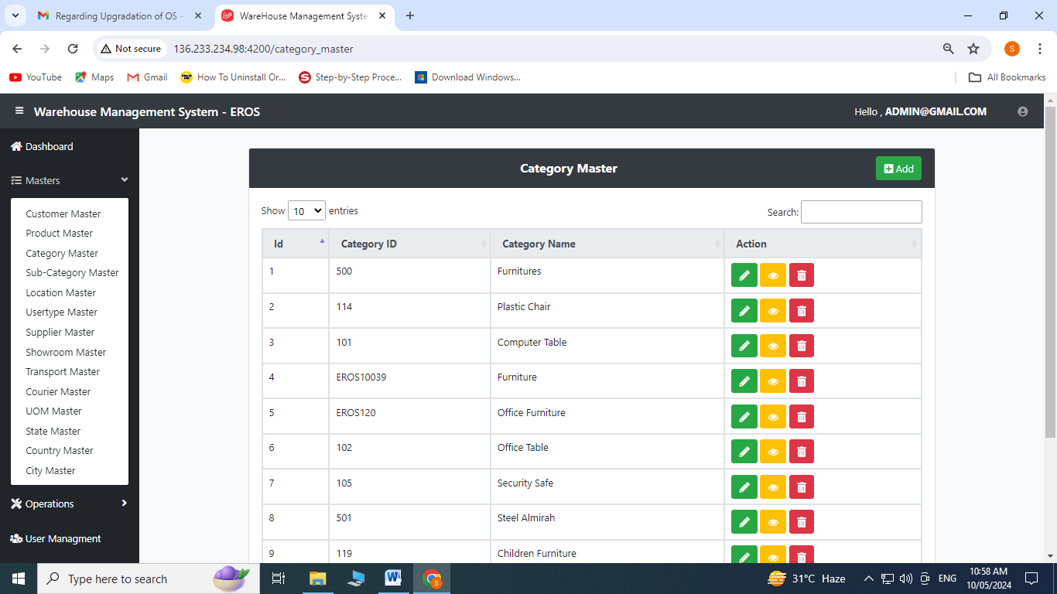

Create Operation:

1. Click on  to add

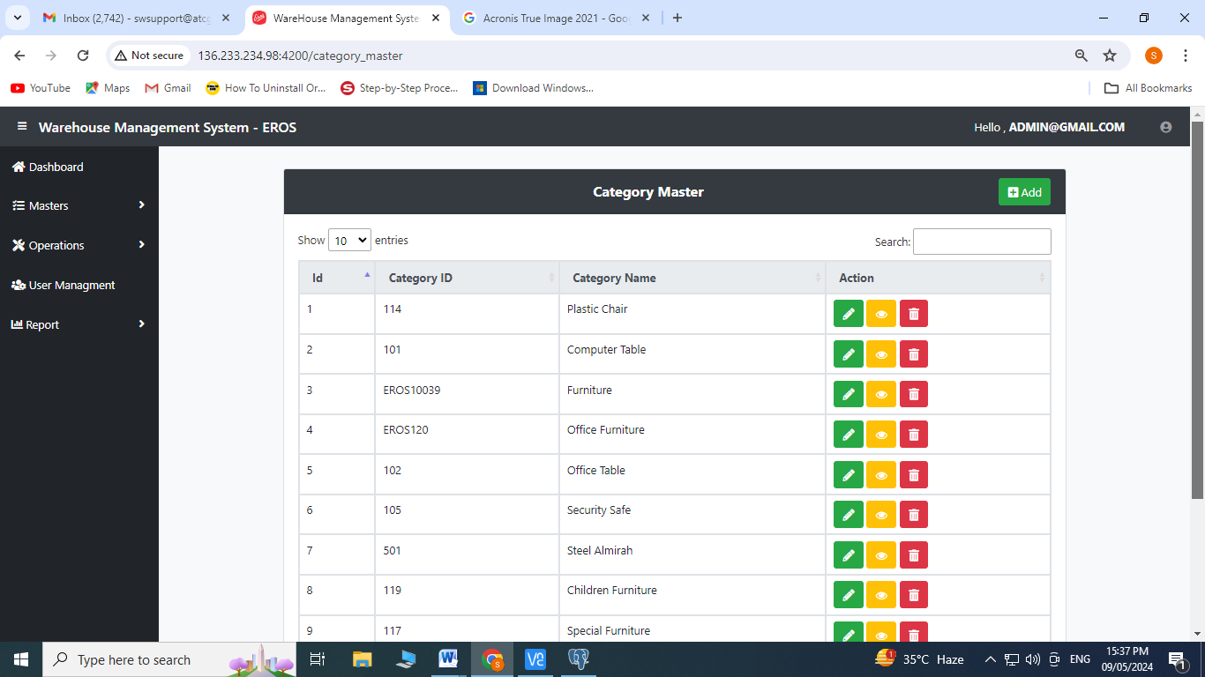

1. Enter Category ID
2. Enter Category Name
3. Click on save

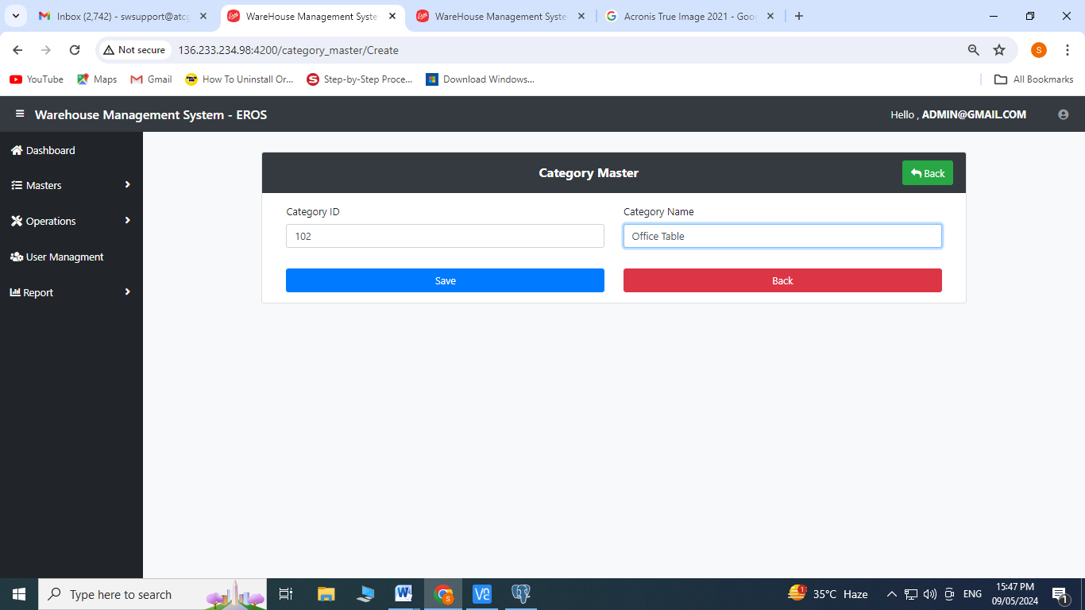

Edit Operation:

Click on  to edit

1. Enter Category ID
2. Enter Category Name
3. Click on save

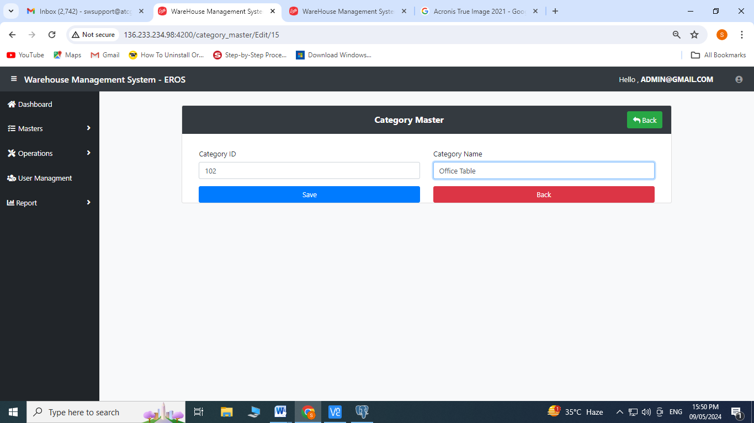

1. **Sub-Category Master:** Click on Sub-category Master from Master’s Menu

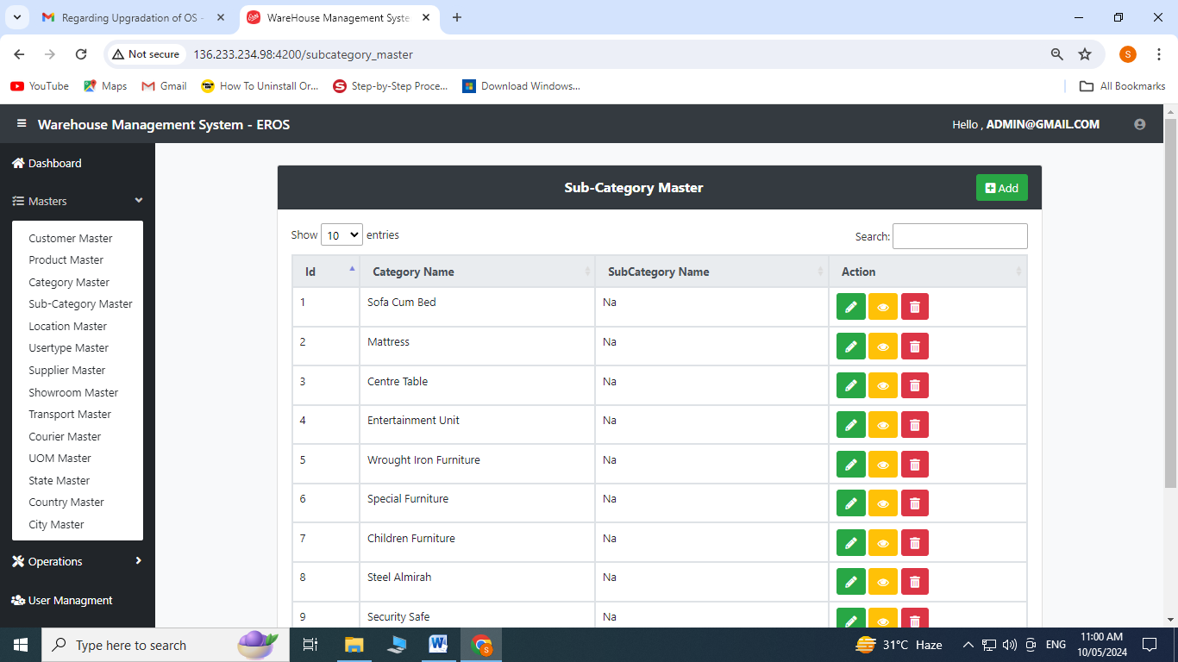

Create Operation:

1. Click on to add

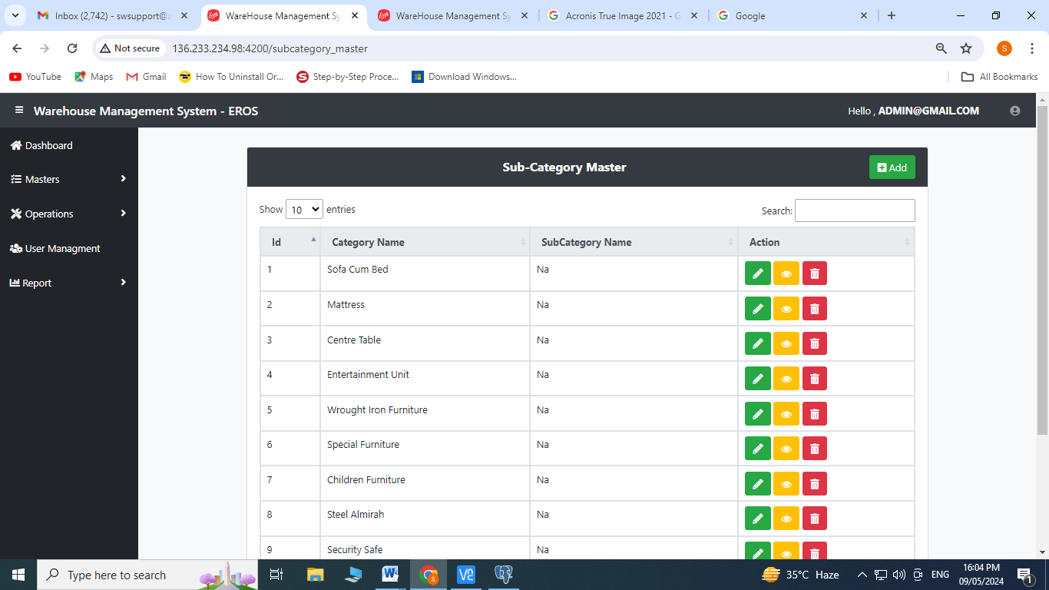

1. Enter Category Name
2. Enter Sub-category Name
3. Click on save

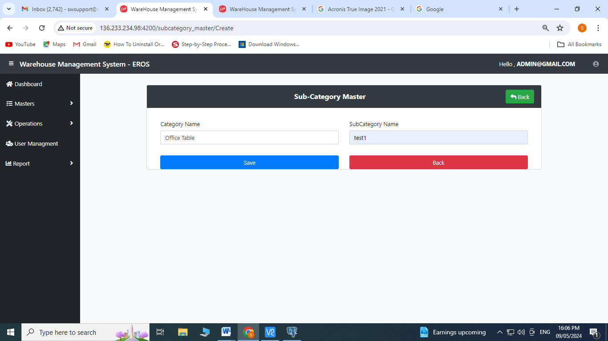

Edit Operation:

1. Click on  to edit

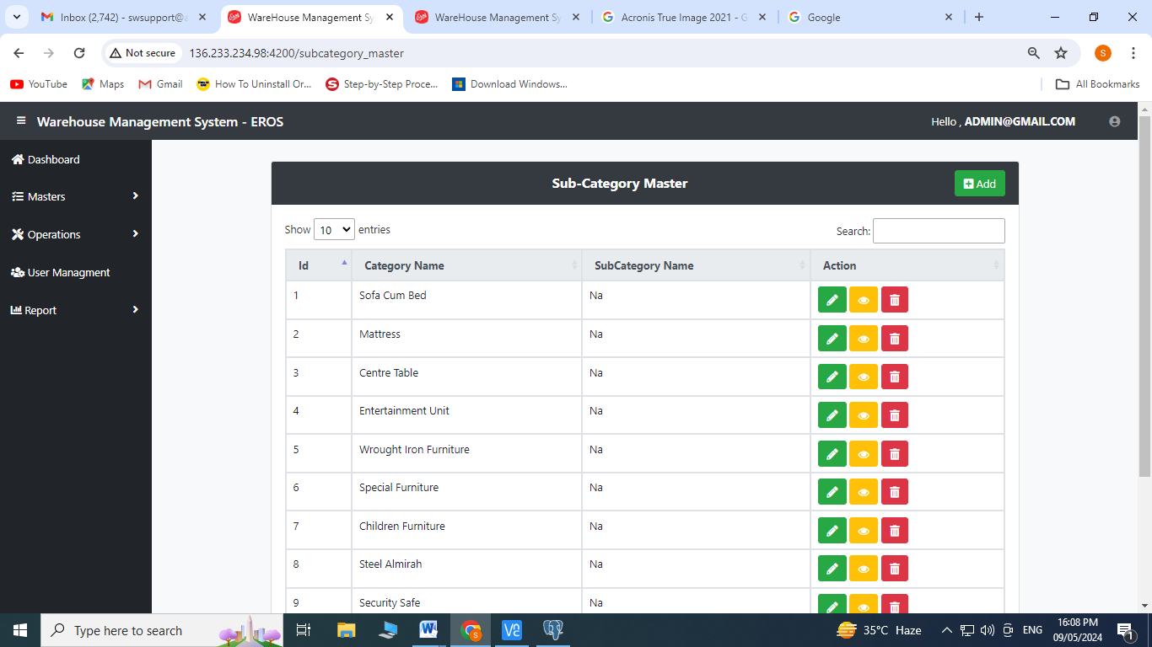

1. Enter Category Name
2. Enter Sub-category Name
3. Click on save

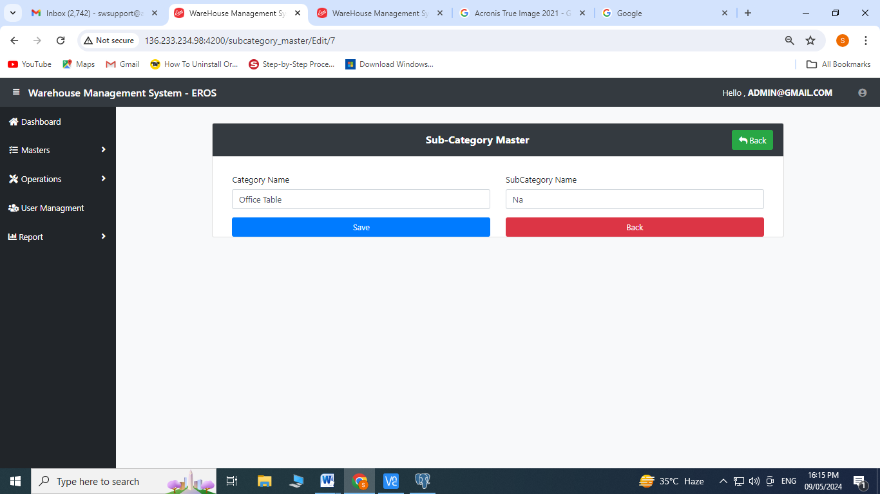

1. **Location Master:** Click on Location Master from the Master’s Menu

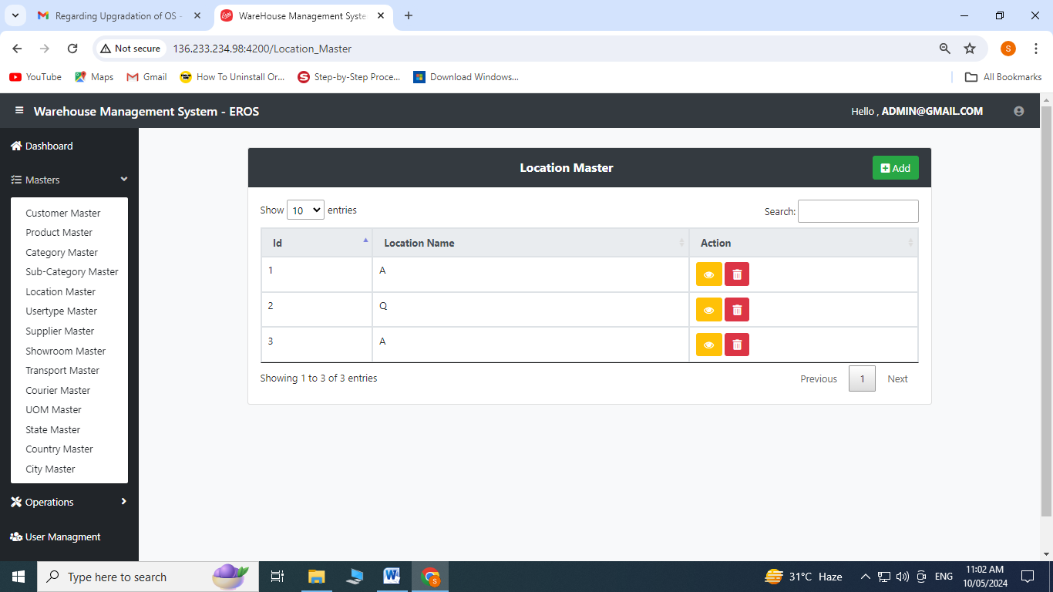

Create Operation:

1. Click on  to add

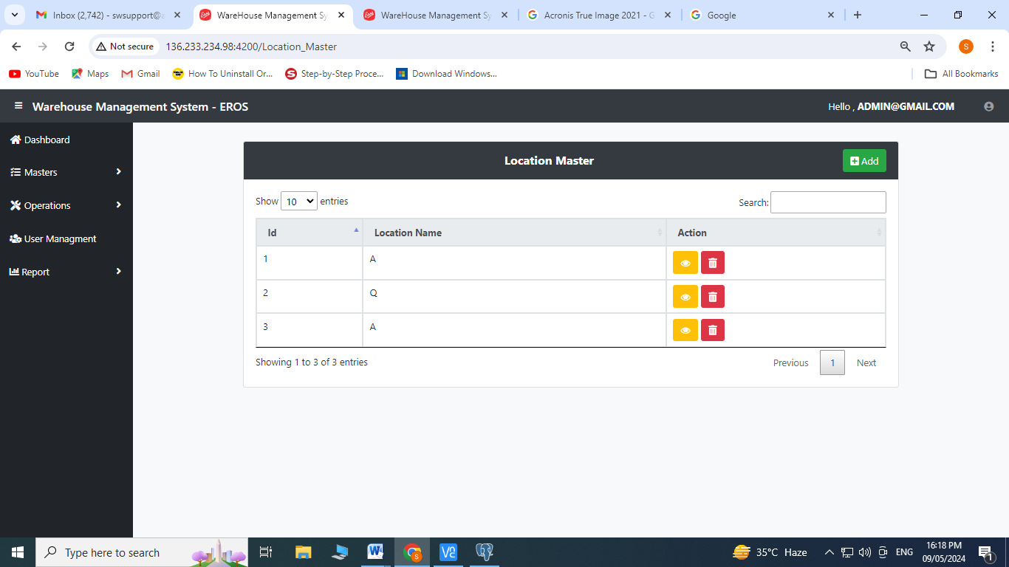

1. Click on  Add button
2. Select **from shelf** from the dropdown menu
3. Select **to shelf** from the dropdown menu
4. Click on Save

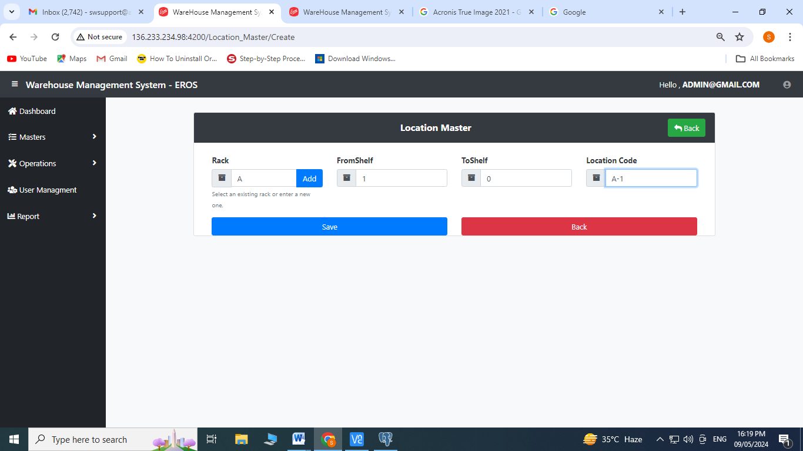

1. **Usertype Location:** Click on Usertype from the Master’s Menu



Create Operation:

1. Click on  to add

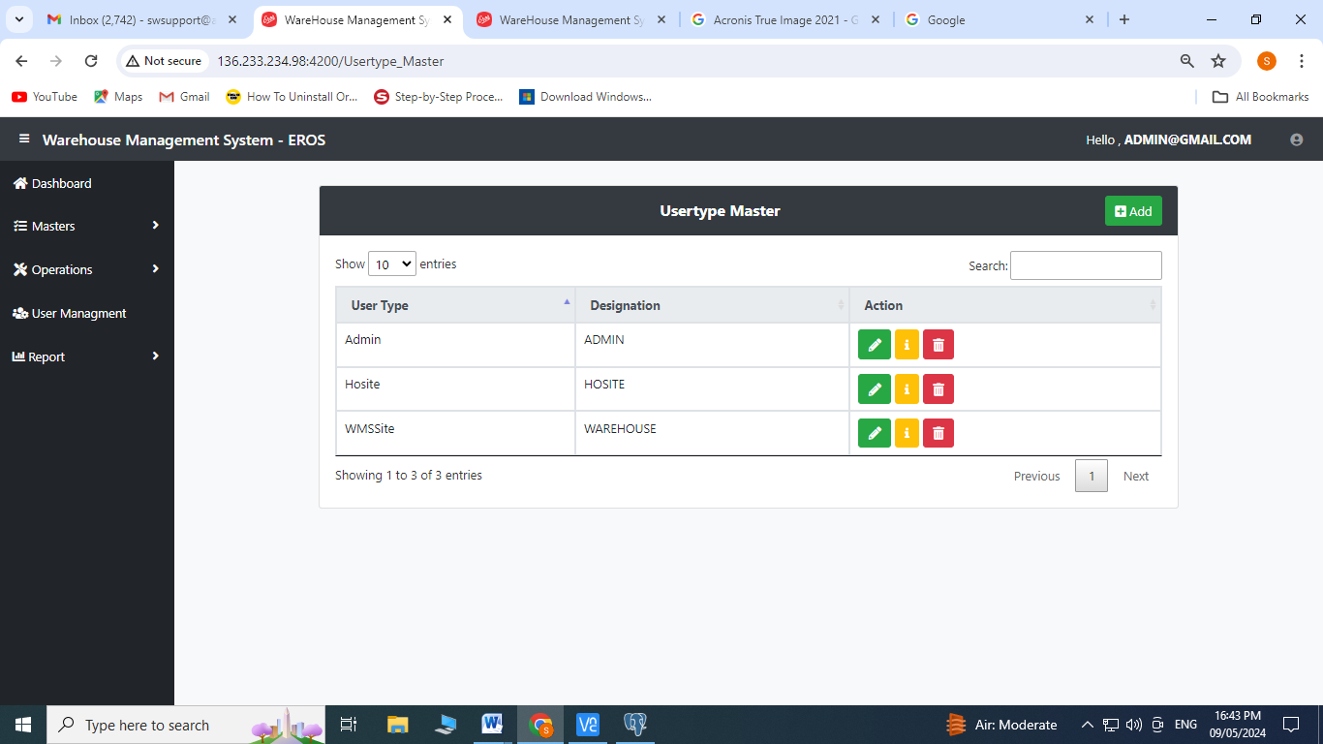

1. Enter User type
2. Enter Designation
3. Click on Save

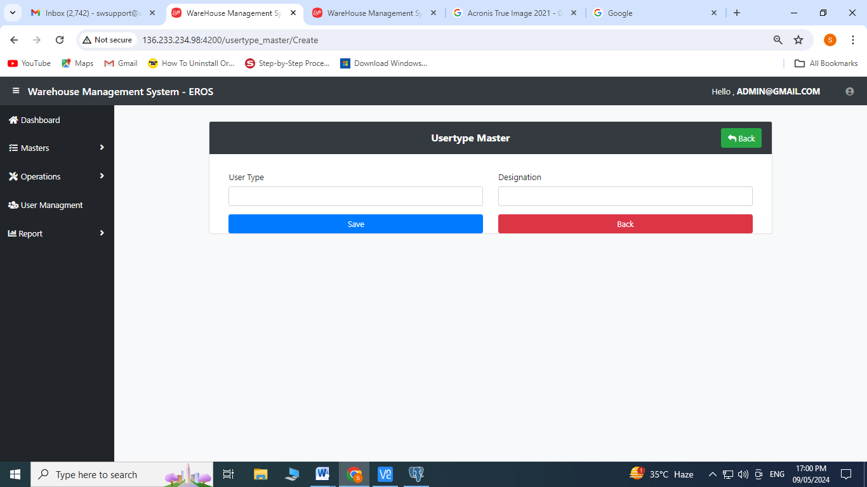

Edit Operation:

1. Click on  to edit

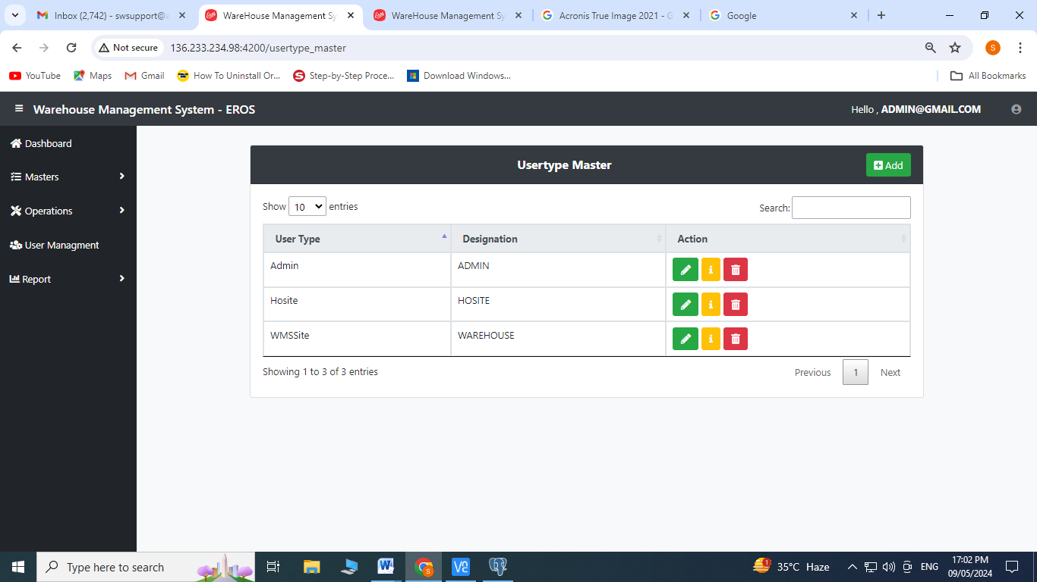

1. Enter User type
2. Enter Designation
3. Click on Save

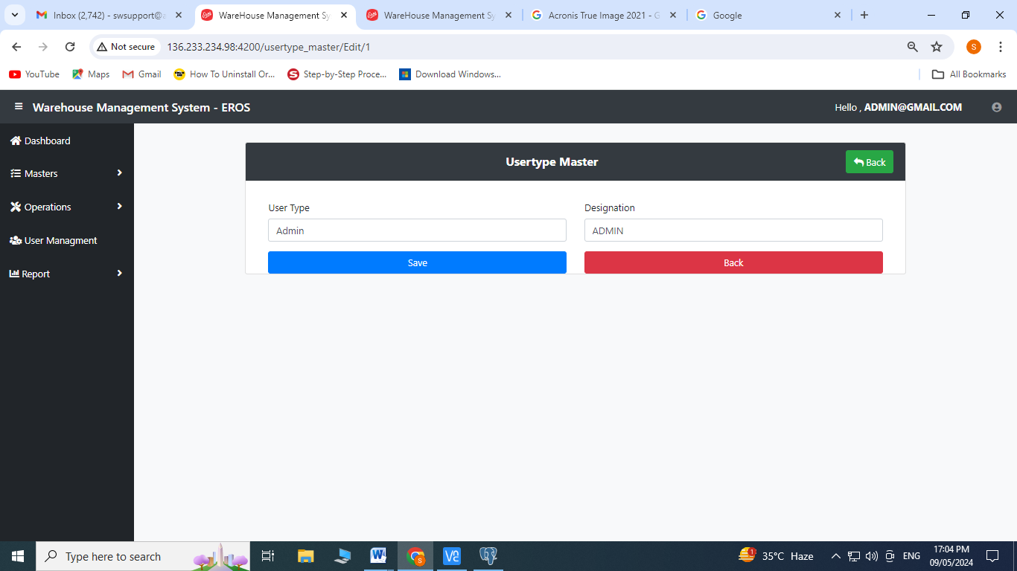

1. **Supplier Master:** Click on Supplier Master from the Master’s Menu

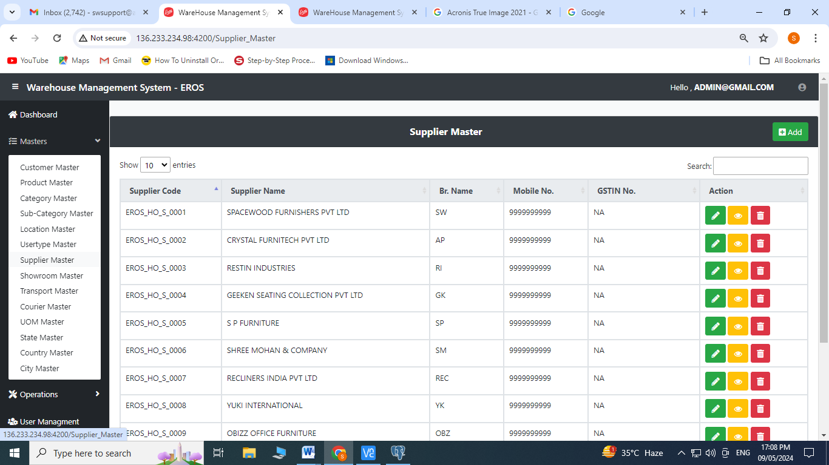

Create Operation:

1. Click on  to add

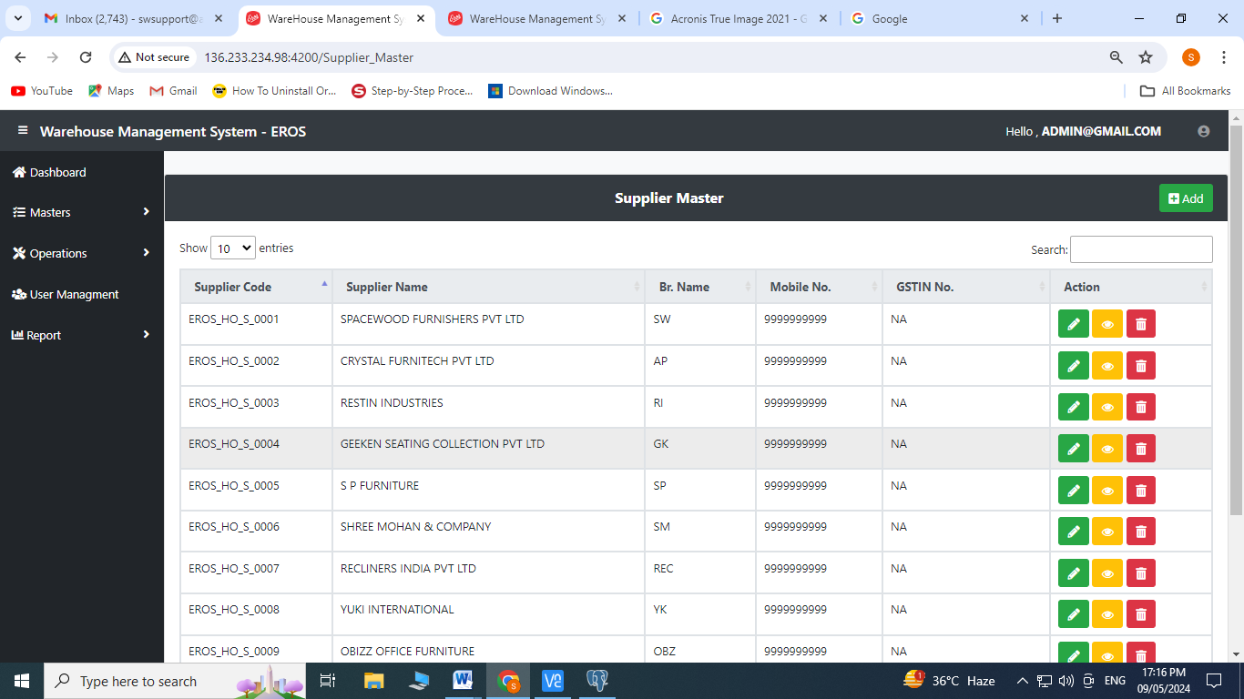

1. Enter Supplier Name, brand name, GST No., Contact No., Email ID
2. Select Country, State, City from the dropdown menu
3. Enter Address and Pin code
4. Click on save

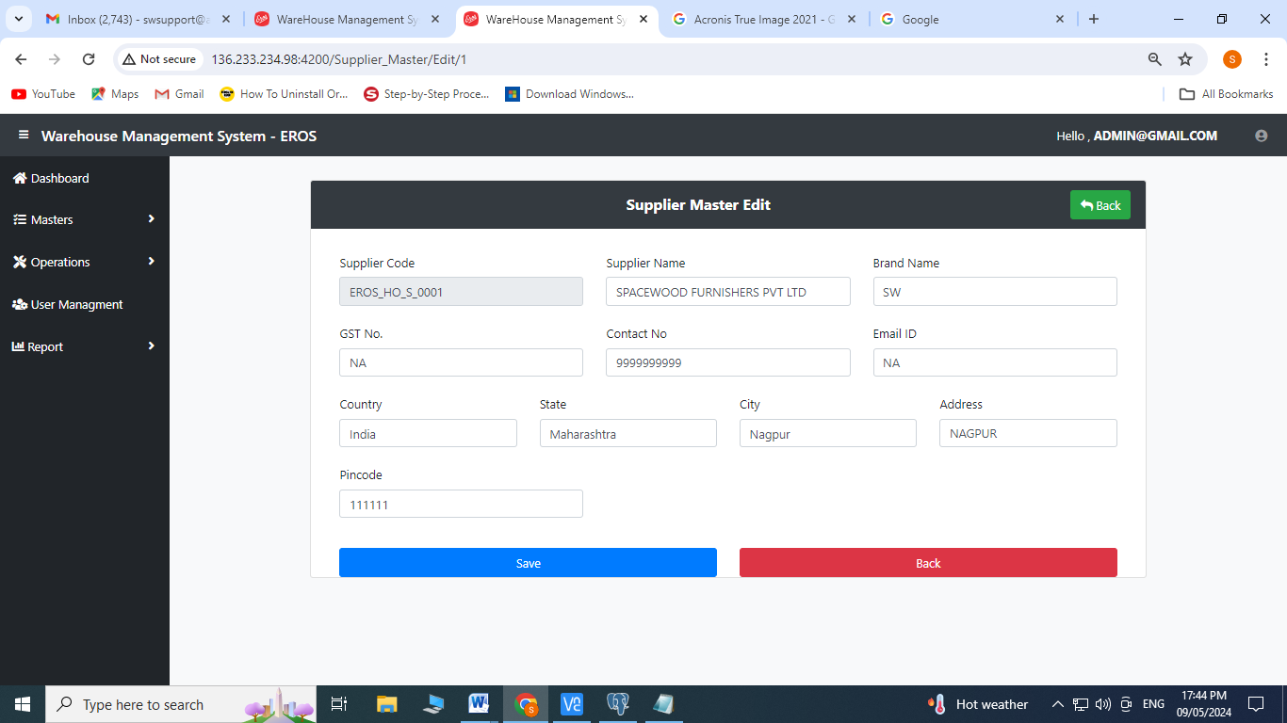

Edit Operation:

1. Click on  to edit

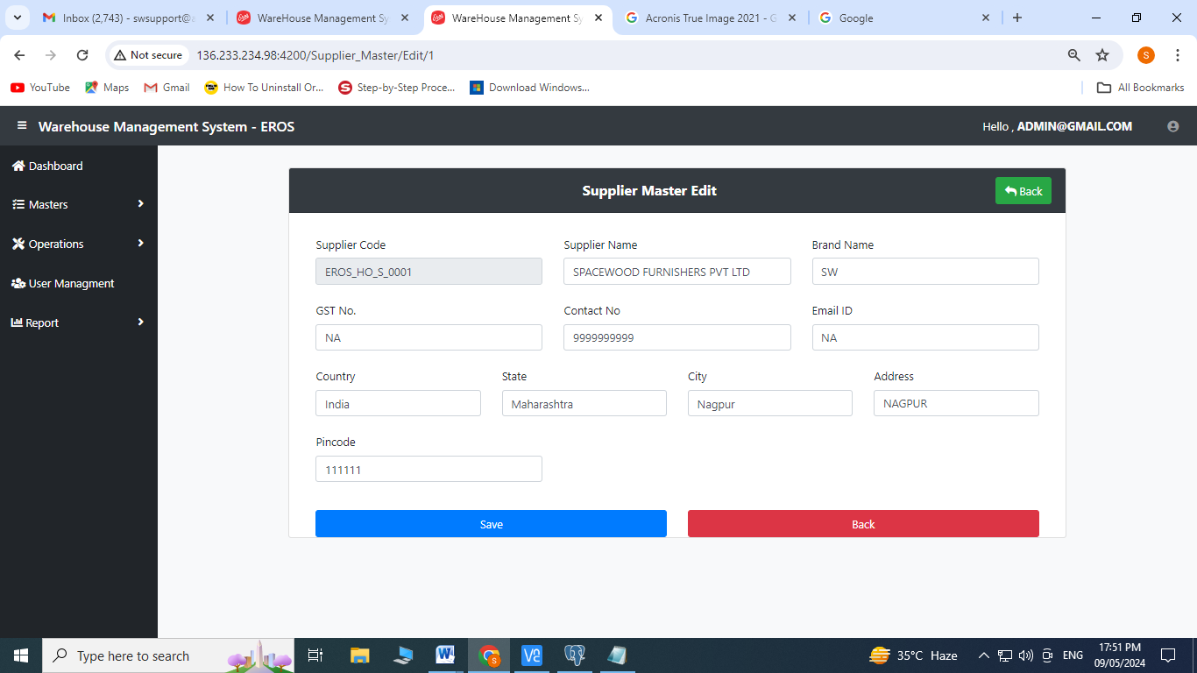

1. Enter Supplier Name, brand name, GST No., Contact No., Email ID
2. Select Country, State, City from the dropdown menu
3. Enter Address and Pincode
4. Click on save
5. **Showroom Master:** Click on Showroom Master from the Master’s Menu

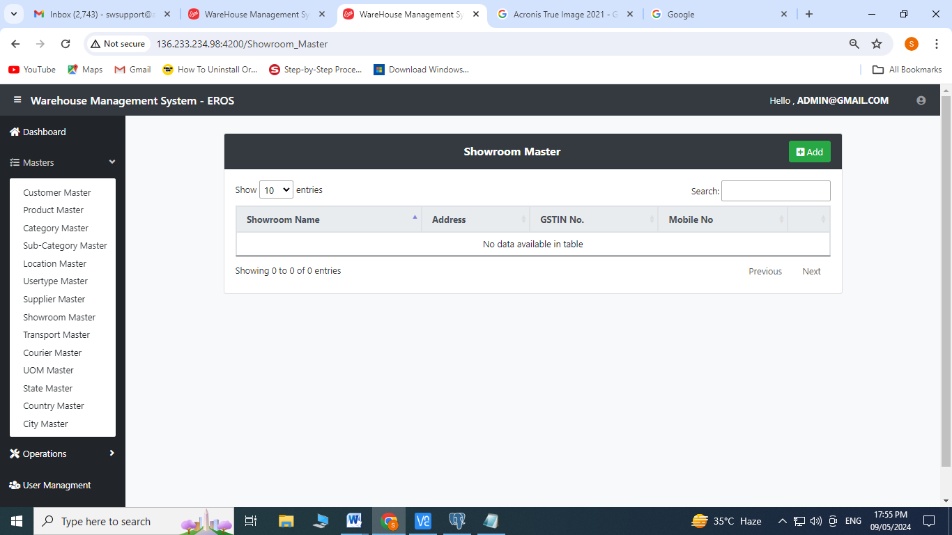

Create Operation:

1. Click on  to add

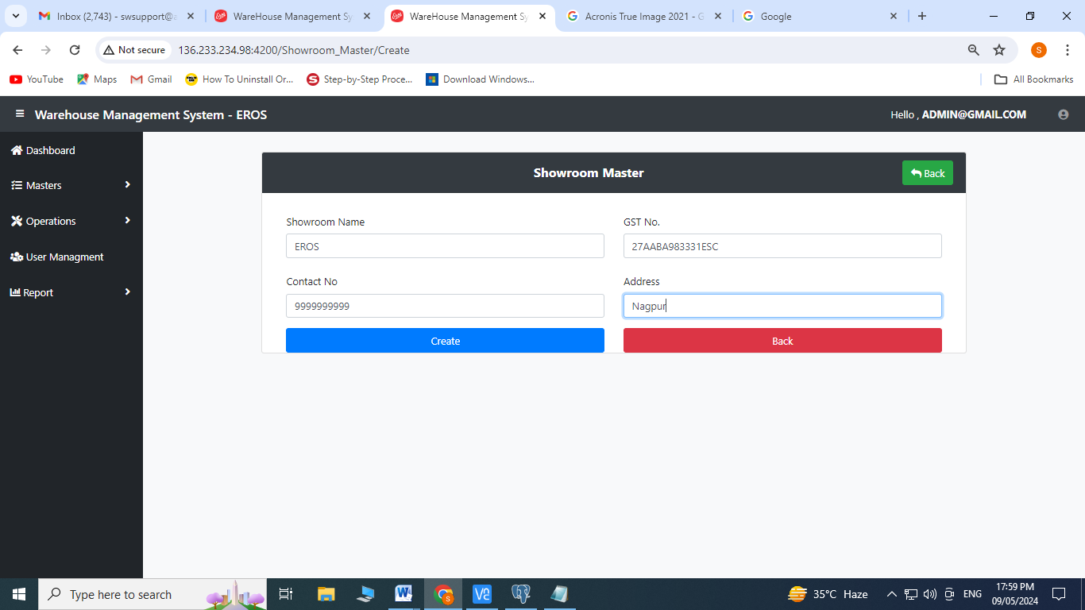

Edit Operation:

1. Click on  to edit

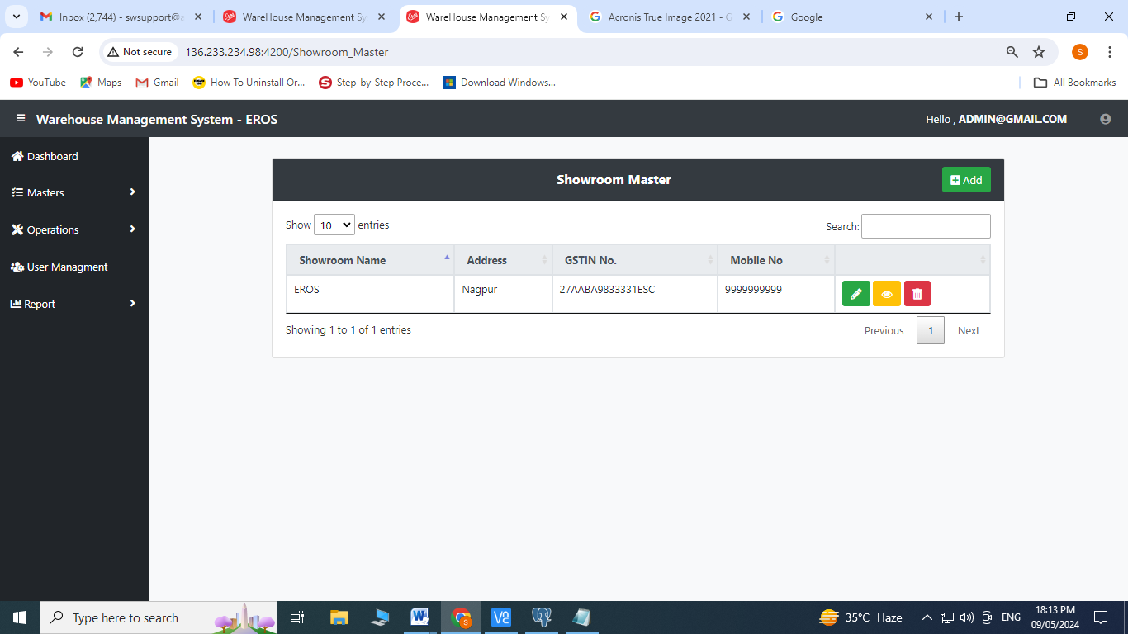

1. Enter Showroom
2. Enter GST No., Contact No., Address
3. Click on create



1. **Transport Master:** Click on Transport Master from Master’s Menu

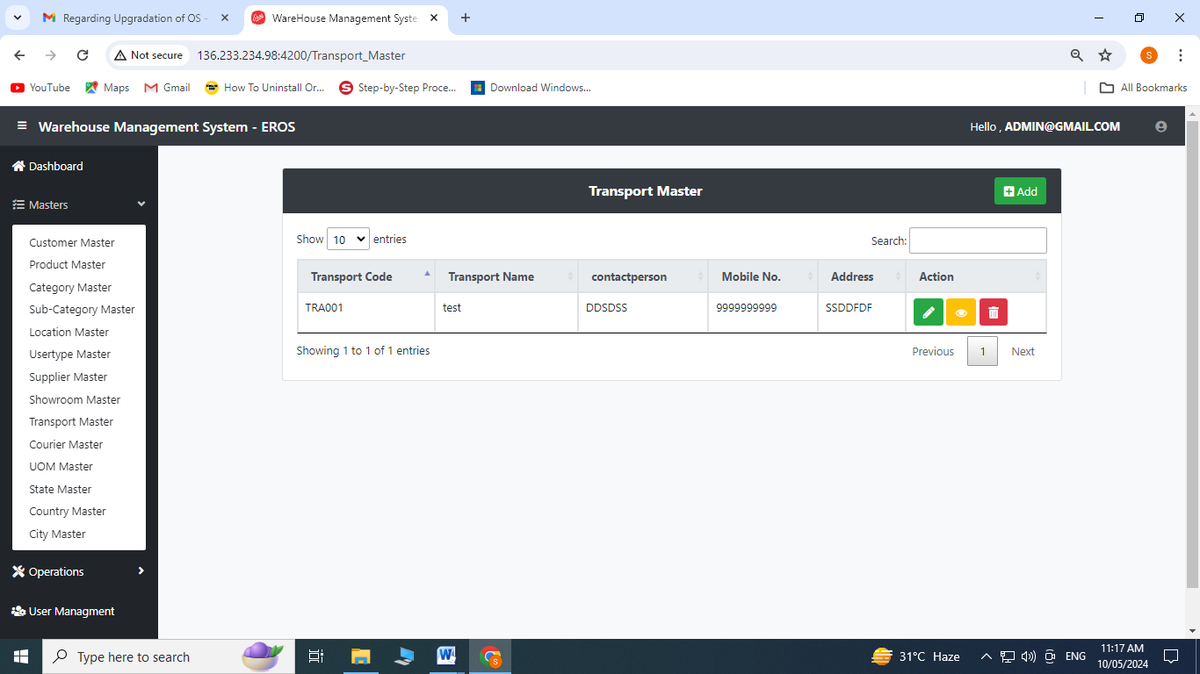

Create Operation:

1. Click on to add

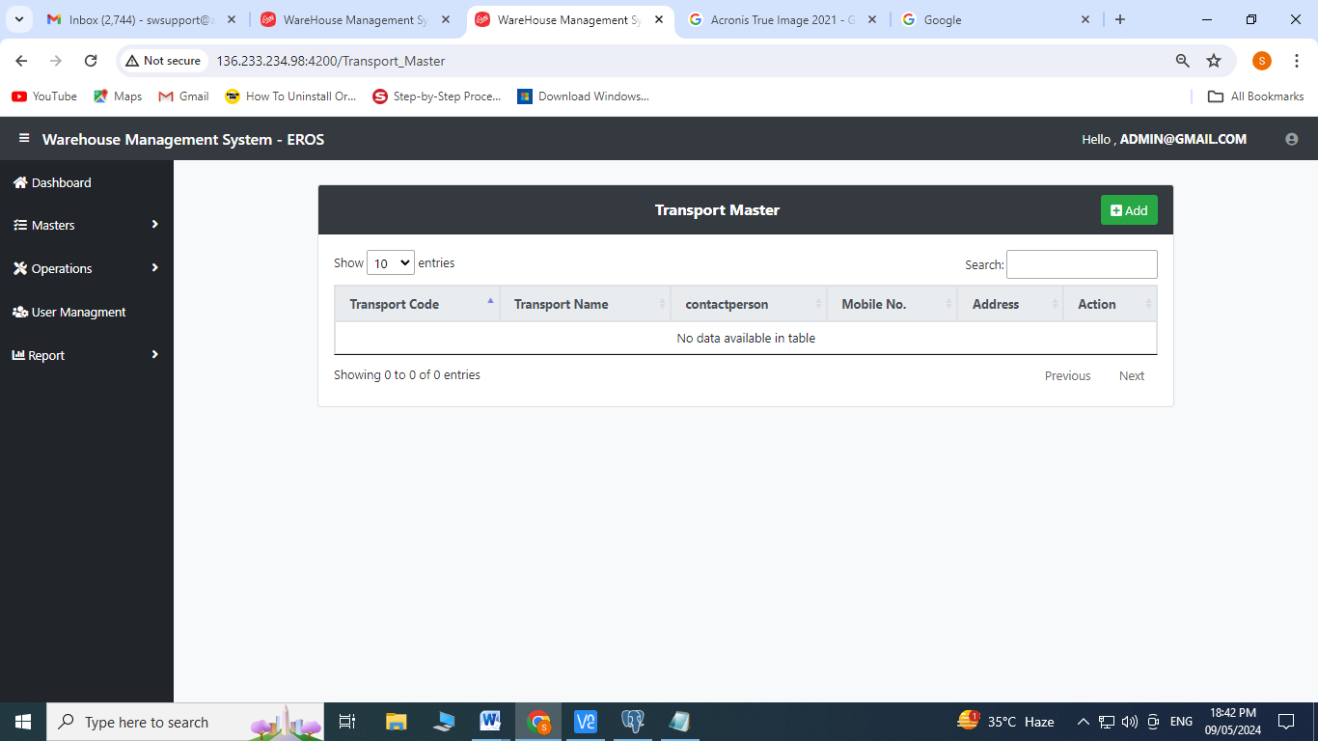

1. Enter Transporter Name, Contact Person, Contact No., Address, City, State, Pincode
2. Click on save

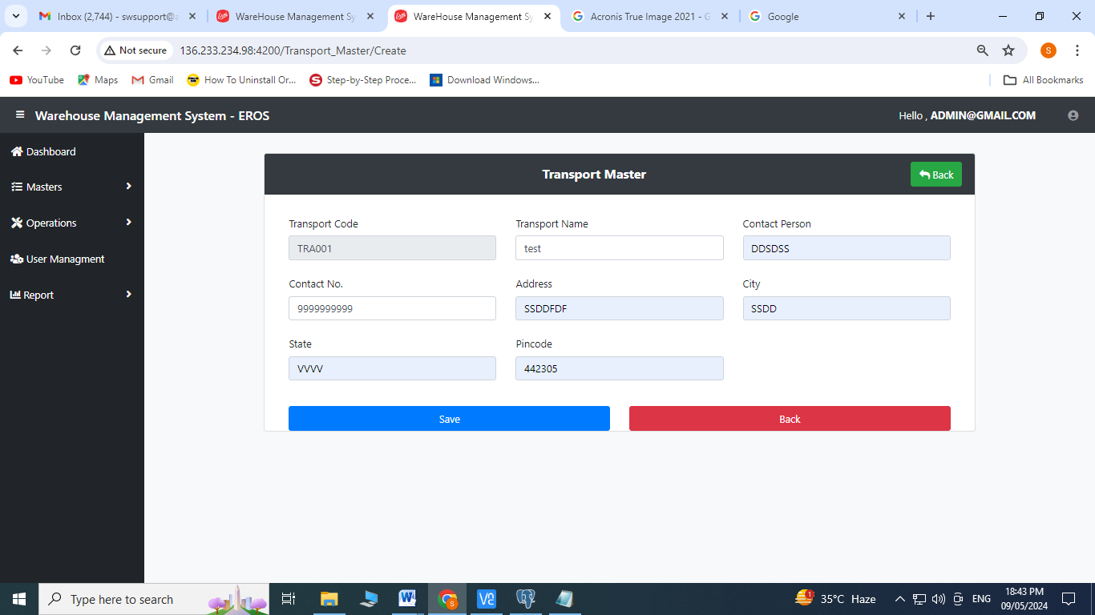

Edit Operation:

1. Click on  to edit

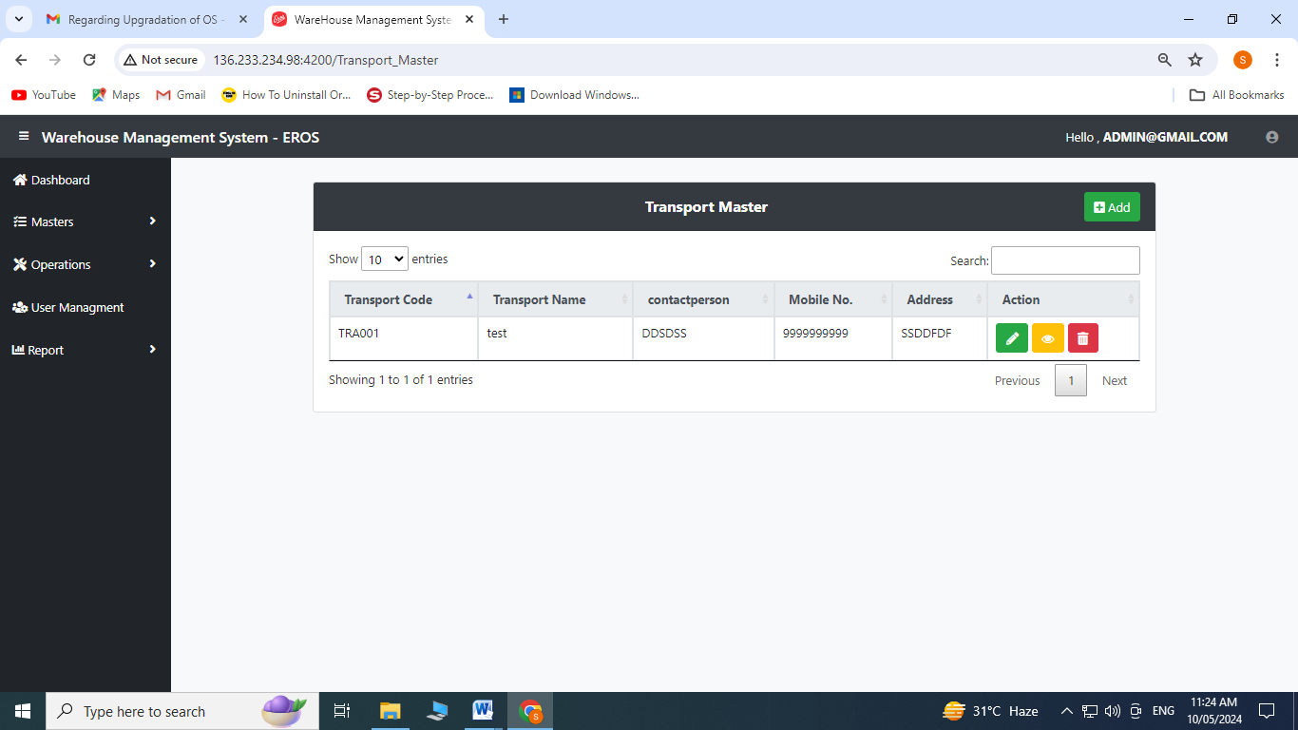

1. Enter Transporter Name, Contact Person, Contact No., Address, City, State, Pincode
2. Click on save

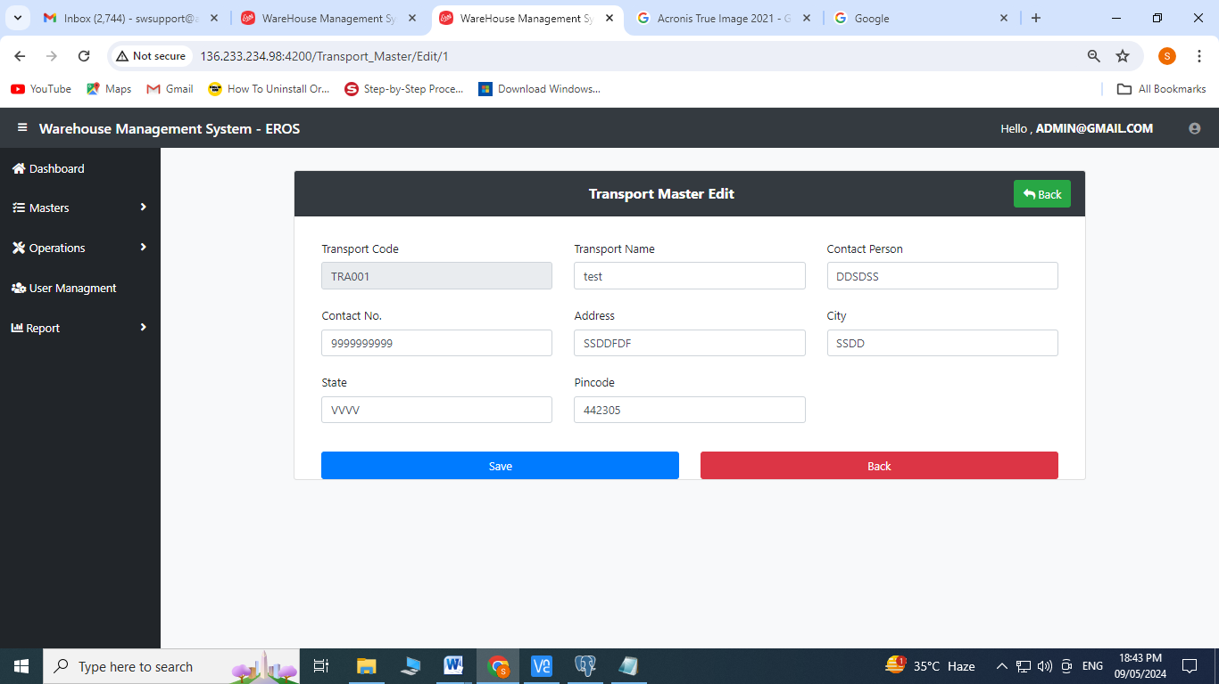

1. **Courier Master:** Click on Courier Master from Master’s Menu

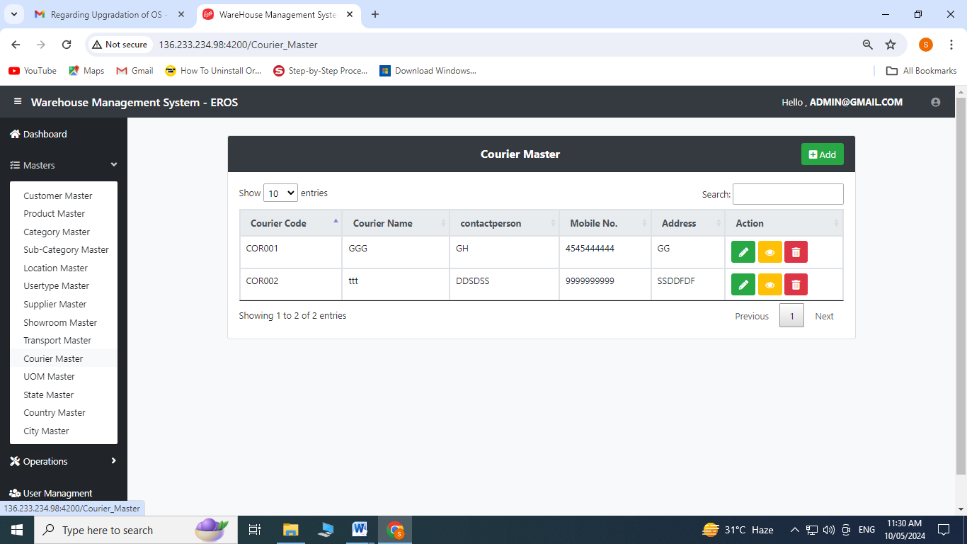

Create Operation:

1. Click on to add

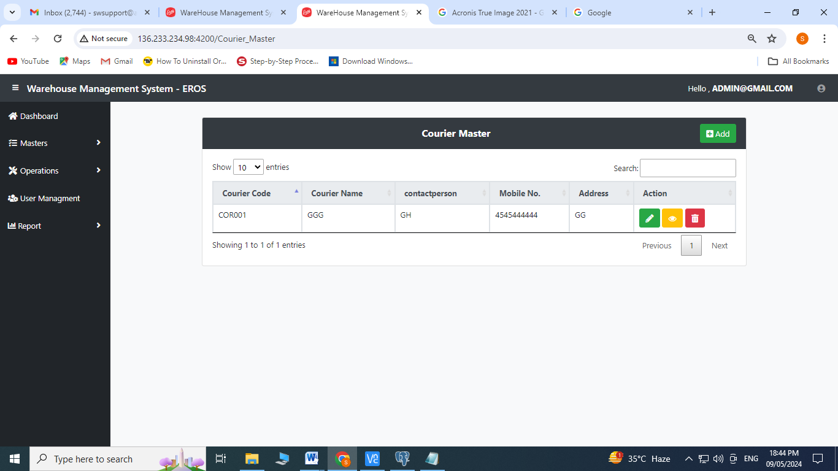

1. Enter Courier Name, Contact Person, Contact No., Address, City, State, Pin code
2. Click on save

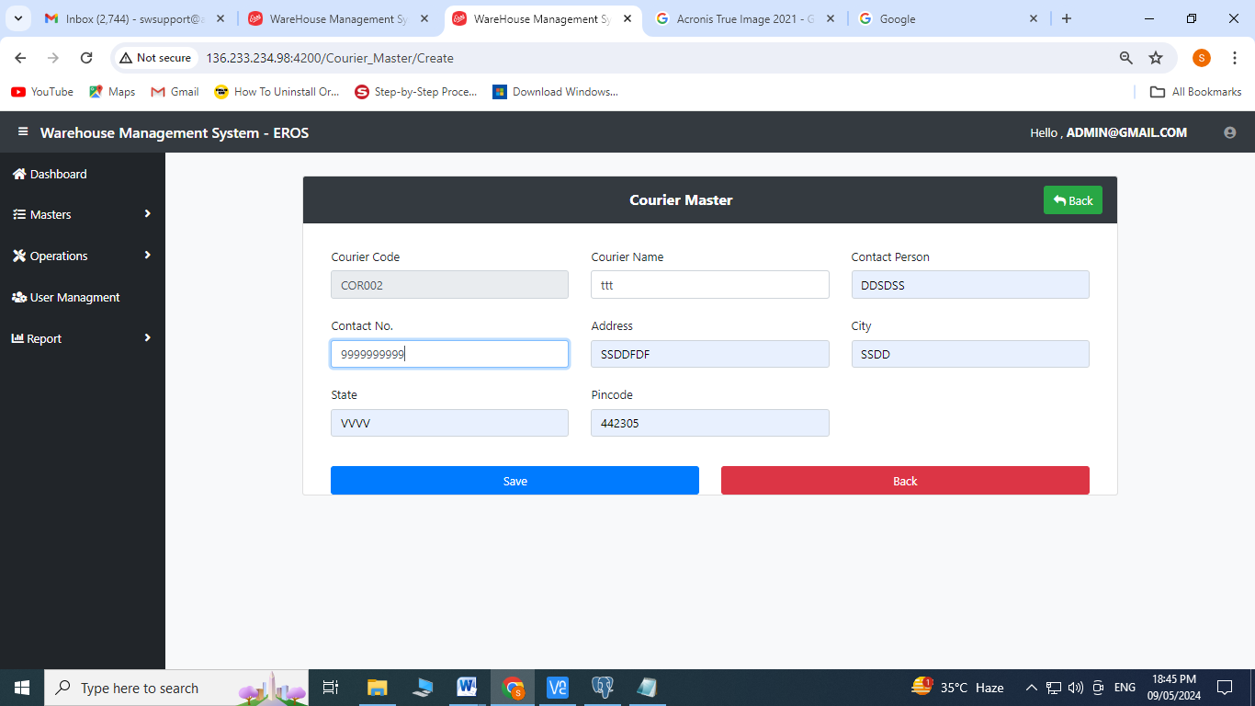

Edit Operation:

1. Click on  to edit

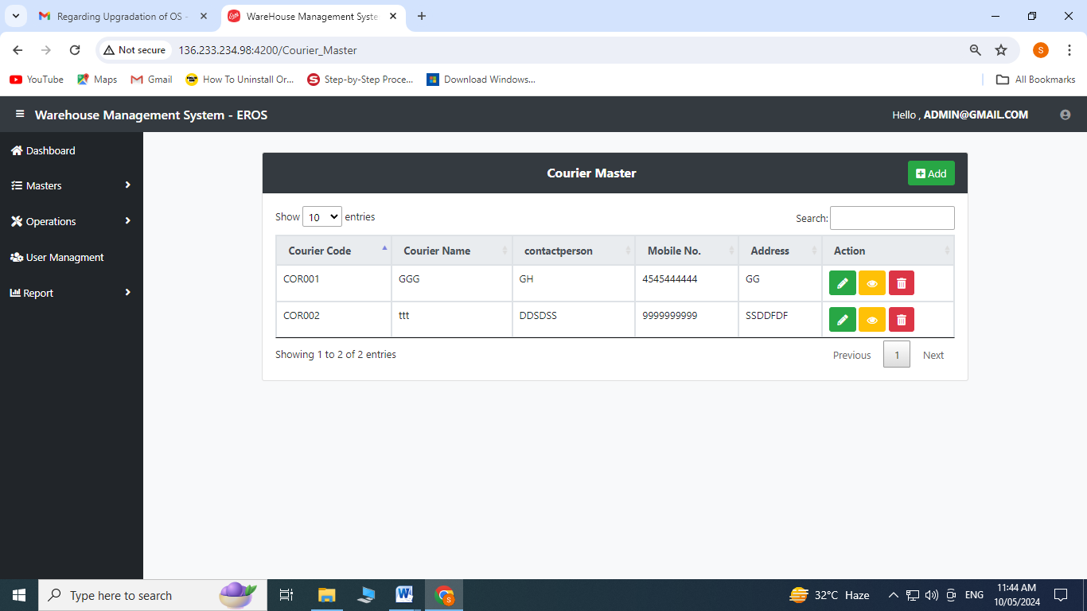

1. Enter Courier Name, Contact Person, Contact No., Address, City, State, Pin code
2. Click on save

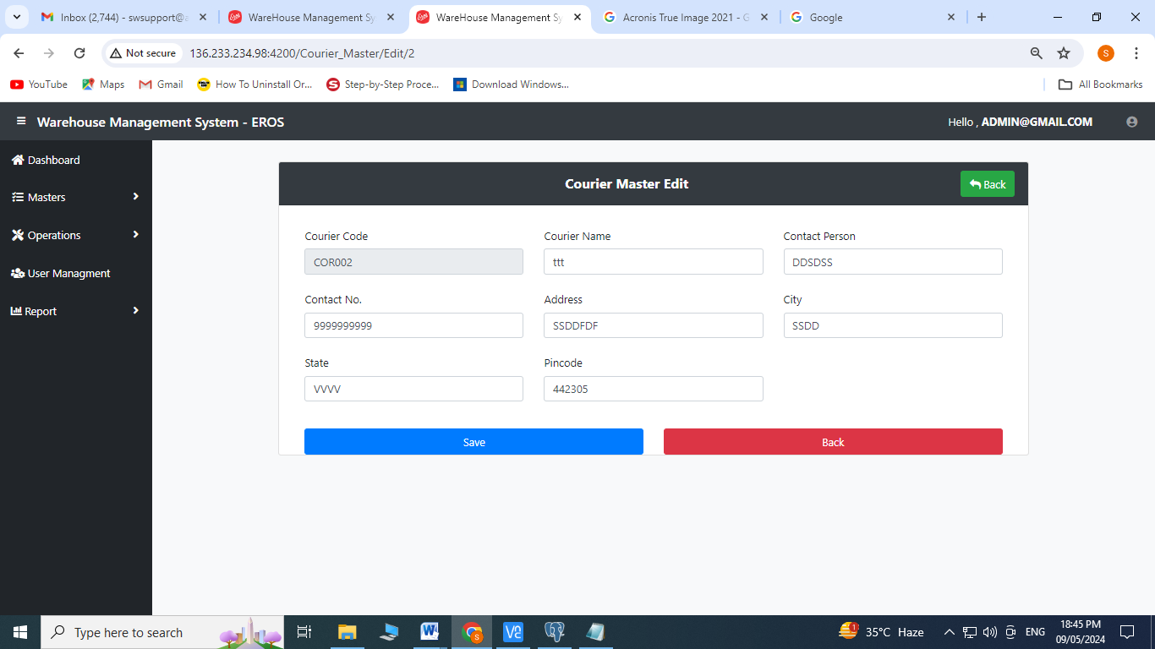

1. **UOM Master:** Click on UOM Master from Master’s Menu

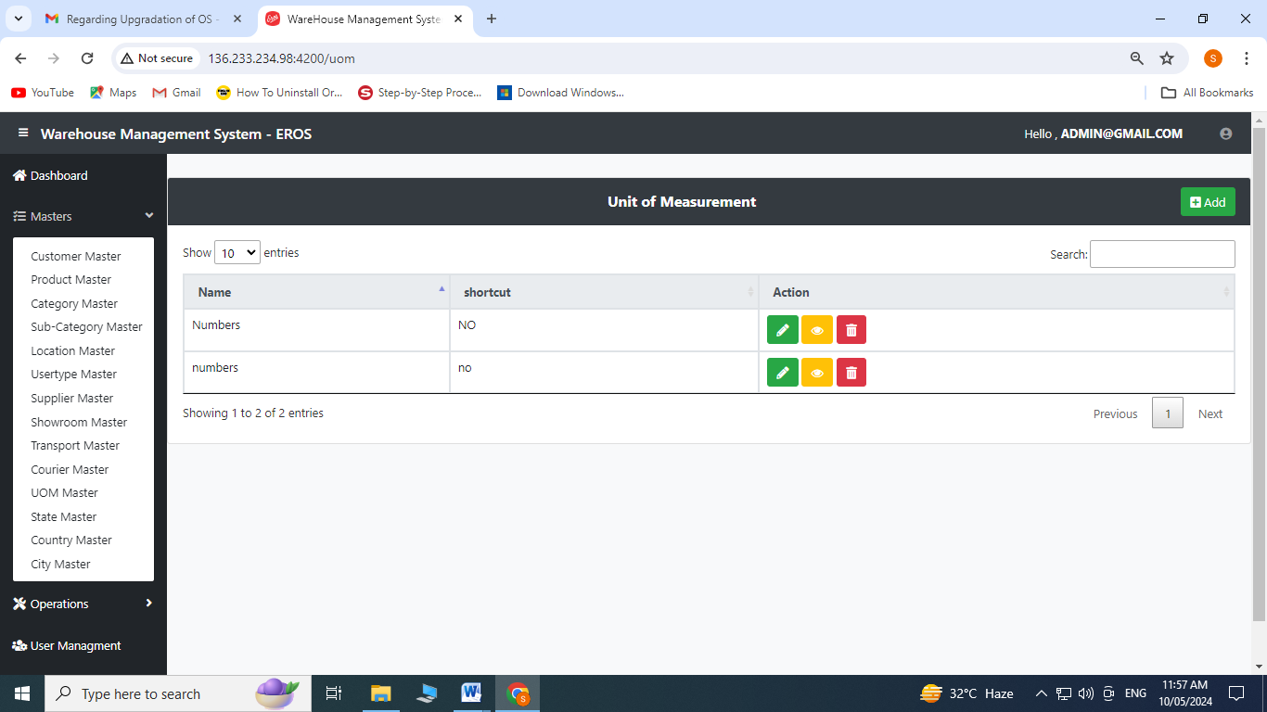

Create Operation:

1. Click on to add

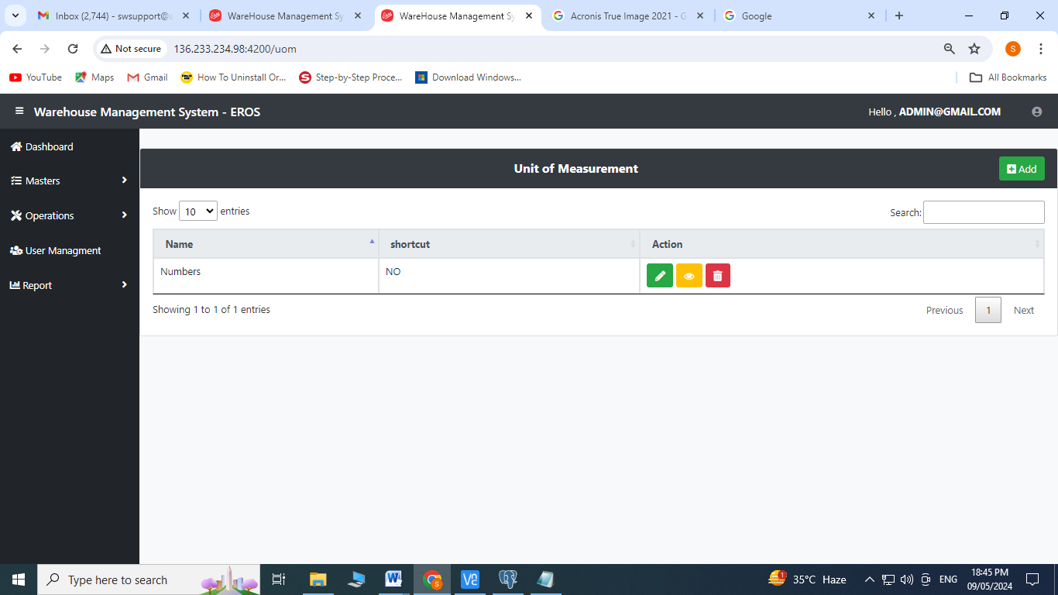

1. Enter Name
2. Enter Shortcut
3. Click on save

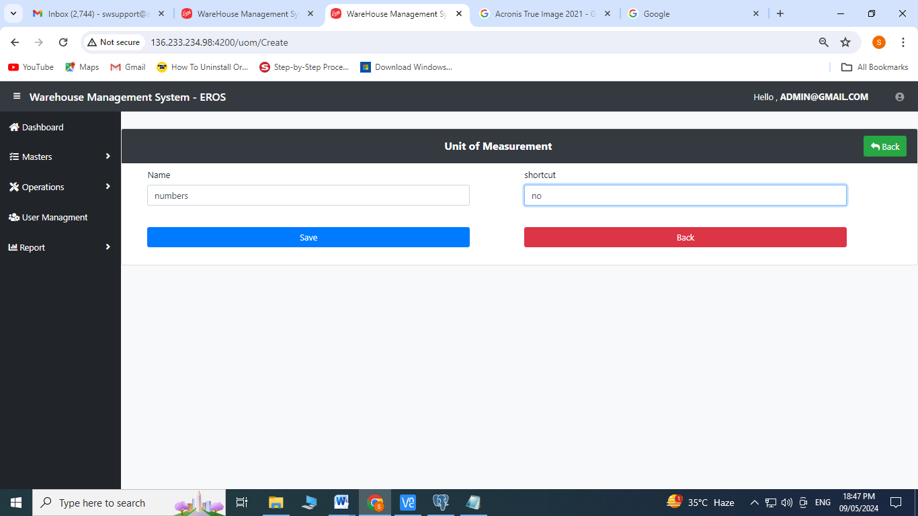

Edit Operation:

1. Click on  to edit

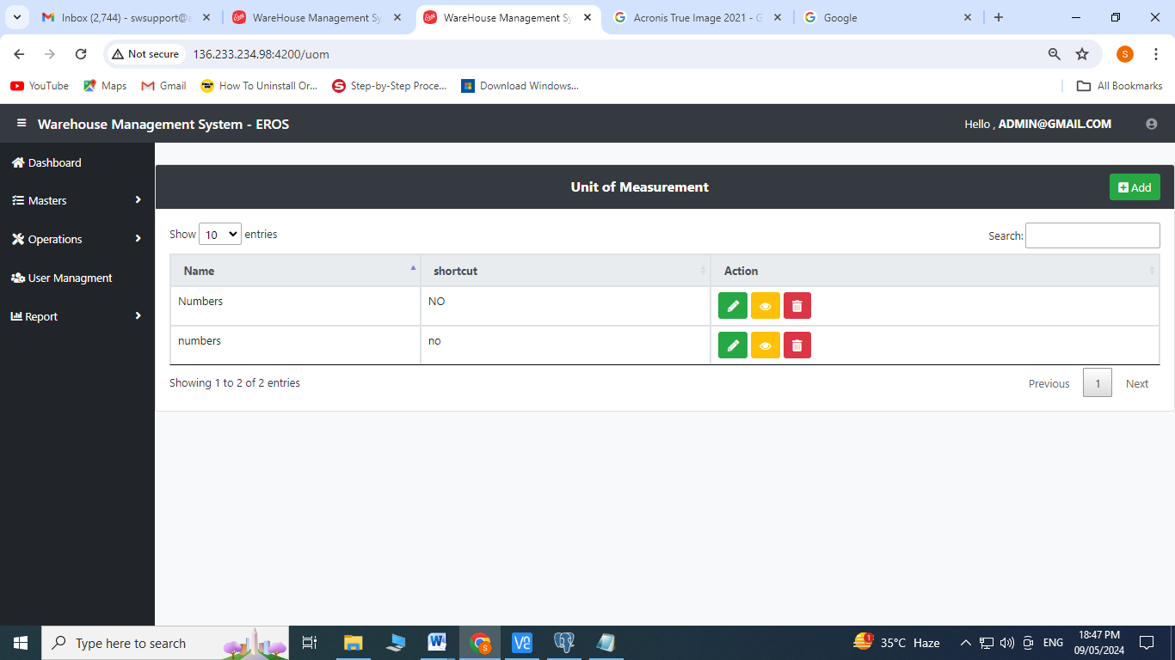

1. Enter Name
2. Enter Shortcut
3. Click on save

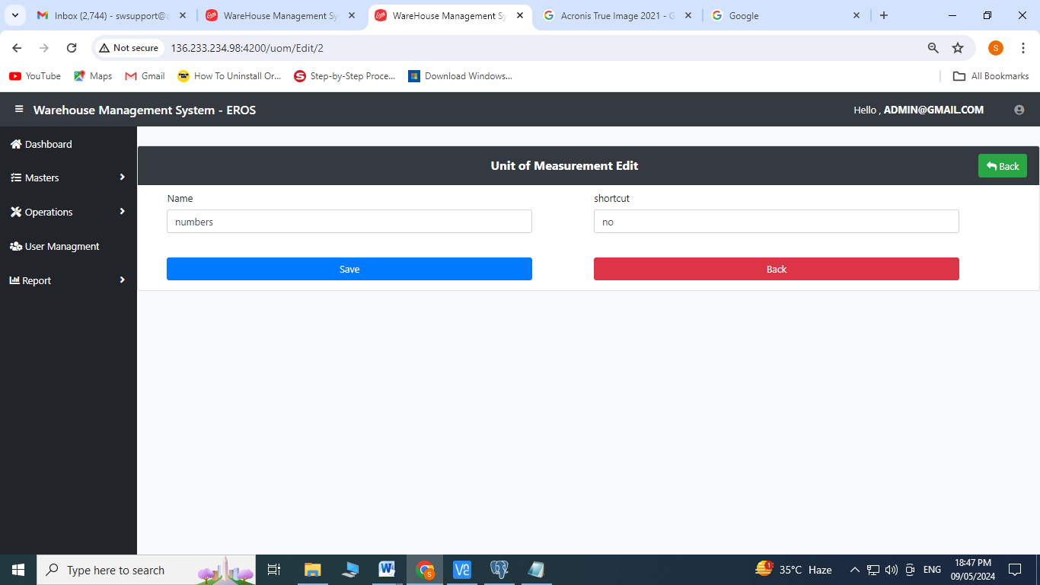

1. **State Master:** Click on State Master from Master’s Menu

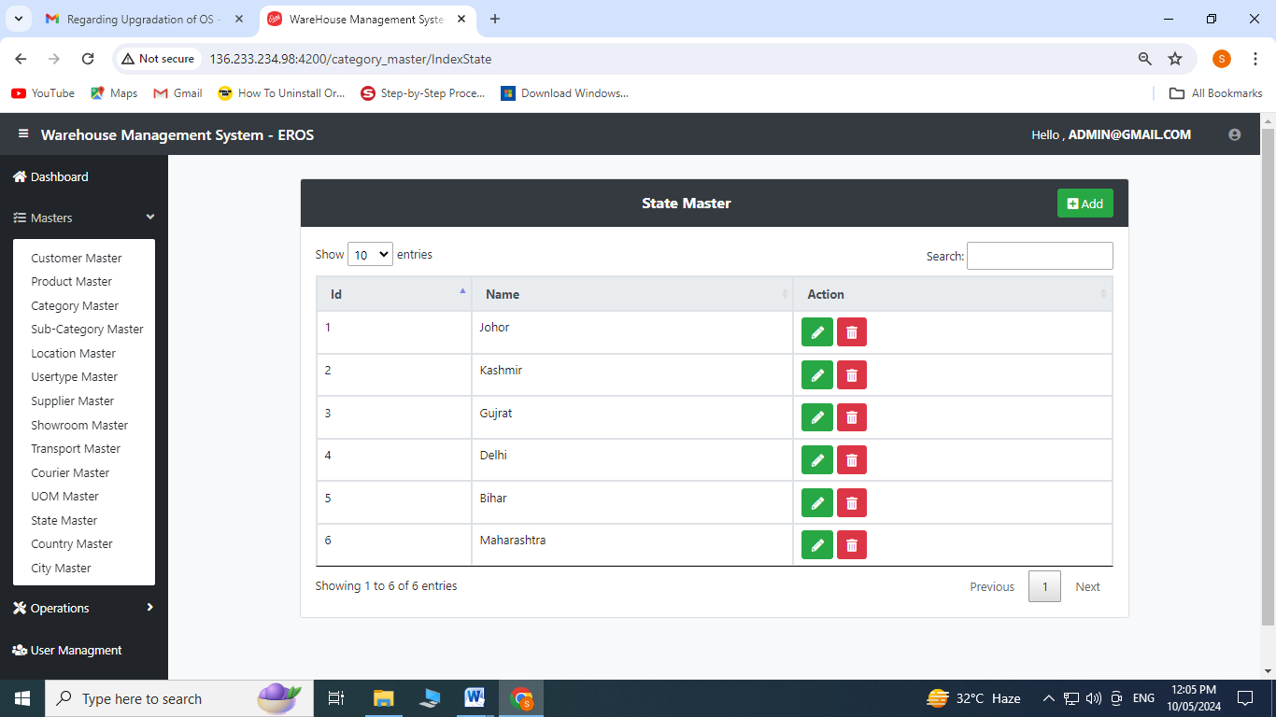

Create Operation:

1. Click on to add

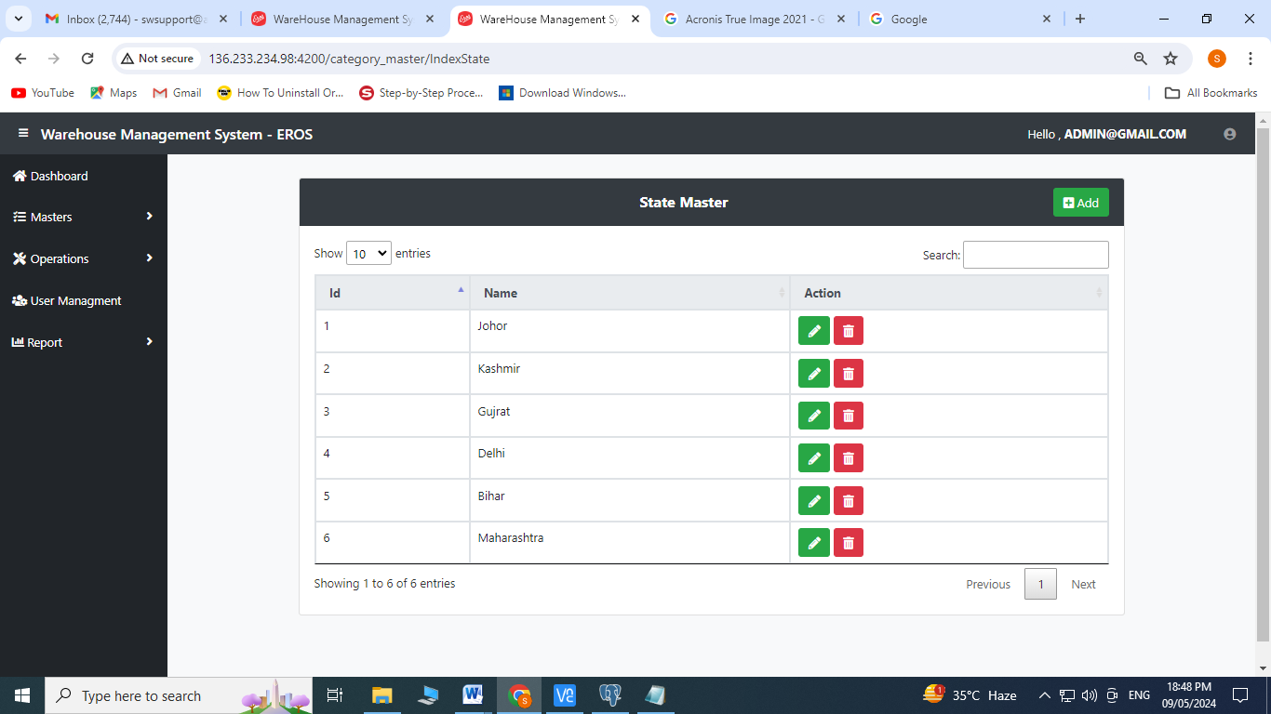

1. Select country name from the dropdown menu
2. Enter State Name
3. Click on Save

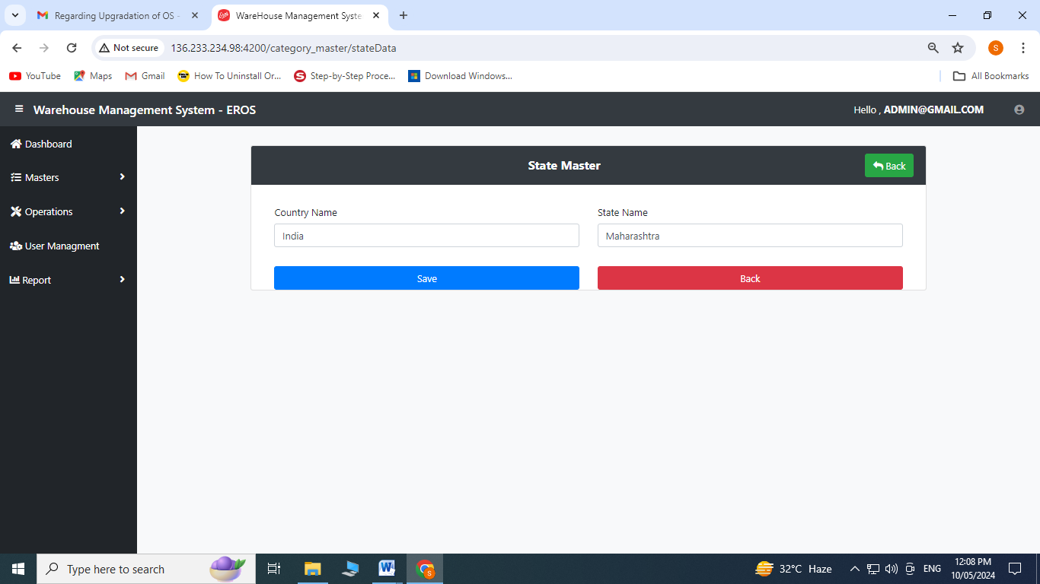

Edit Operation:

1. Click on  to edit

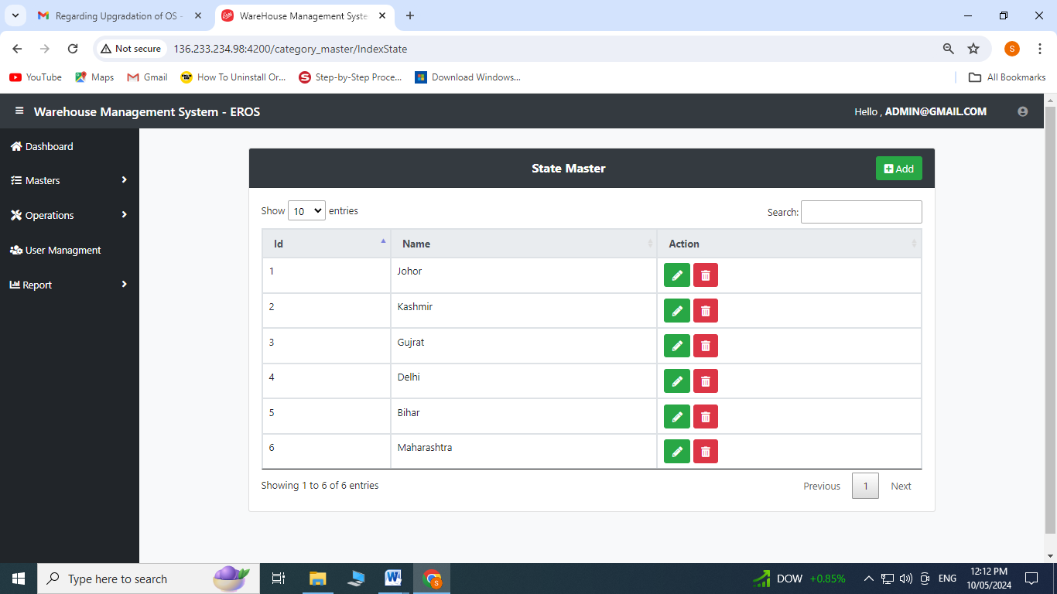

1. Enter State Name
2. Click on Save

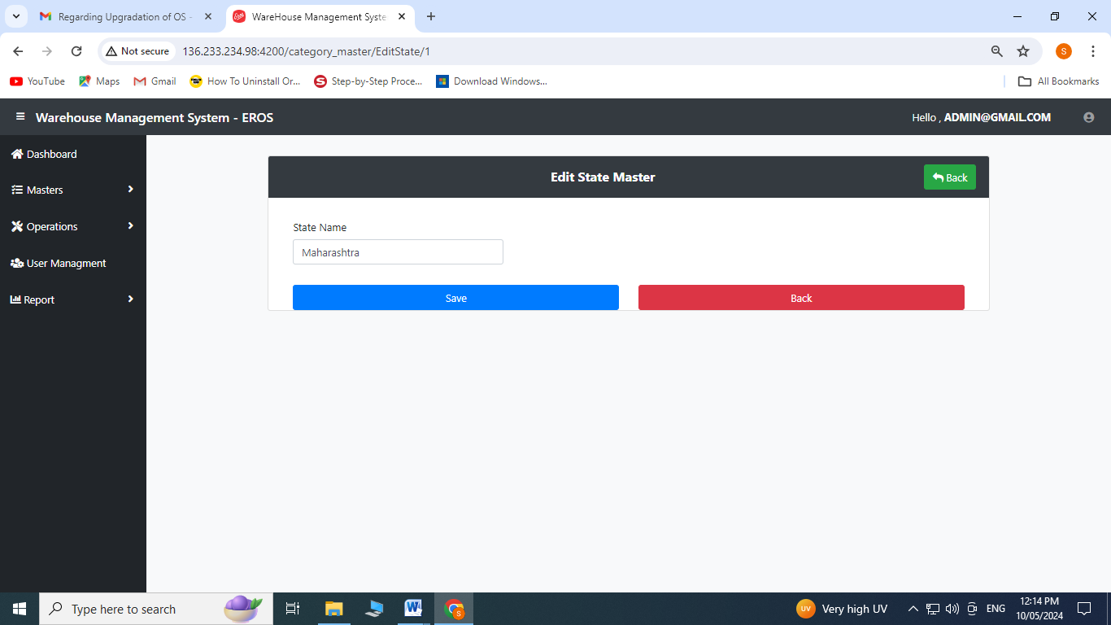

1. **Country Master:** Click on Country Master from Master’s Menu

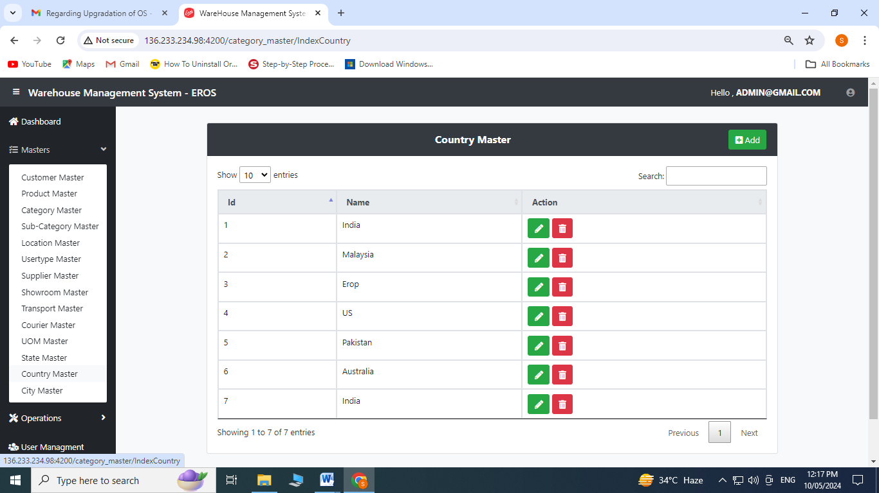

Create Operation:

1. Click on to add

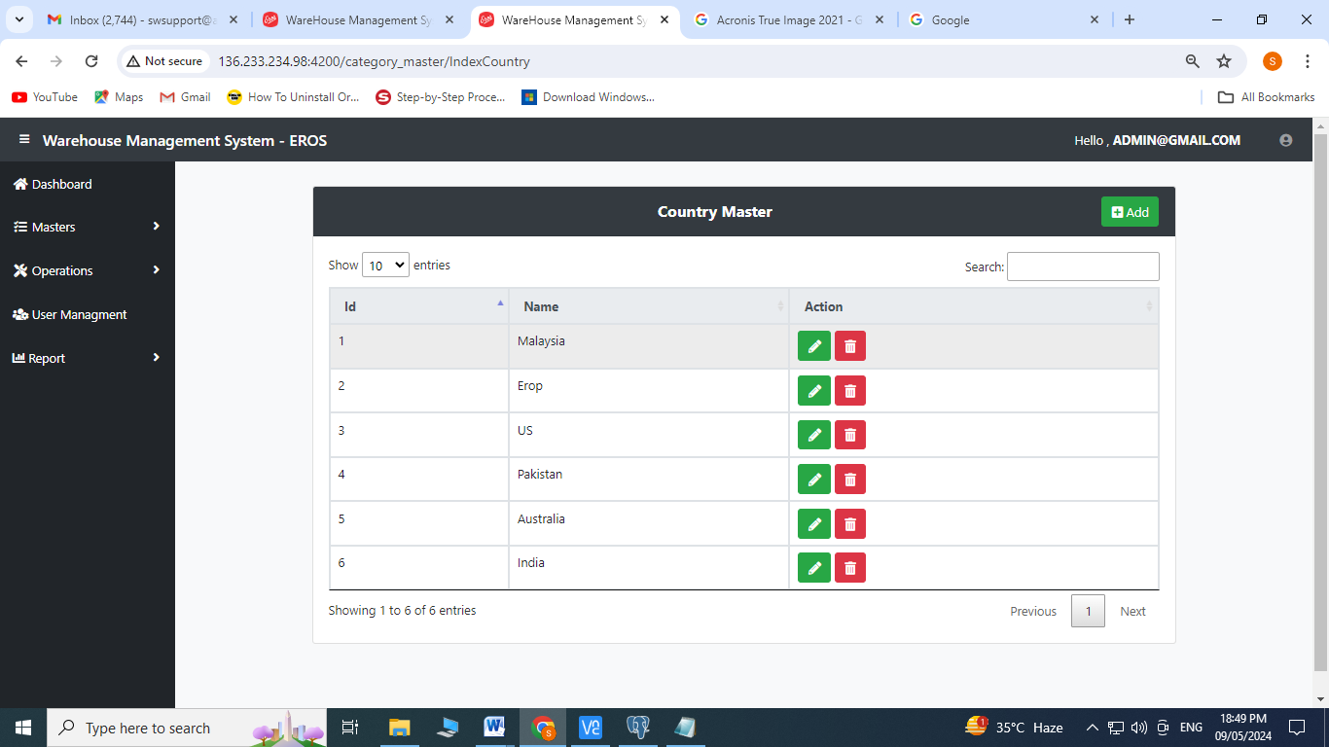

1. Enter Country Name
2. Click on Save

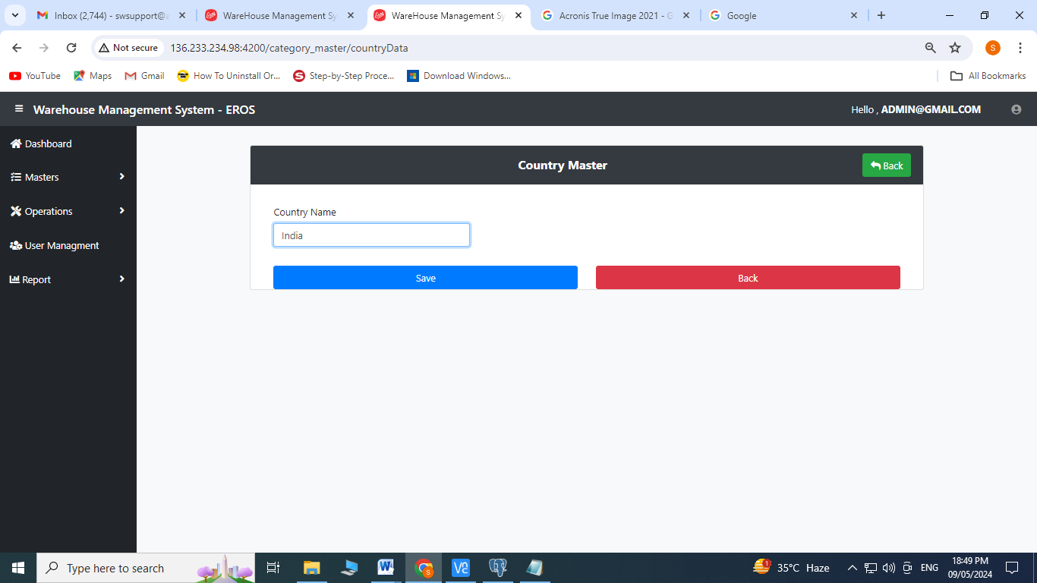

Edit Operation:

1. Click on  to edit

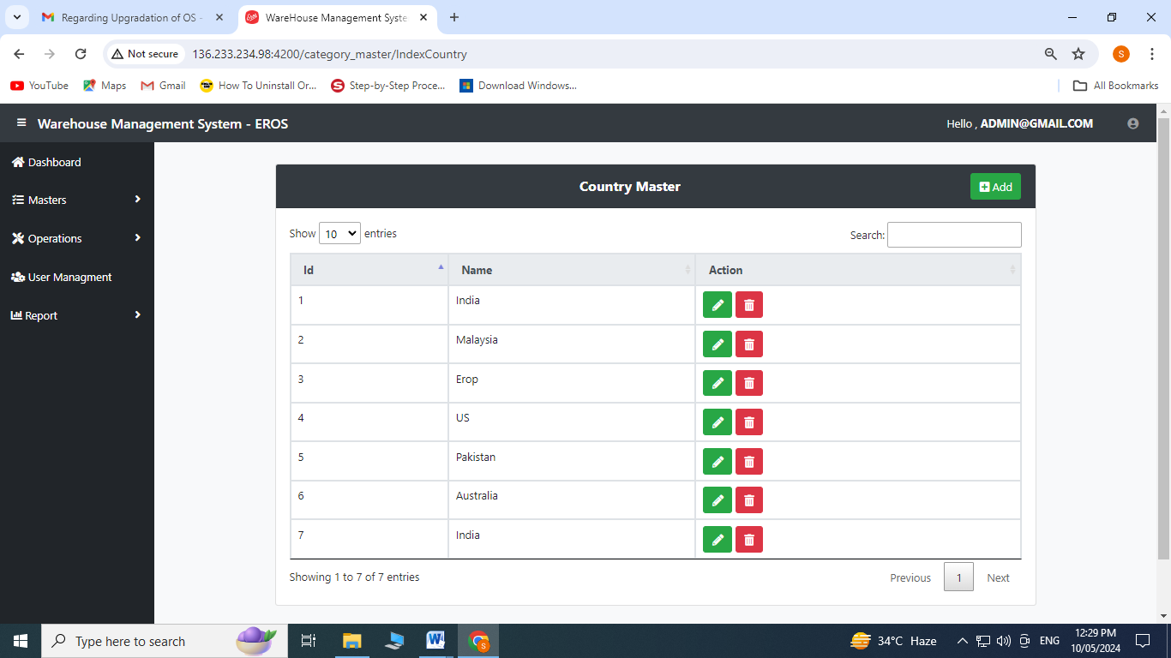

1. Enter Country Name
2. Click on save

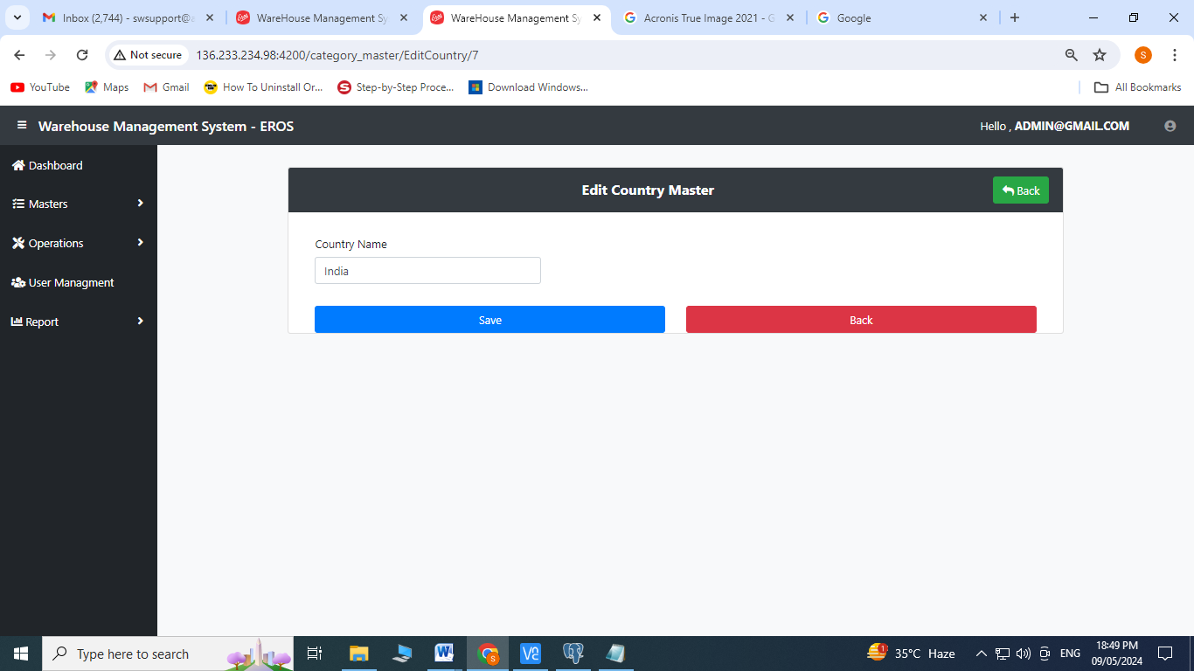

1. **City Master:** Click on City Master from Master’s Menu

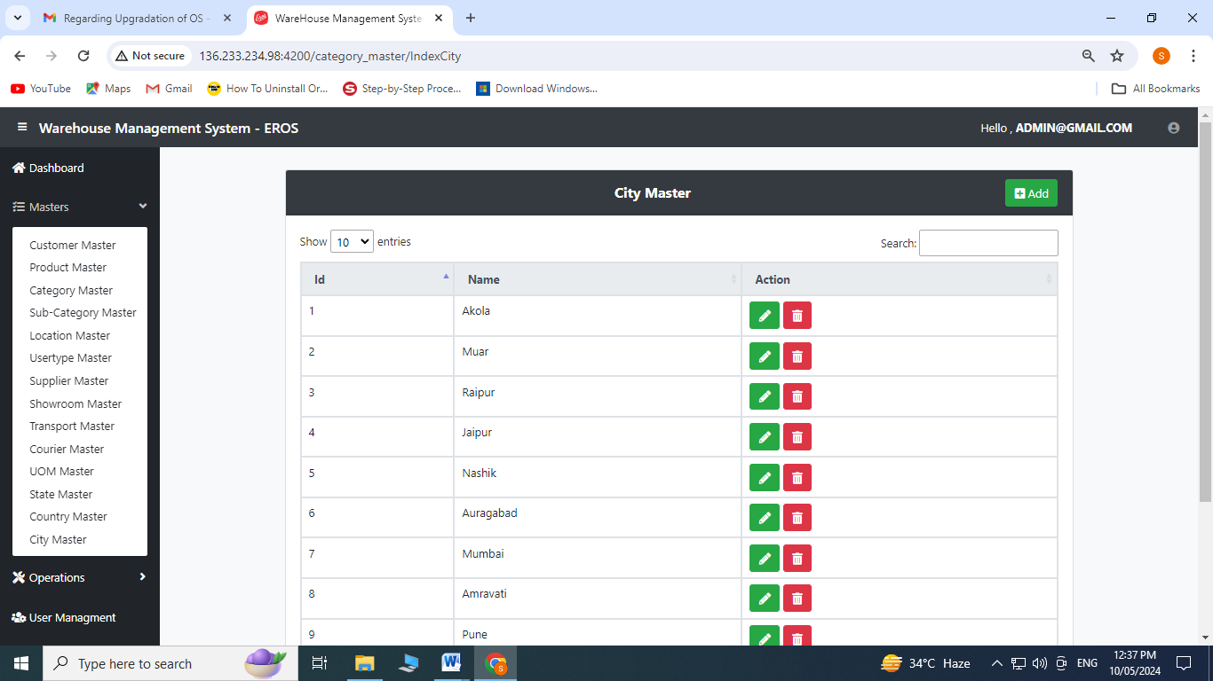

Create Operation:

1. Click on to add

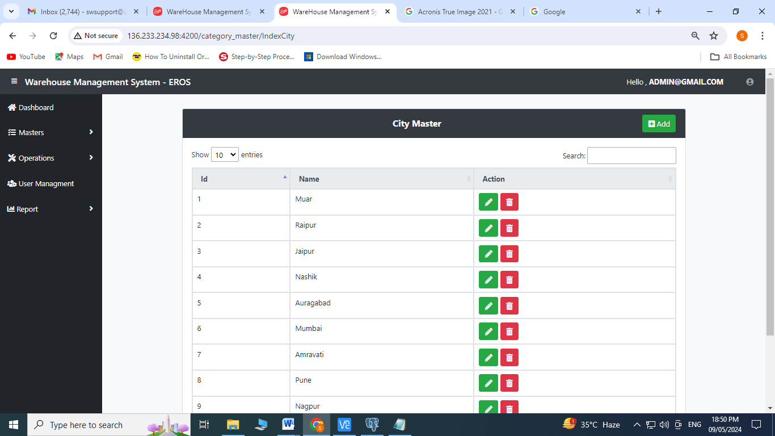

1. Select State Name from the dropdown menu
2. Enter City Name
3. Click on Save

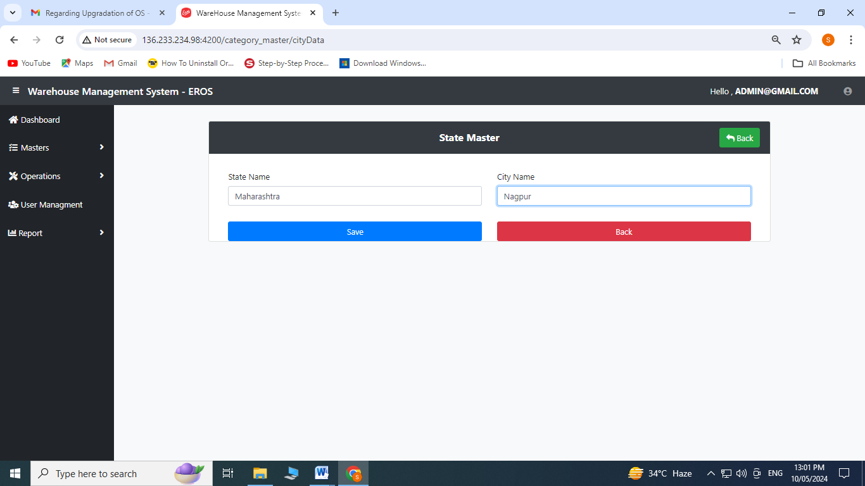

Edit Operation:

1. Click on  to edit

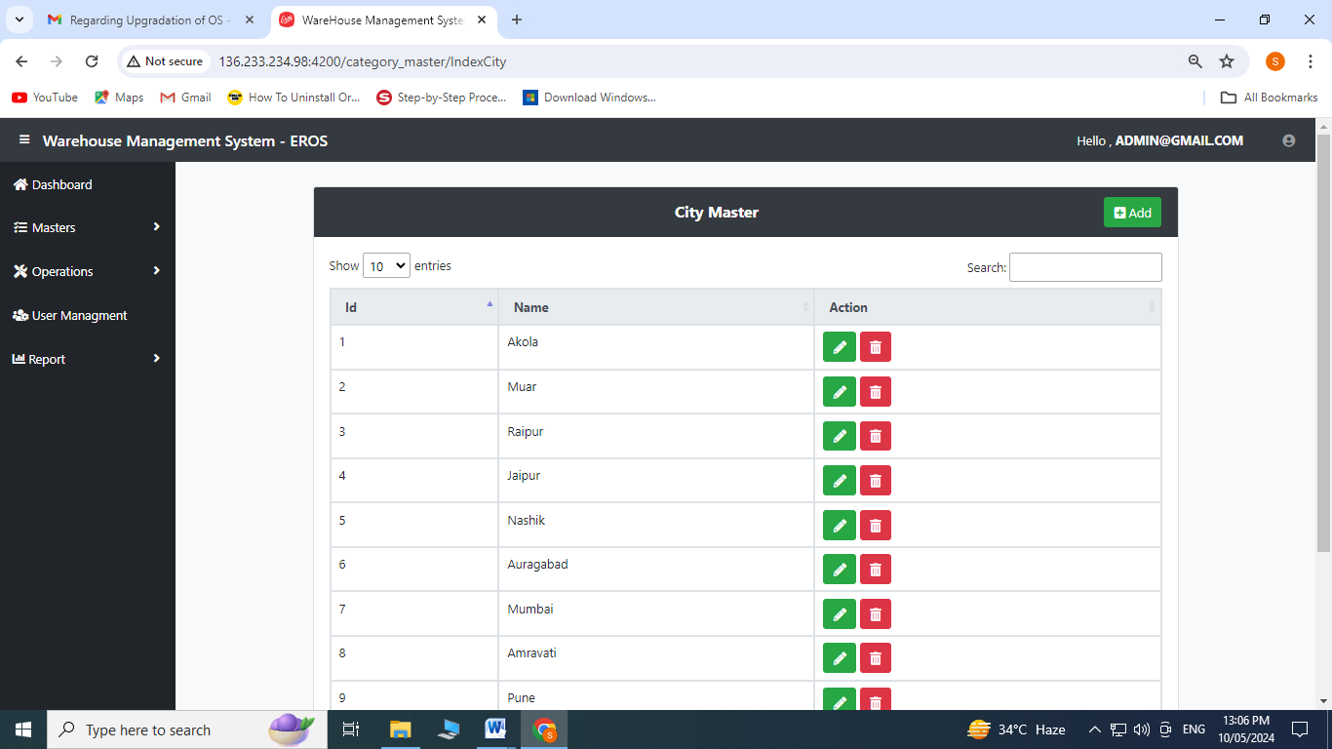

1. Enter City Name
2. Click on Save

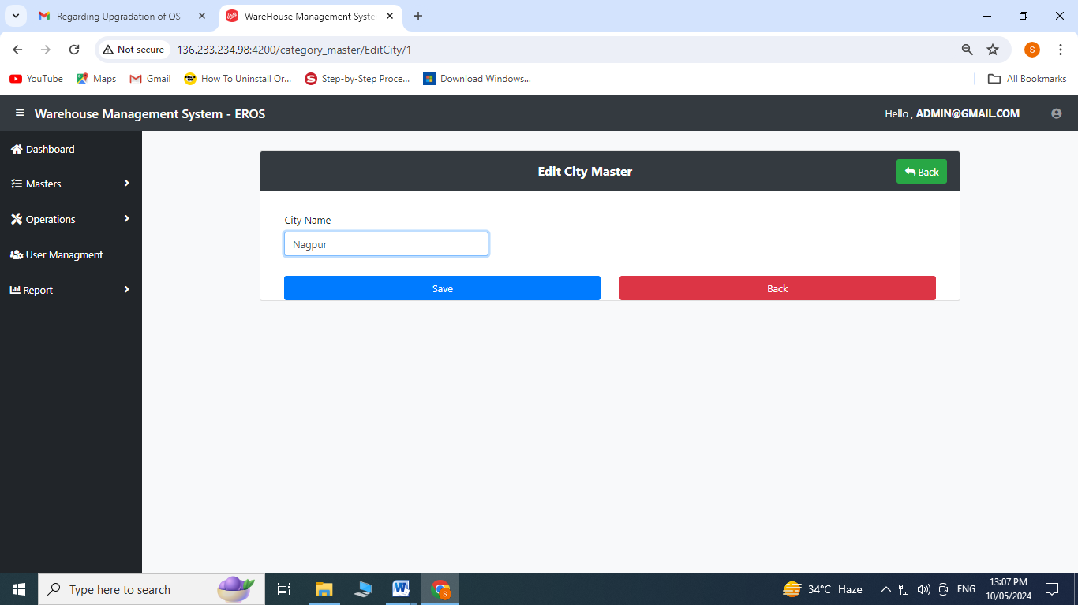

**Operations**

1. **Purchase Order Entry:** Click on the purchase order entry from the operation’s menu

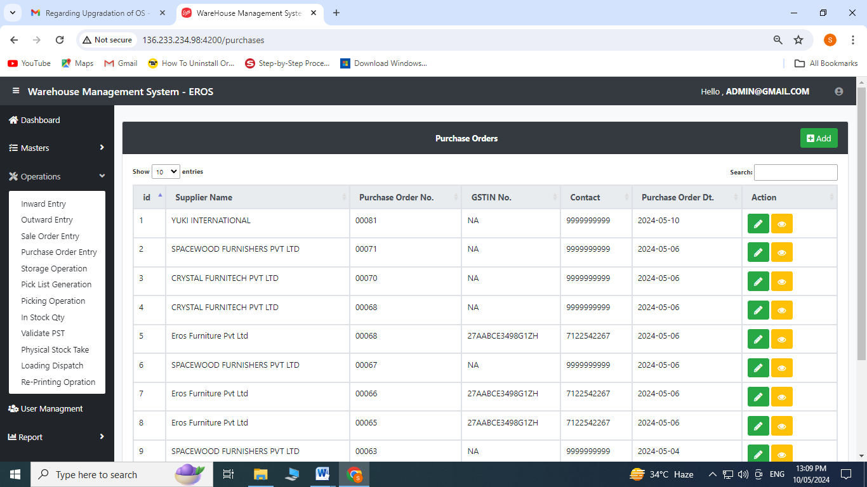

Create Operation:

1. Click on to add

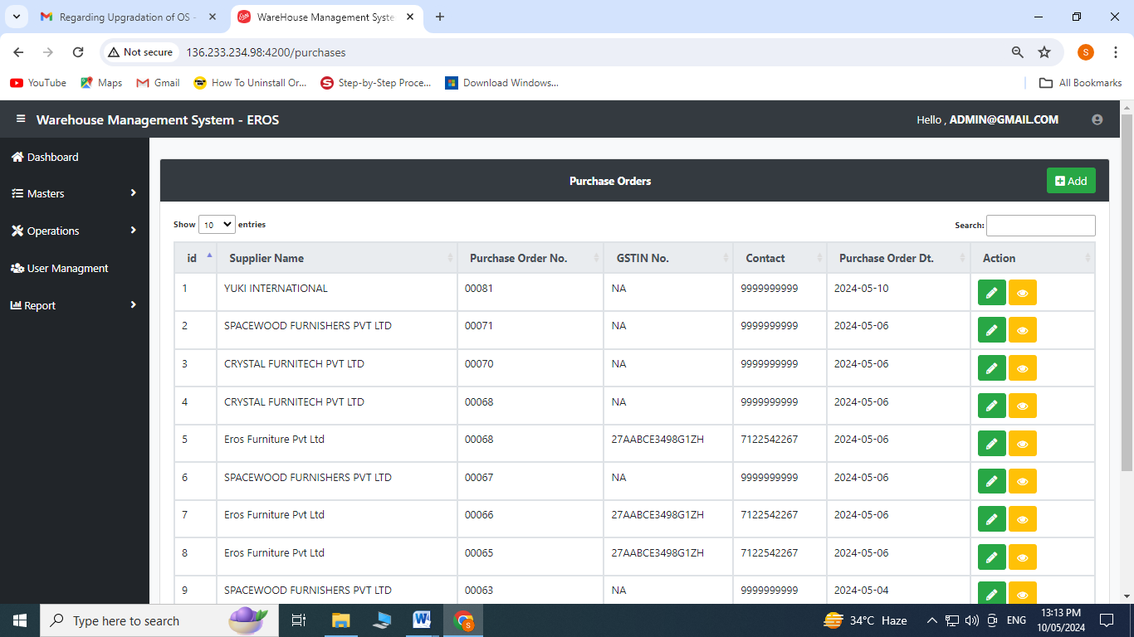

Create Operation:

1. Enter Purchase Order No.
2. Enter Supplier Name
3. Enter GSTIN No.
4. Enter Contact No. and Address
5. Enter product description
6. Select qty. from the dropdown
7. For adding more products click on 
8. Click on save

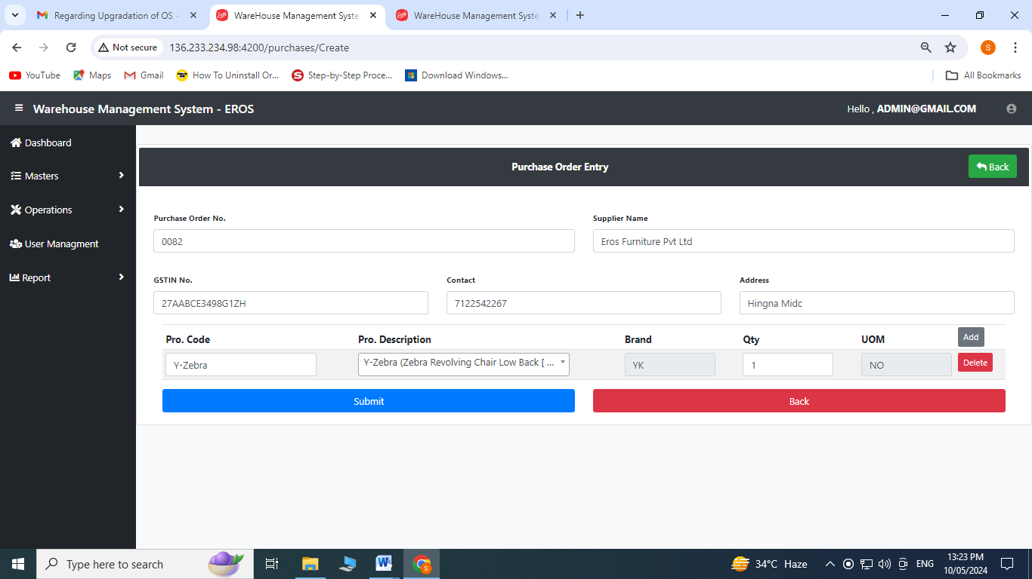

Edit Operation:

1. Click on  to edit

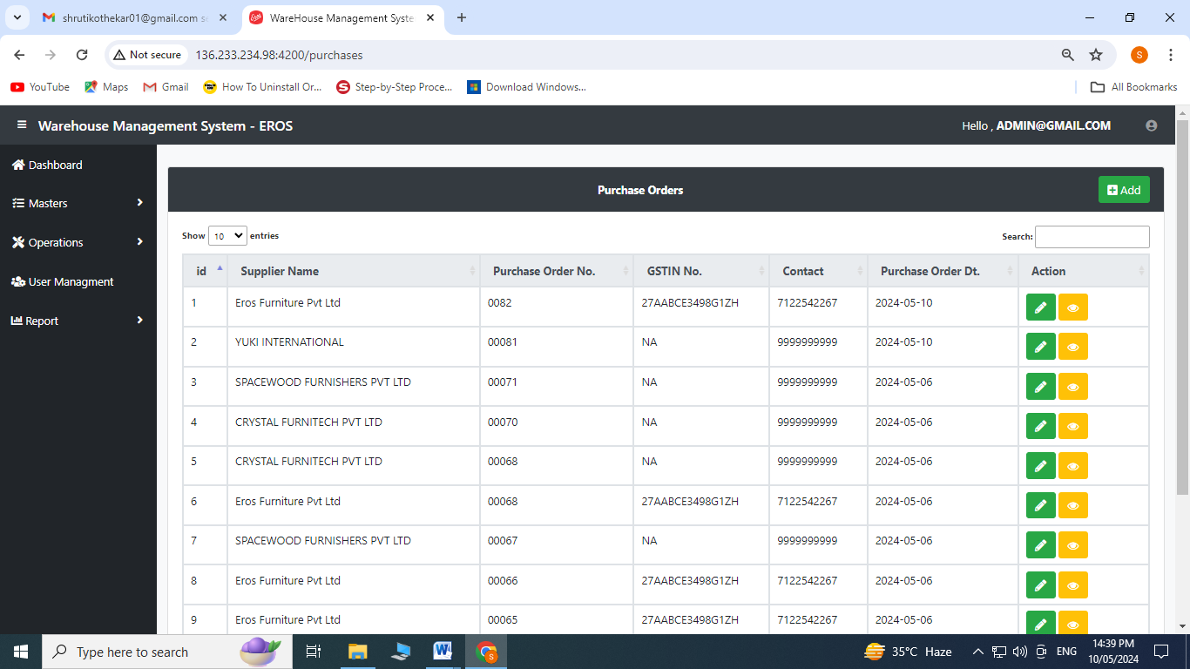

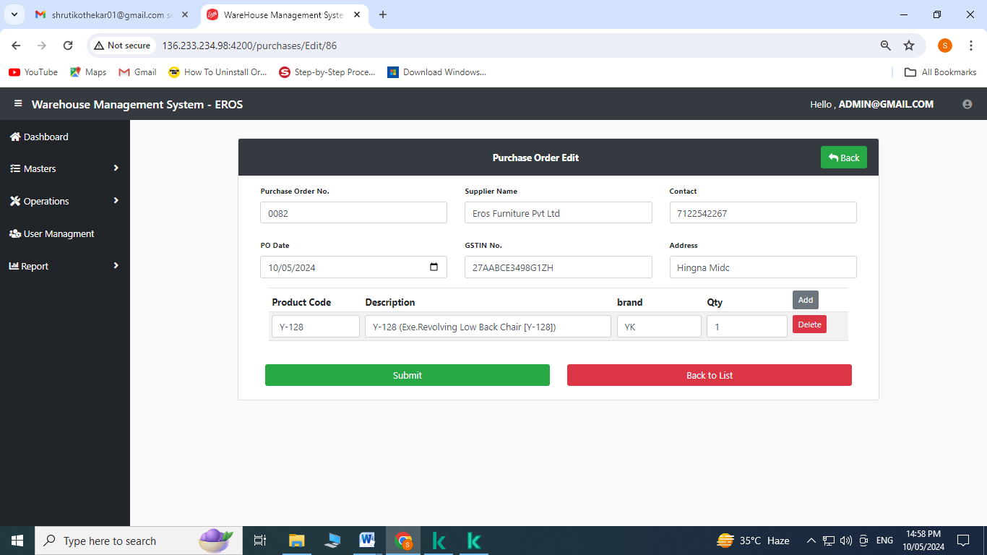

1. Enter Purchase Order No.
2. Enter Supplier Name
3. Enter Contact No.
4. Select PO date
5. Enter GSTIN No.
6. Enter Address
7. Enter product description
8. Select qty. from the dropdown
9. For adding more products click on 
10. Click on save

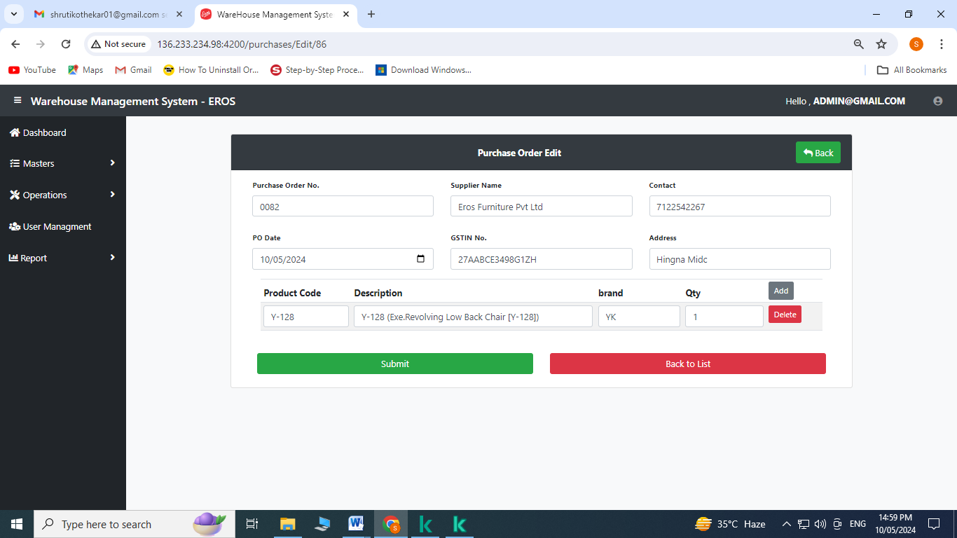

1. **Inward Entry:** Click on the inward entry from the operation’s menu

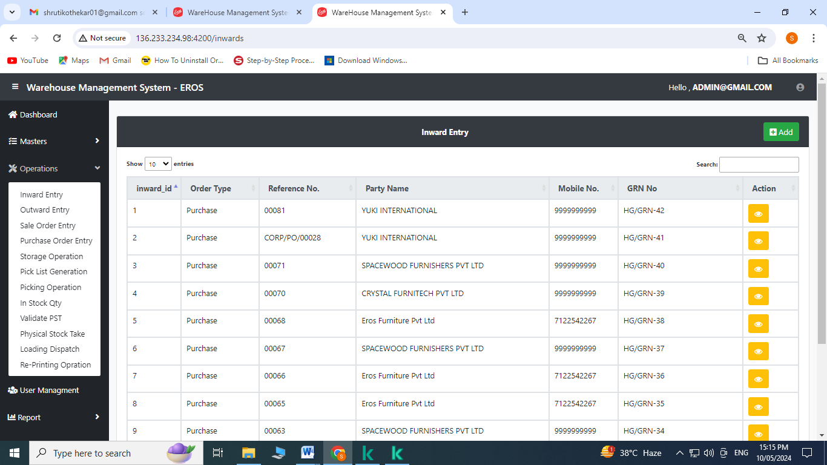

Create Operation:

1. Click on to add

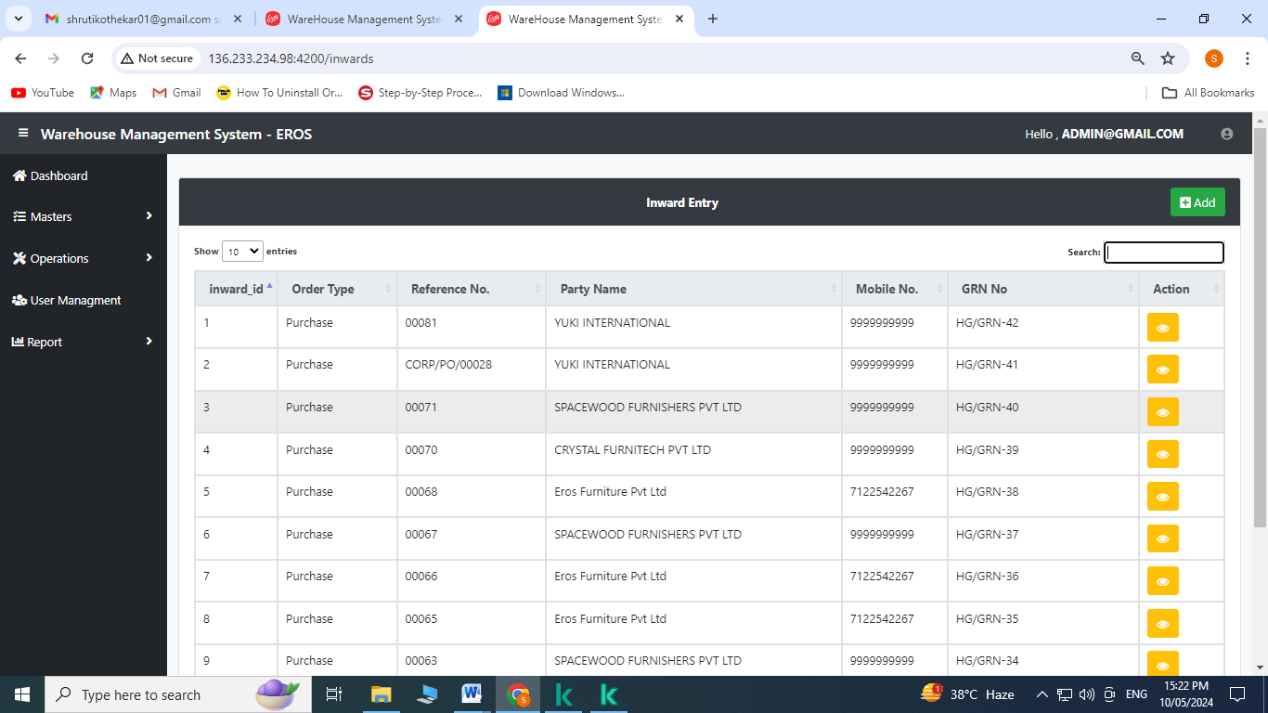

1. Click on Purchase

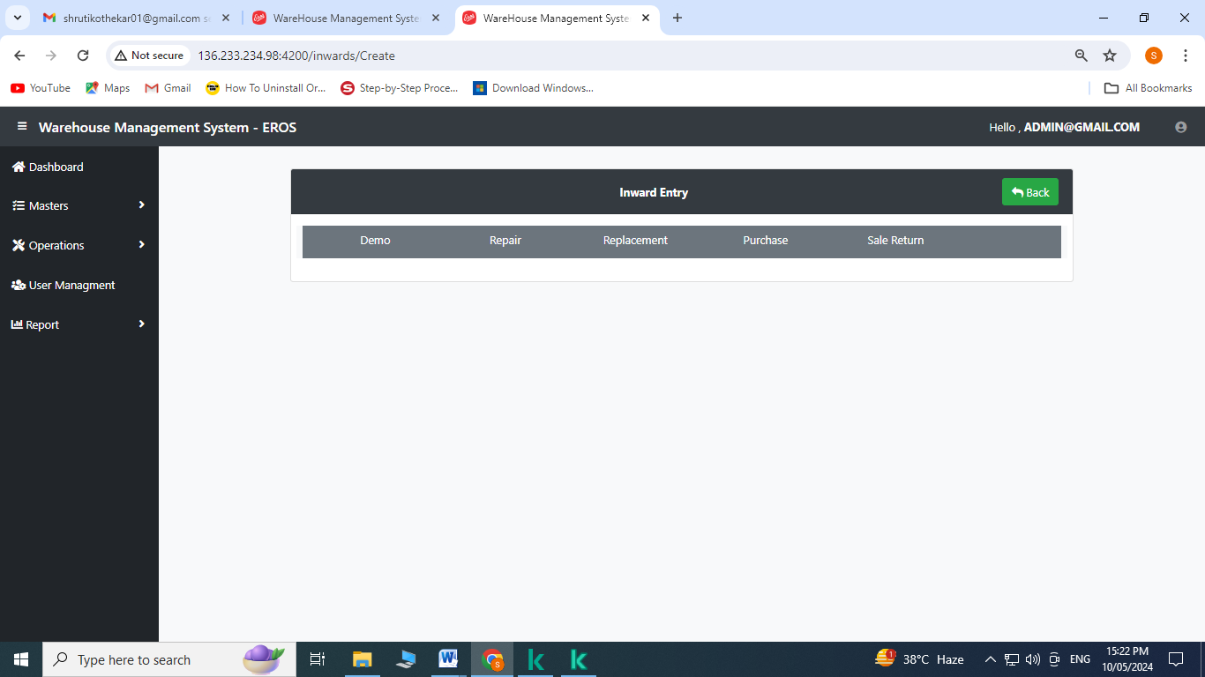

1. Select the purchase order no. from the dropdown menu
2. Select qty. from the dropdown menu
3. Enter no. of set/product
4. Enter no. of set/shipper
5. Enter no. of shipper/qty.
6. Select GRN Date
7. Enter Batch code
8. Enter remarks (if required)
9. Click on create

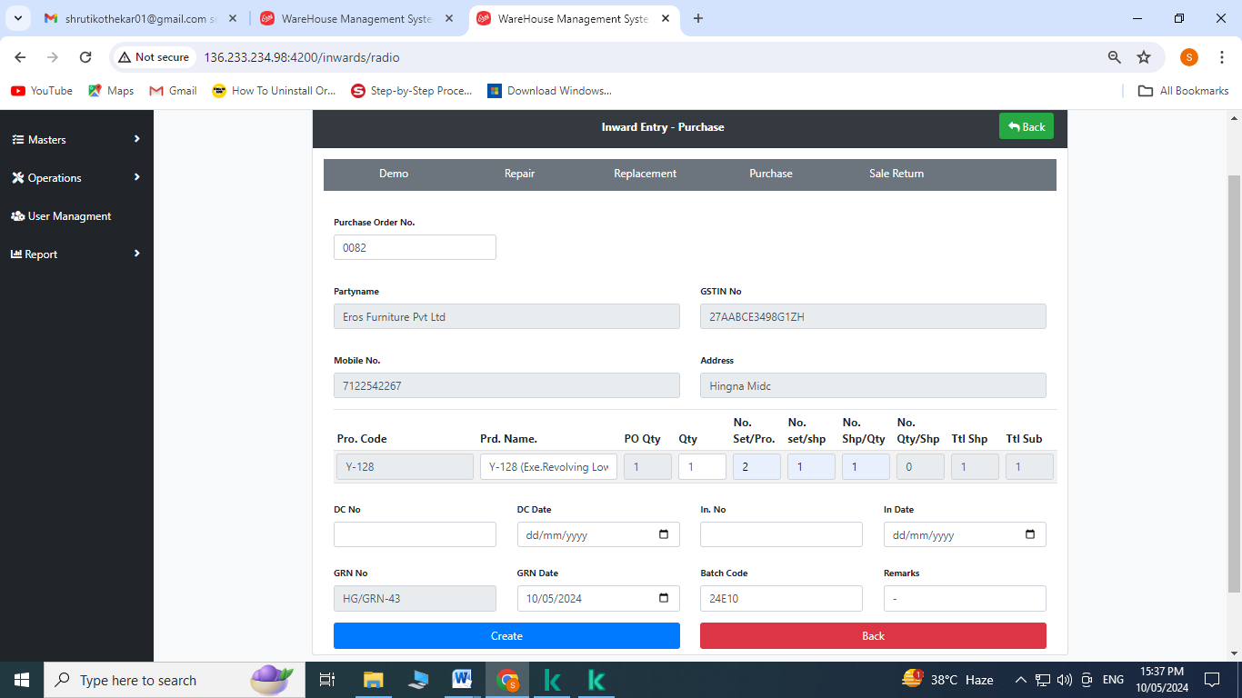

**Note:** This part is optional.



Click on shipperwise

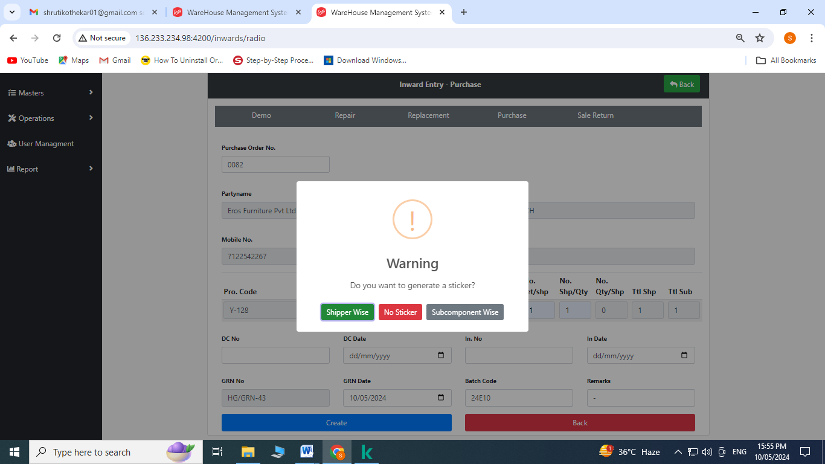

Click on OK

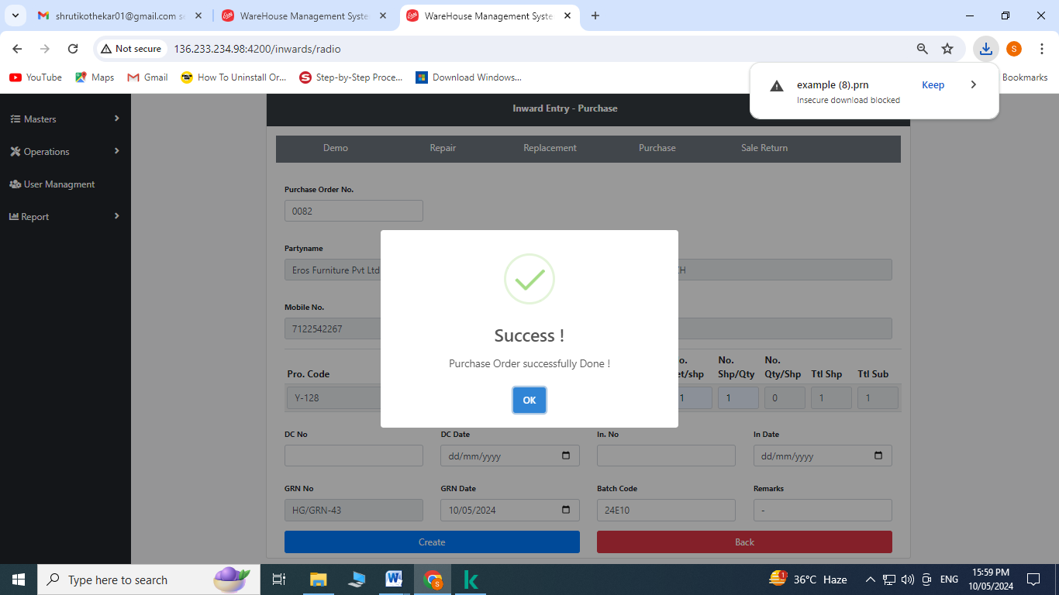

1. **Re-printing Operation:** Click on re-printing operation from the operation’s menu

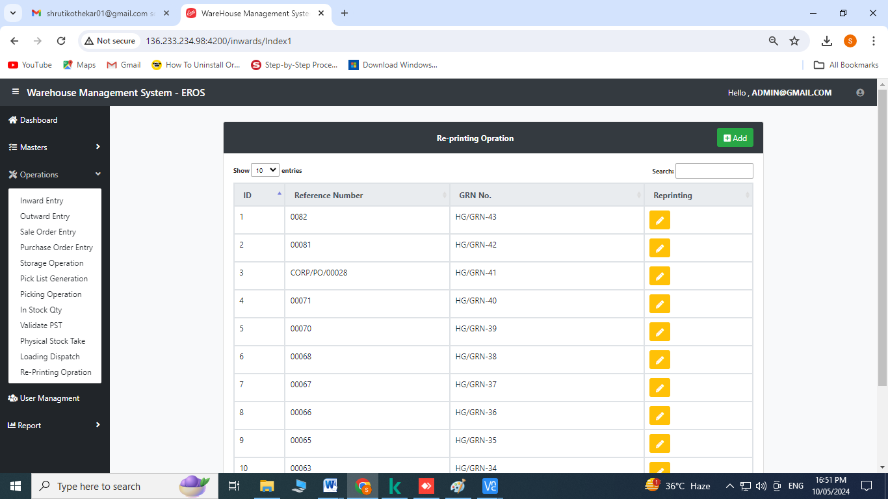

1. Click on  to reprint

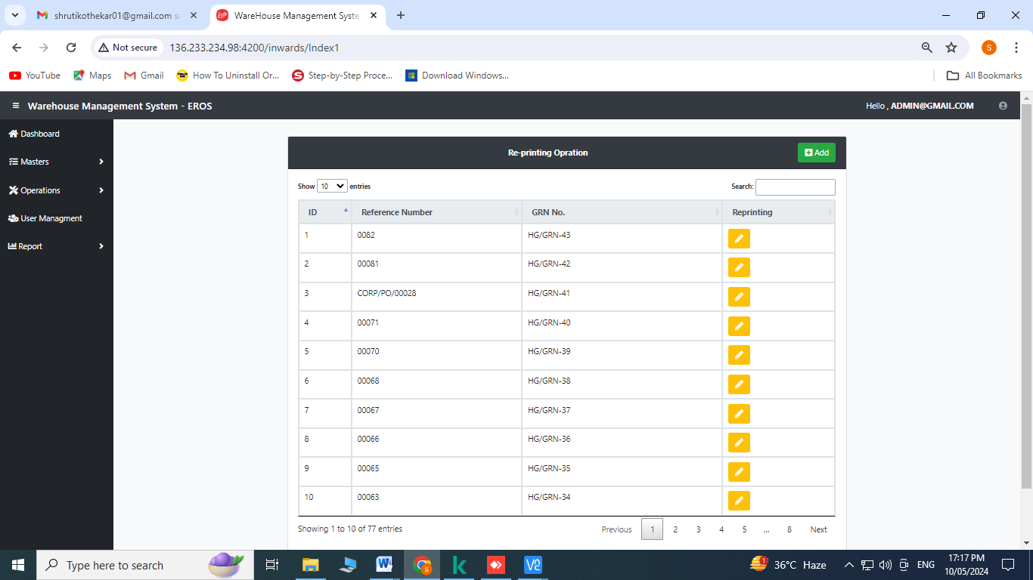

Click on the checkbox

Click on save

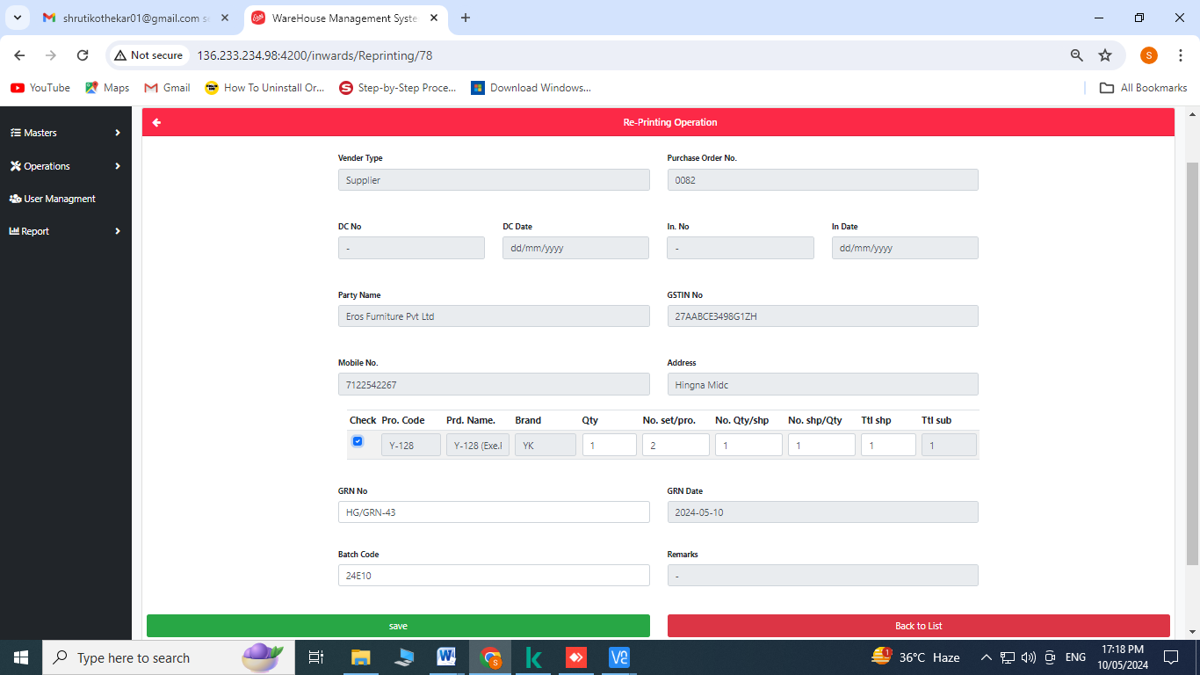

1. **Storage Operation:** Click on storage operation from the operation’s menu

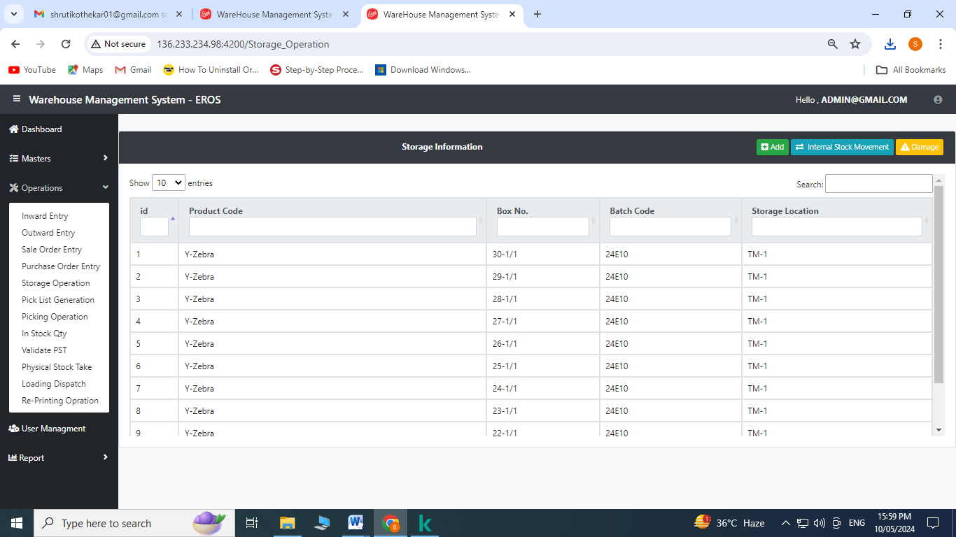

Create Operation:

1. Click on to add

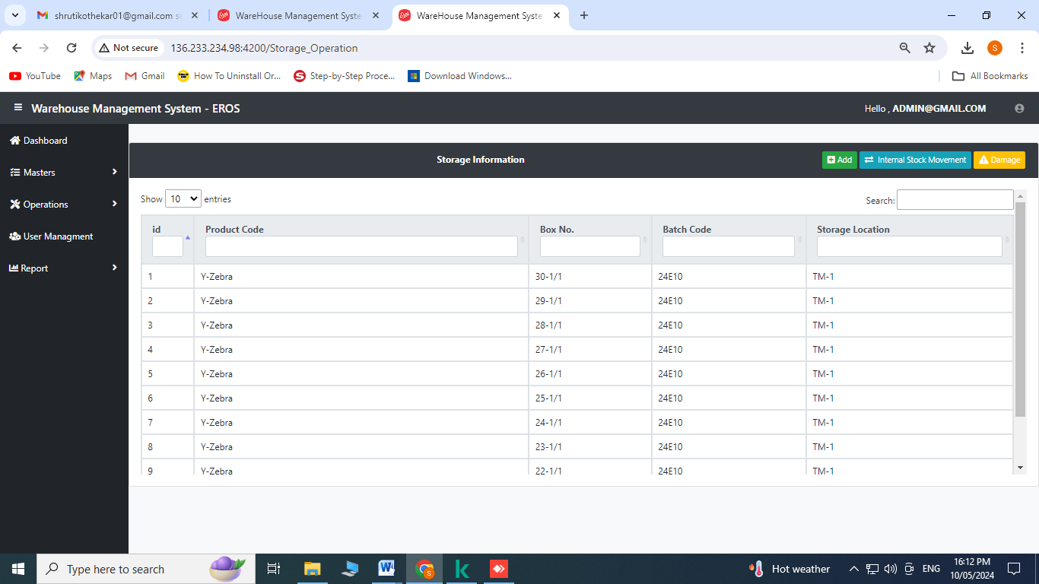

Click on storage location and scan the barcode

Click on product code and scan the barcodes one by one

Click on save

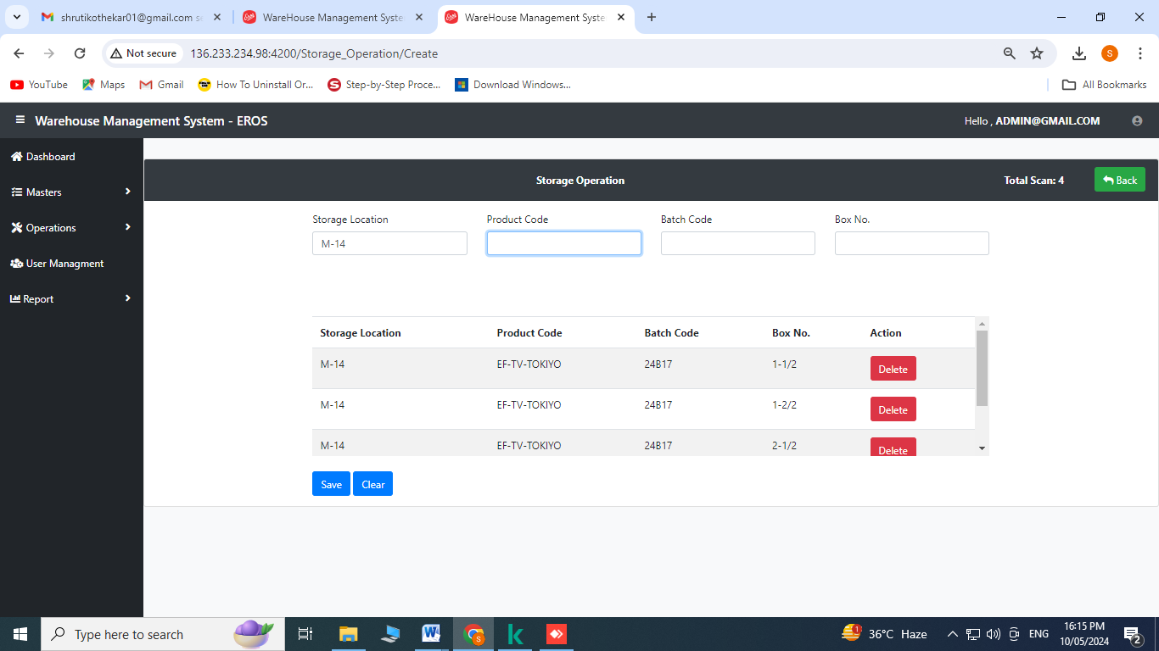

Click on OK

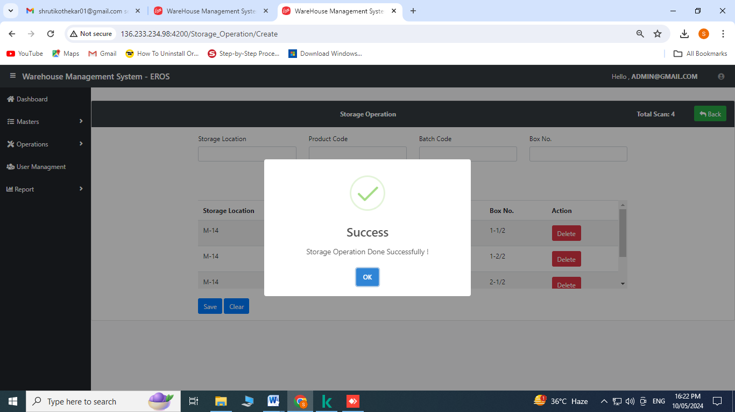

For Internal Stock Movement:

Click on 

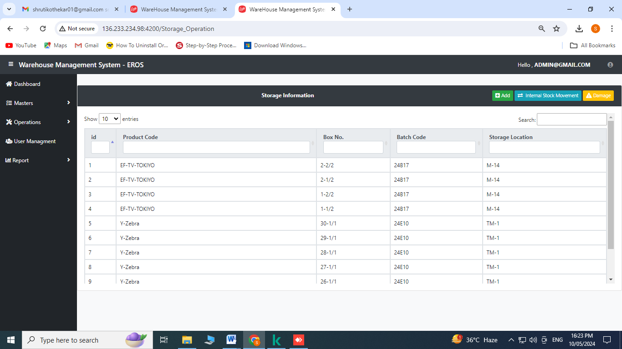

Click on enter new location and scan the barcode for relocating

Click on product code and scan the barcodes one by one

Click on save

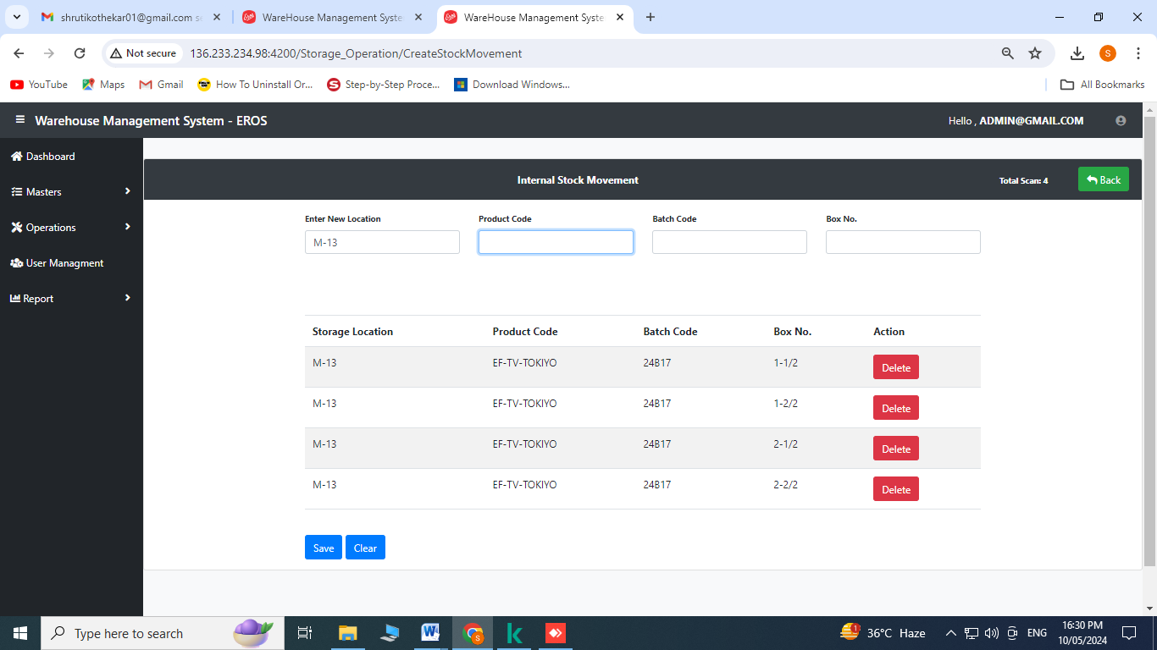

Click on OK

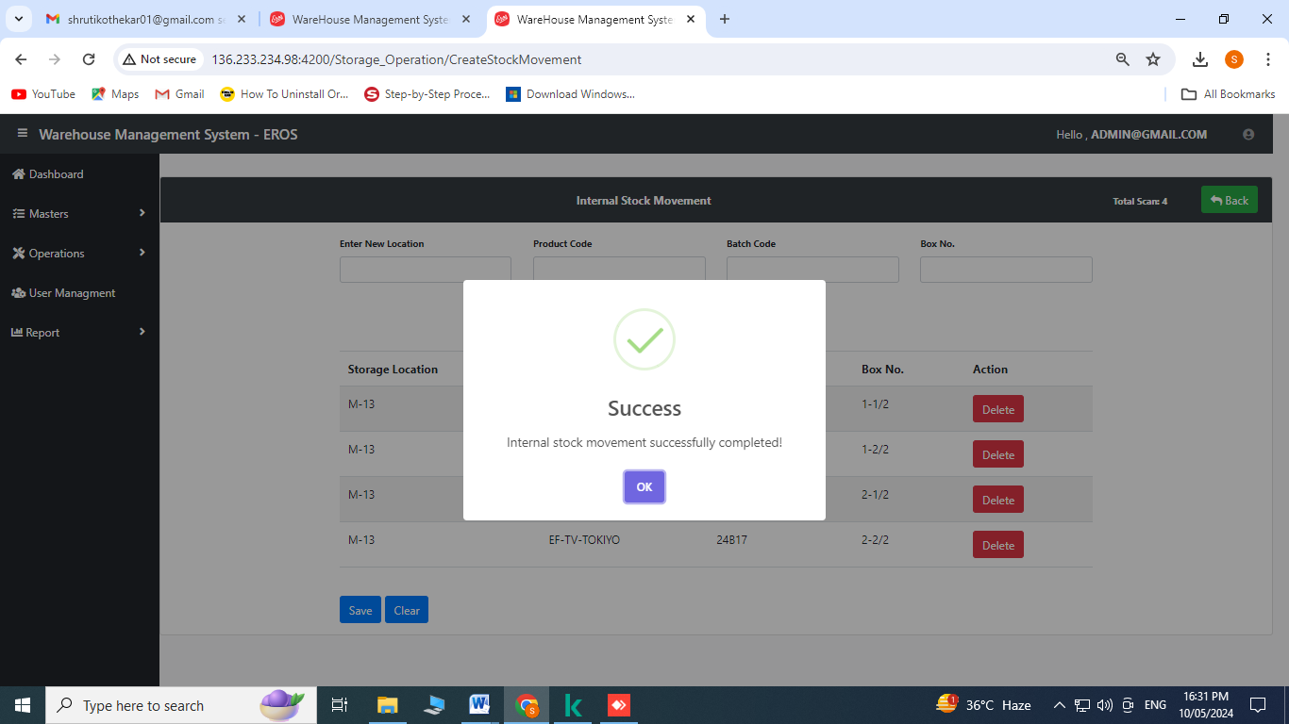

For Damage:

Click on 

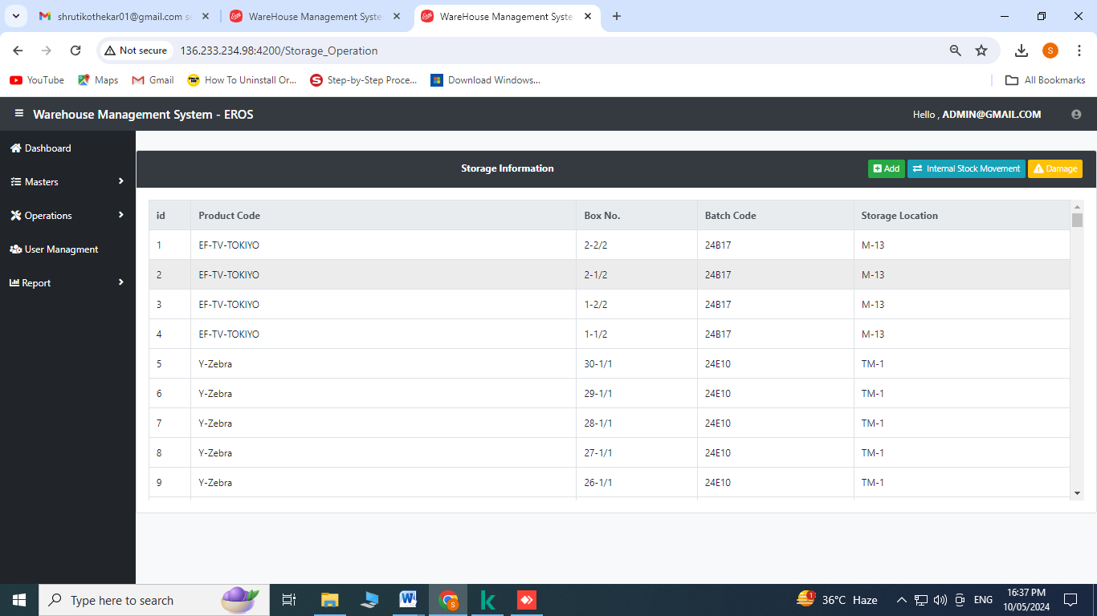

Click on 

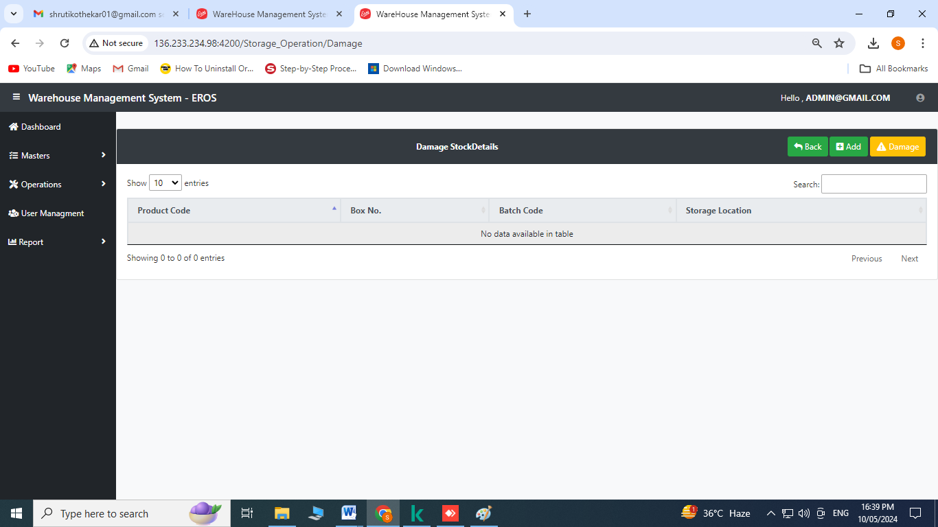

Click on storagelocation and scan the barcode for relocating to other location

Click on product code and scan the barcodes one by one

Click on save

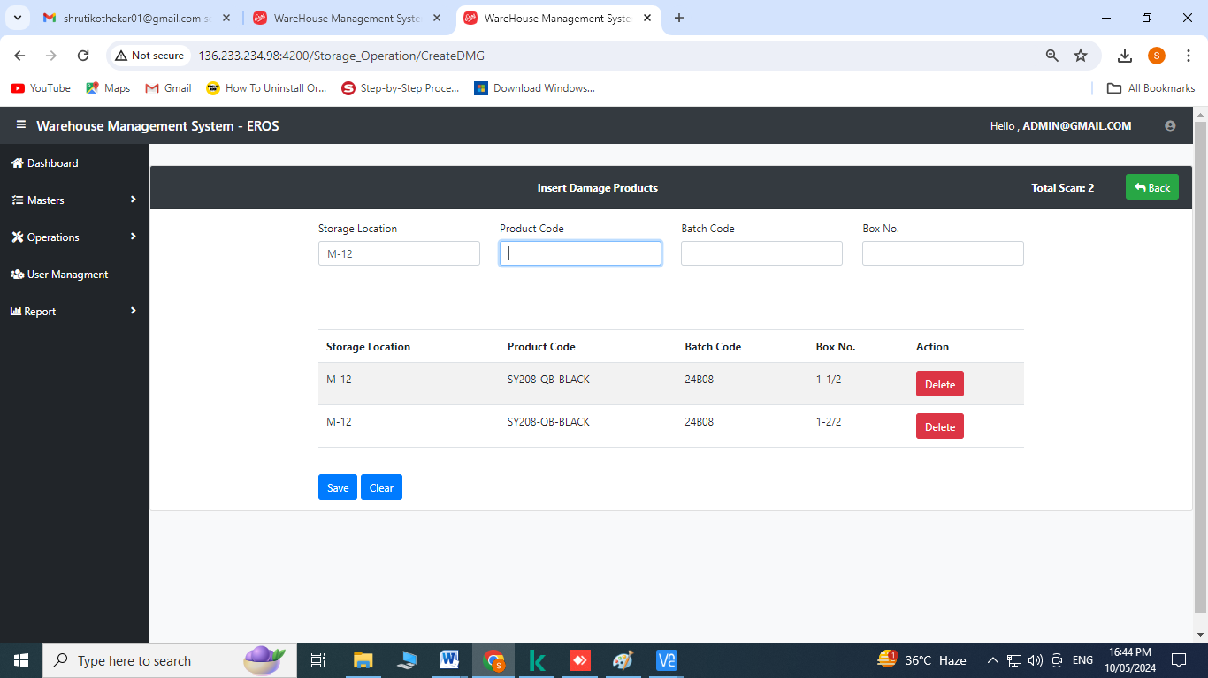

1. **In stock Qty.:** Click on in stock qty. from the operation’s menu
2. For checking the products in stock- Enter the product code or product name on 

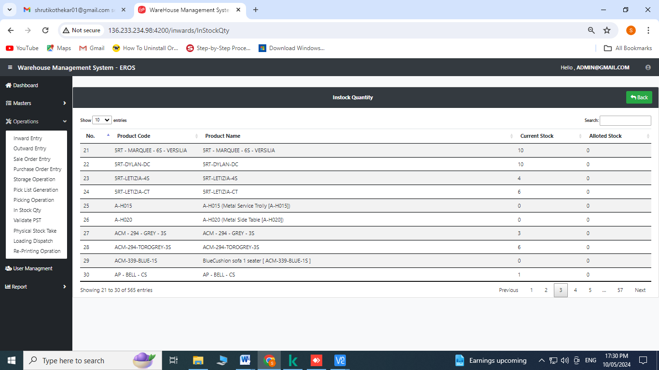

1. **Sale Order Entry:** Click on sale order entry from the operation’s menu

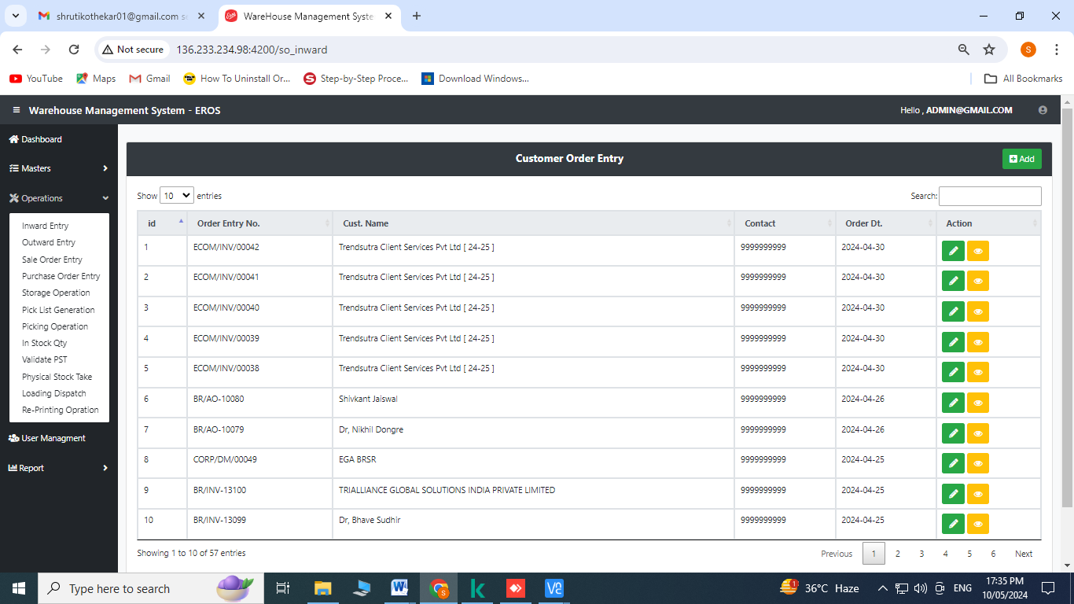

Create Operation:

1. Click on to add

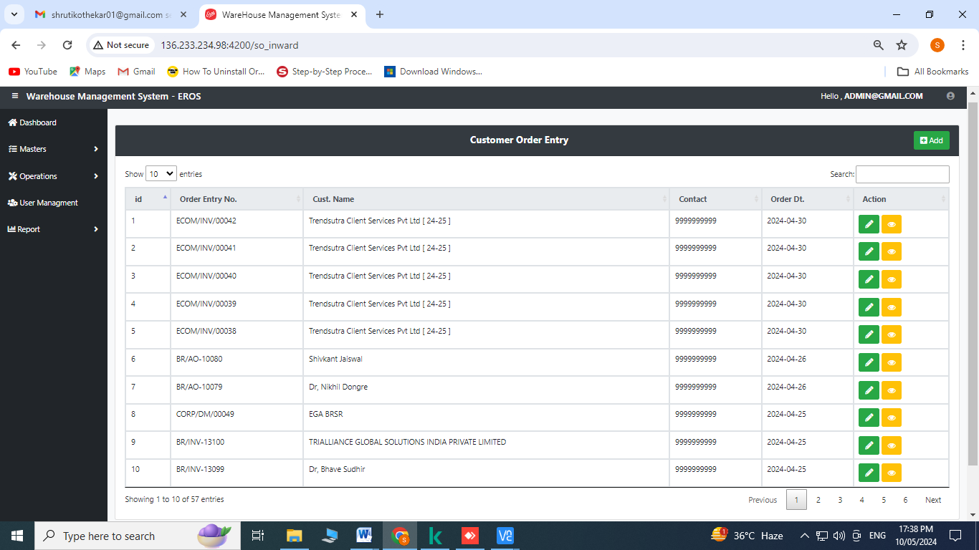

Select the Order type from the dropdown menu

Enter Sale order no.

Select B2B or B2C to the checkbox- In case of B2B customer name can be entered through the dropdown menu and In case of B2C- customer name manually can be entered and enter the remaining data as contact, email, shipping address, city, state

Select product description

Select qty. from the dropdown menu

Stock can be checked by clicking on 

Click on  for adding more products

Click on submit

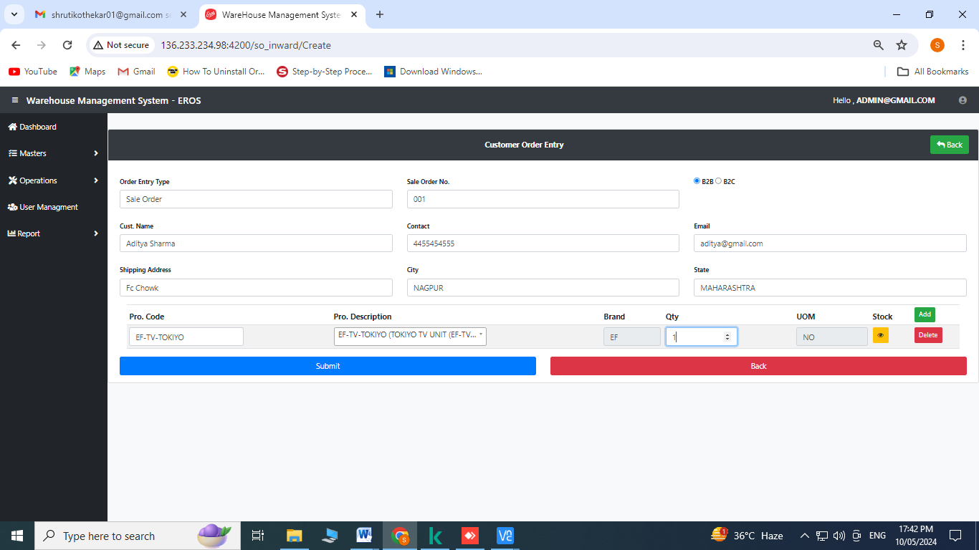

Click on submit

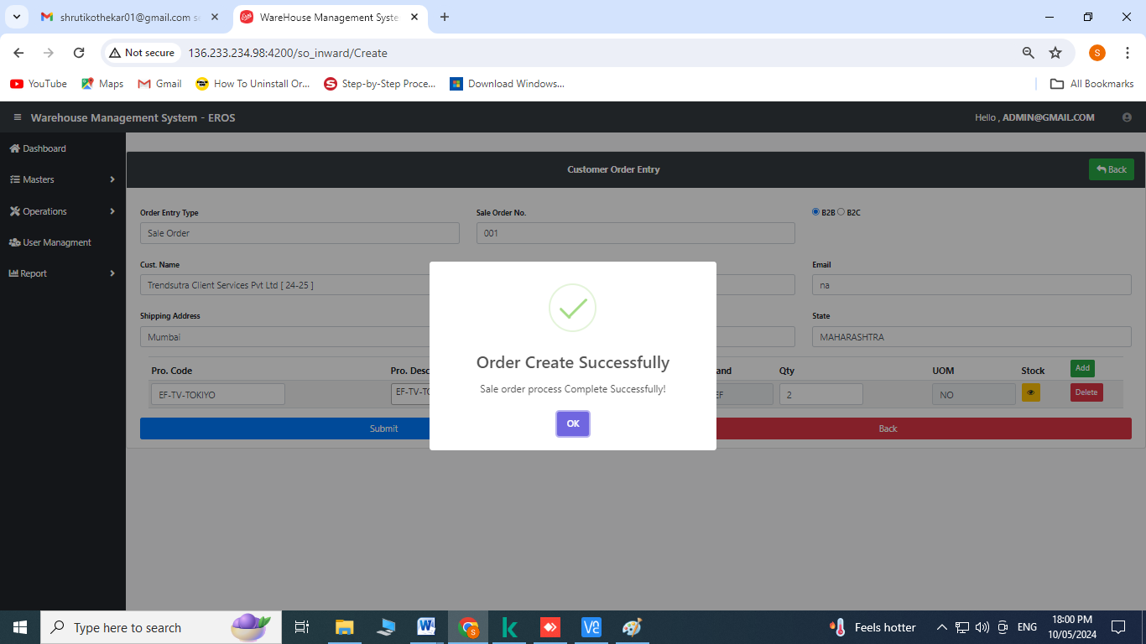

1. **Pick List Generation:** Click on pick list generation from the operation’s menu

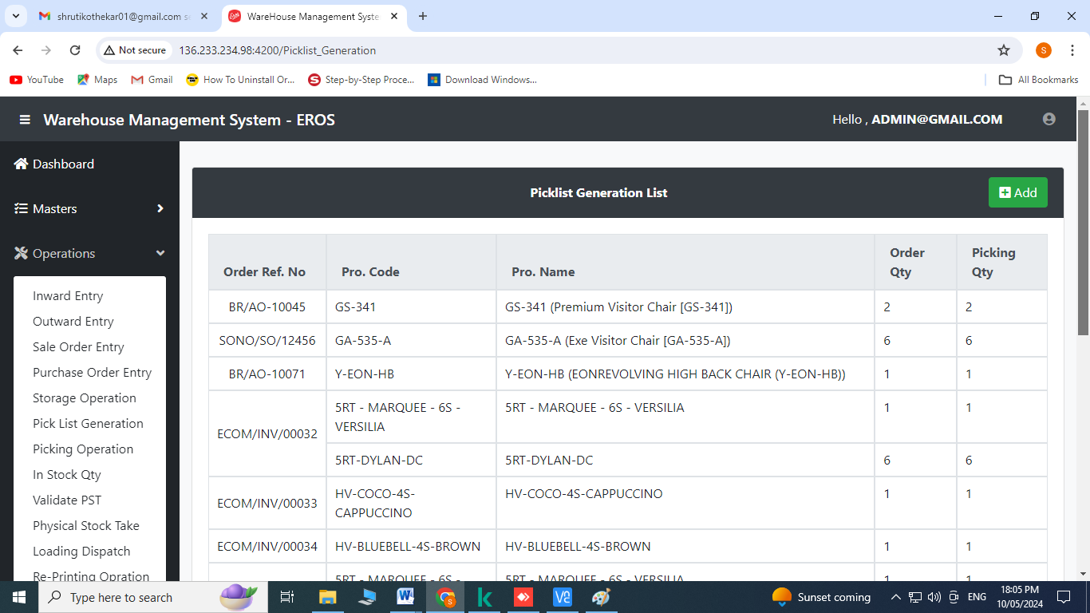

Create Operation:

1. Click on to add

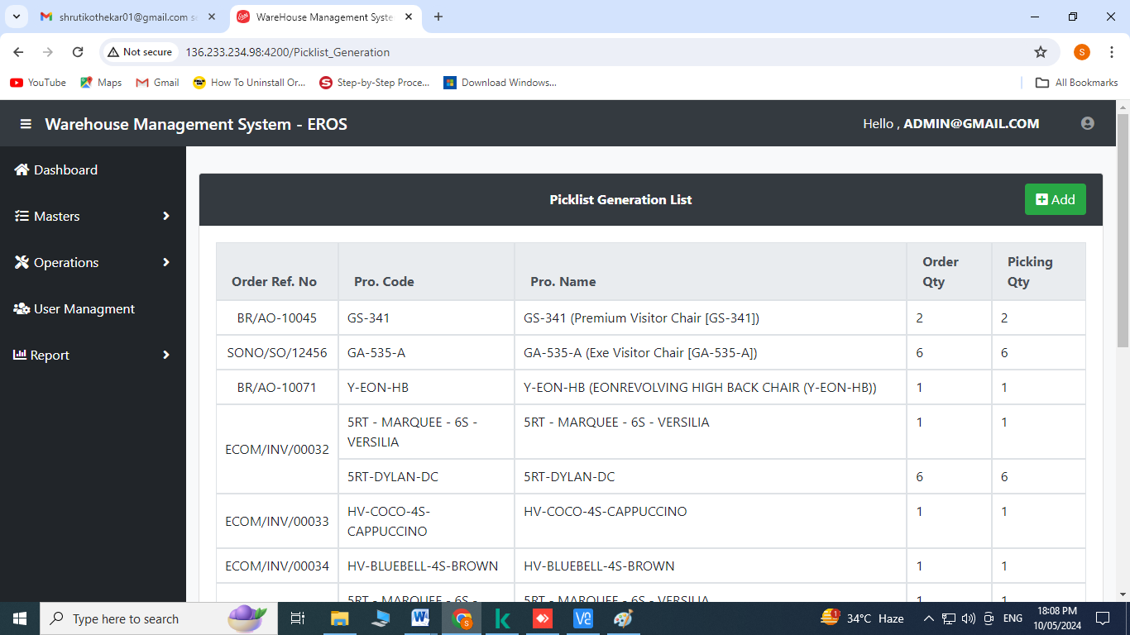

Select Sale Order No.

Stock can be checked by clicking on 

Enter picking qty.

Click on generate

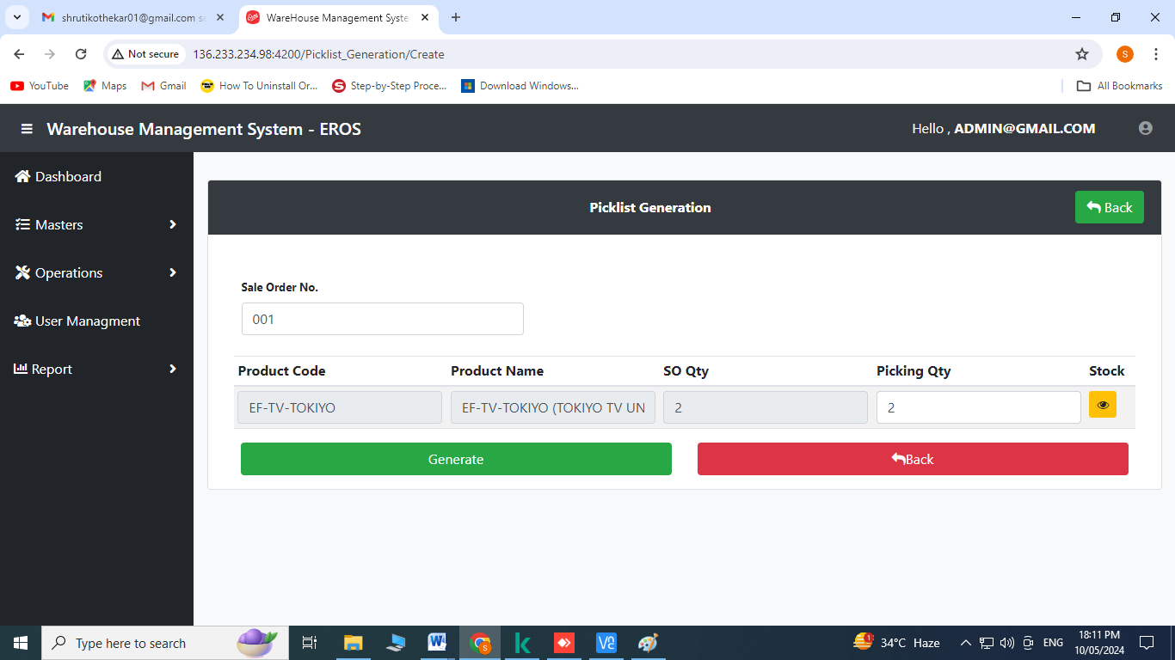

Click on OK

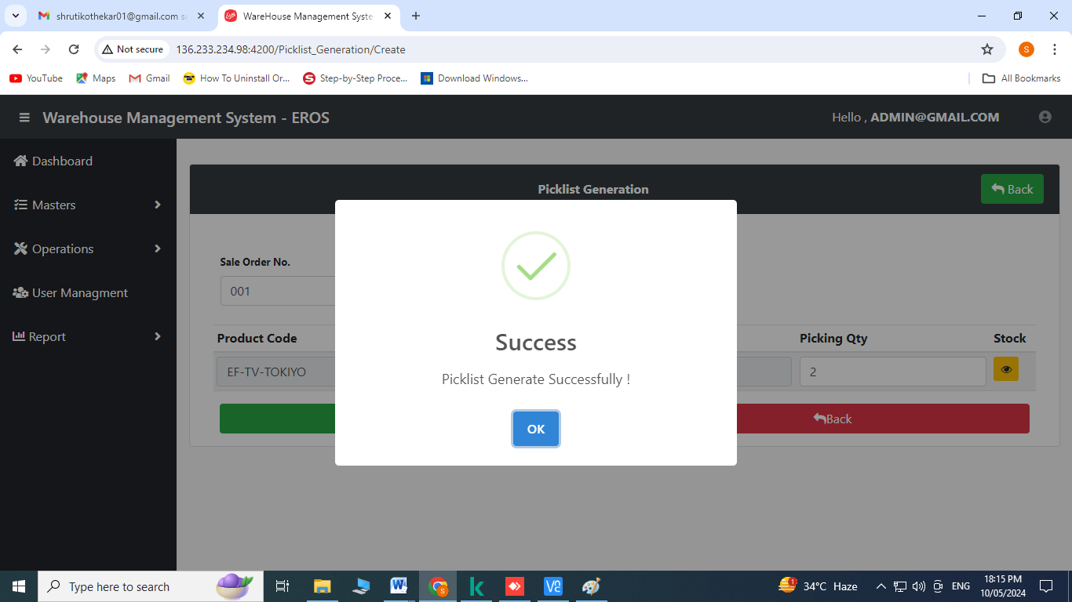

1. **Pick List Operation:** Click on picking operation from the operation’s menu

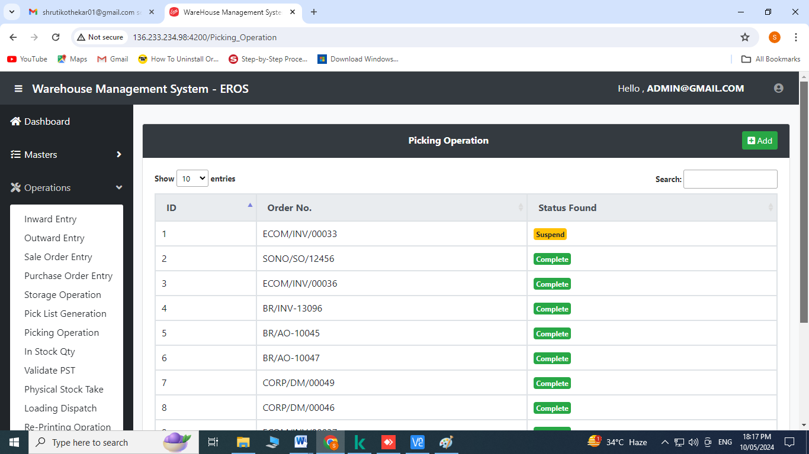

Create Operation:

1. Click on to add

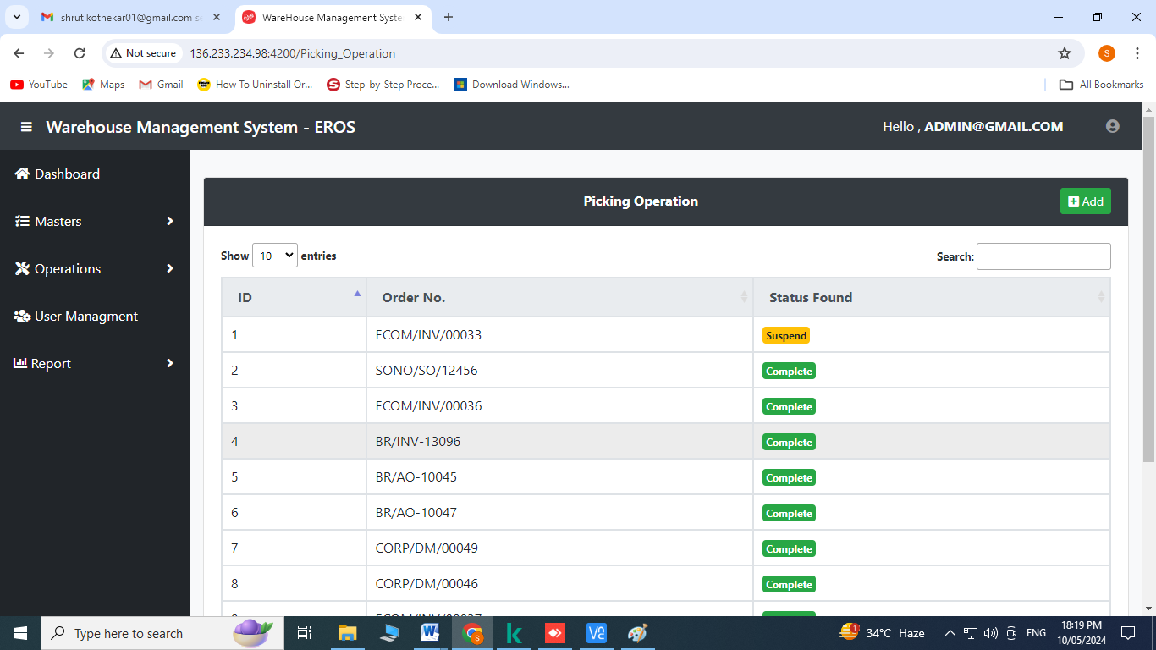

Select Order No.

Click on  to check product details required to be picked

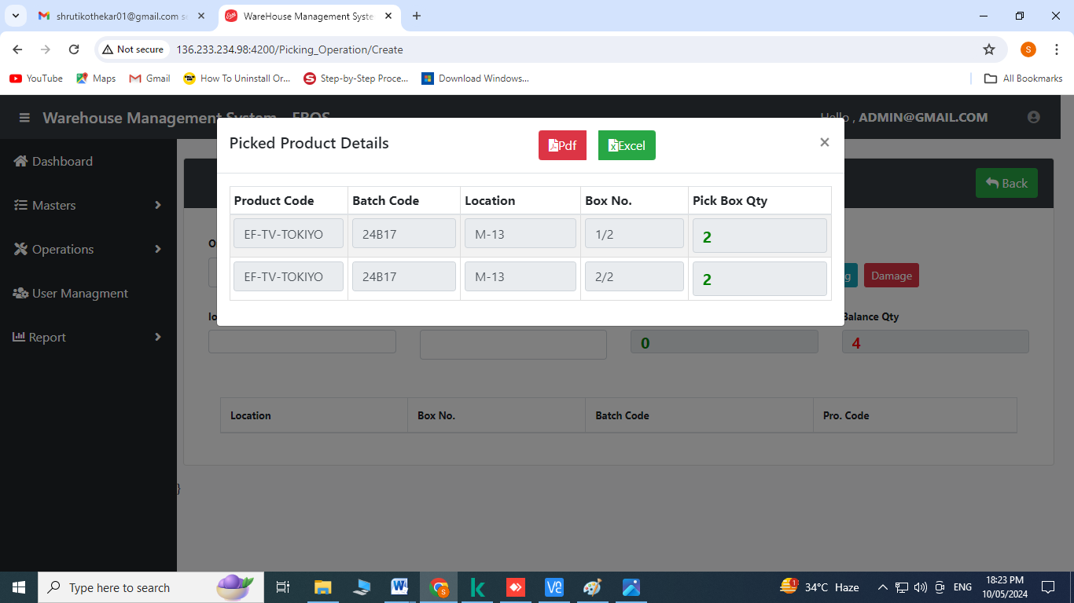

Click on 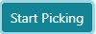

Click on location and scan the barcode

Click on box no. and scan the barcodes

Click on OK

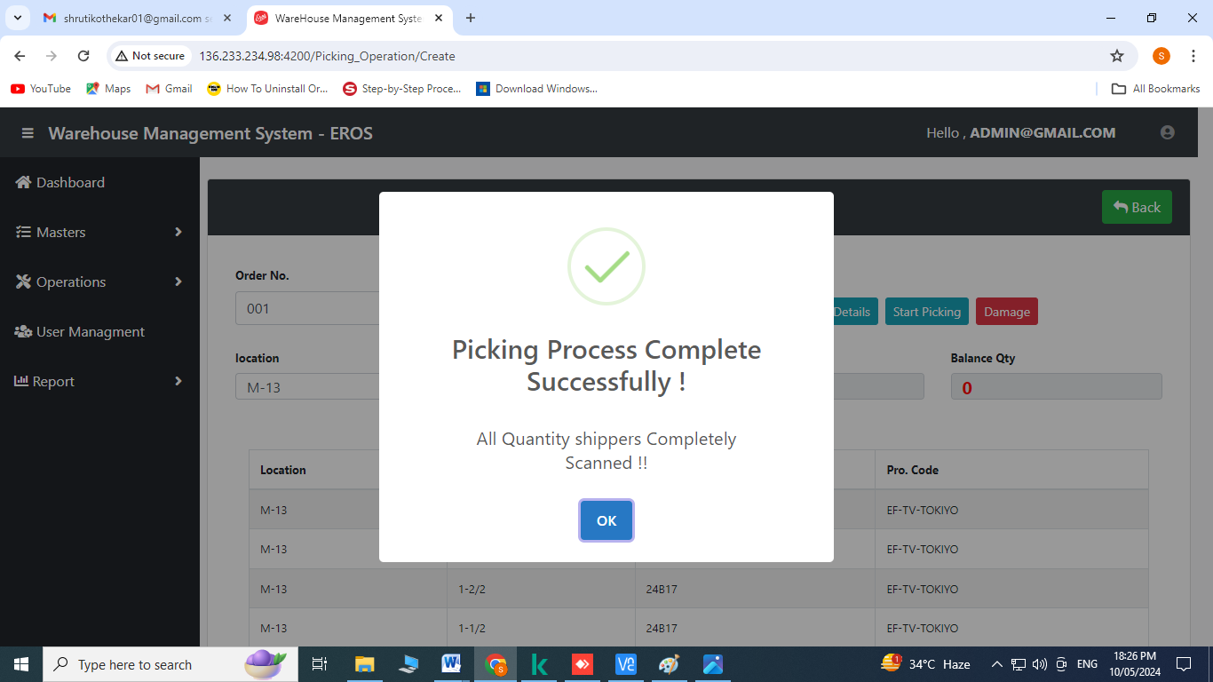

**Note:** 1) If the status shows  on the index page of picking operation that means all the required products has been picked.

2) If the status shows  on the index page of picking operation that means picking operation is incomplete for the required products.

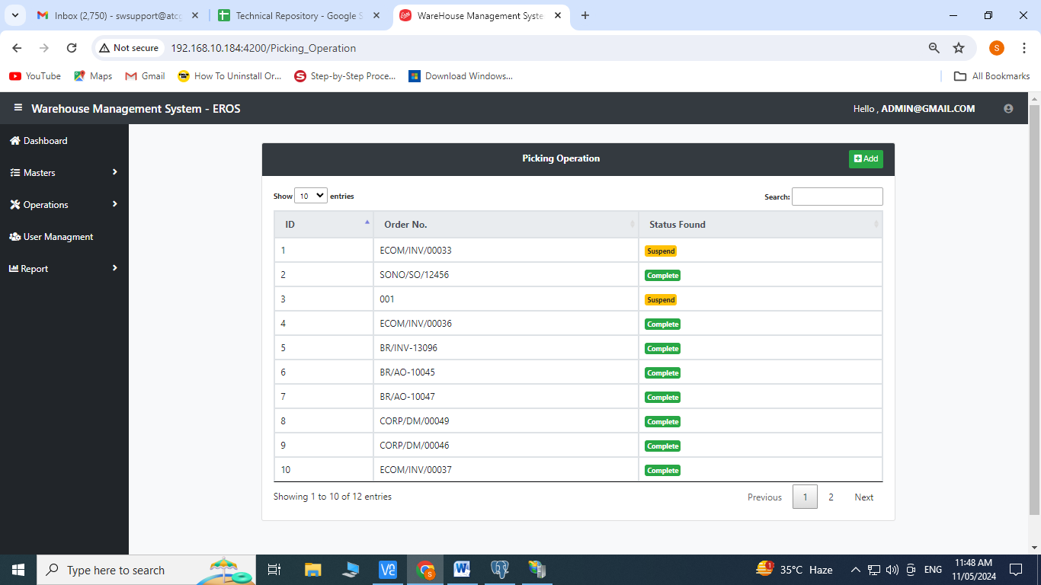

1. **Loading and Dispatch Operation:** Click on loading & dispatch operation from the operation’s menu

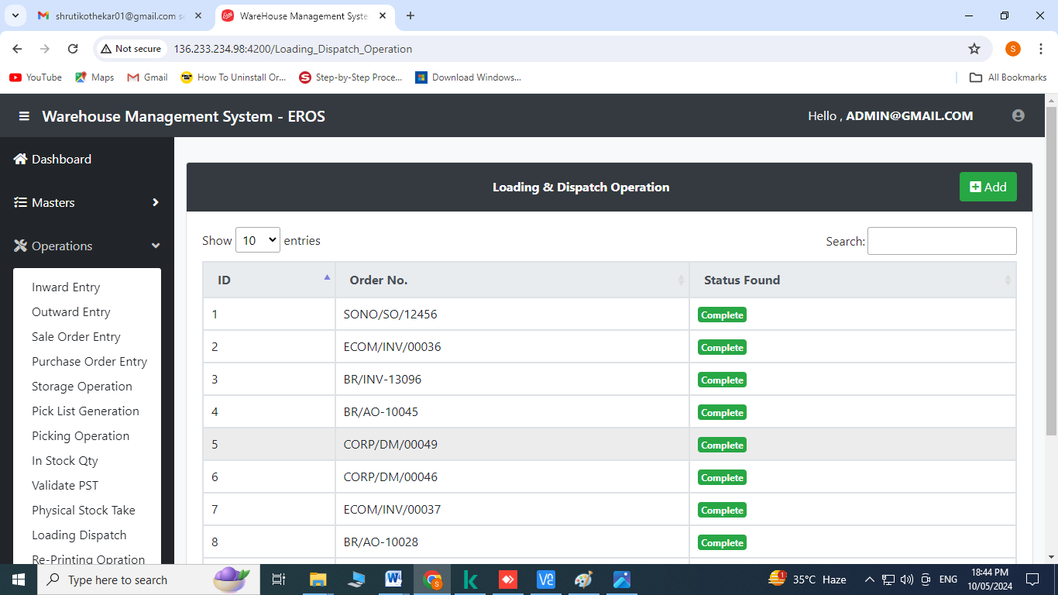

Create Operation:

Click on  to add

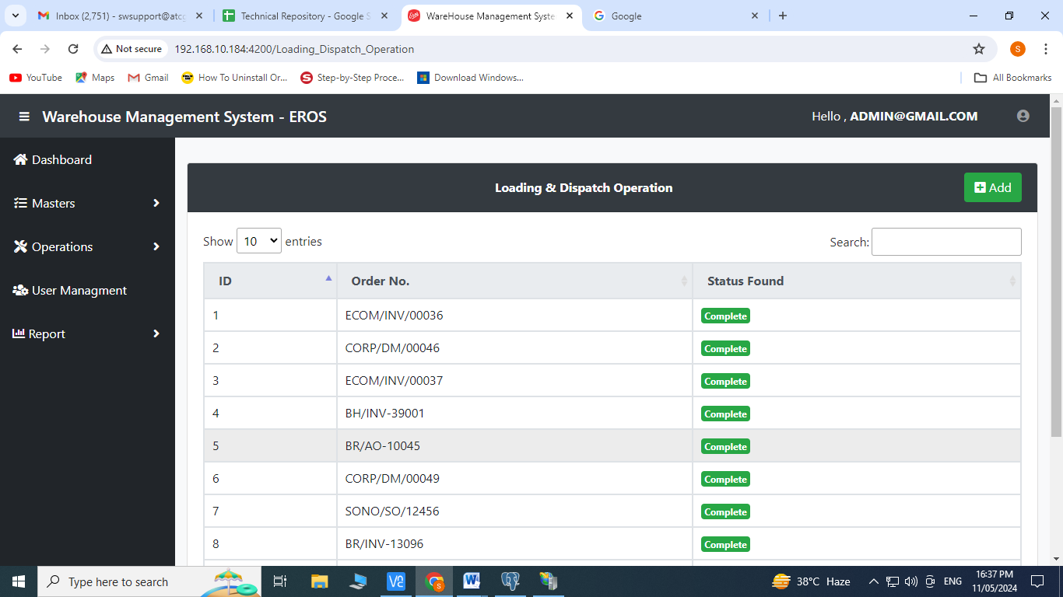

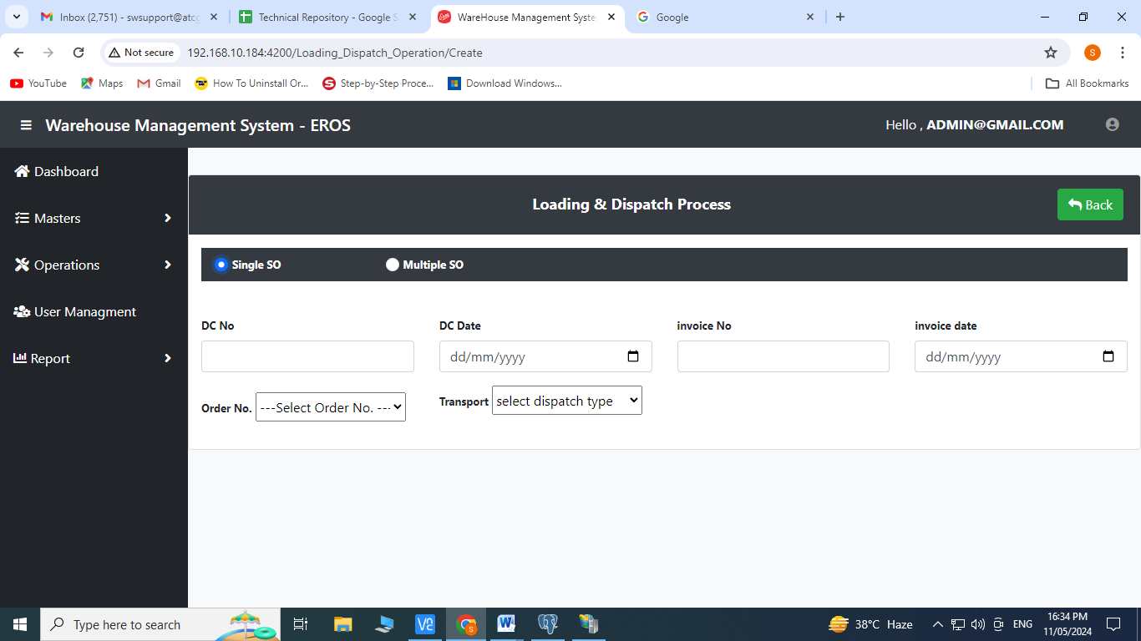

Select Checkbox of Single SO or Multiple SO

For Single SO: Enter DC No., DC Date, invoice no., invoice date

Select order no. from the dropdown menu

Select Transport from the dropdown menu

Enter courier name, docket no. and dispatch date

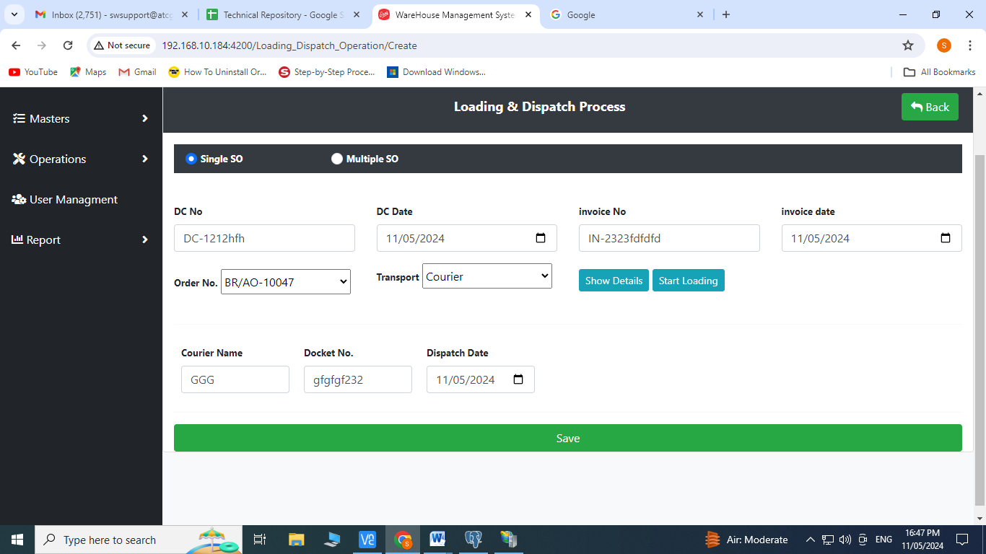

Click on 

Click on shipper no. and start scanning the barcodes

Click on save

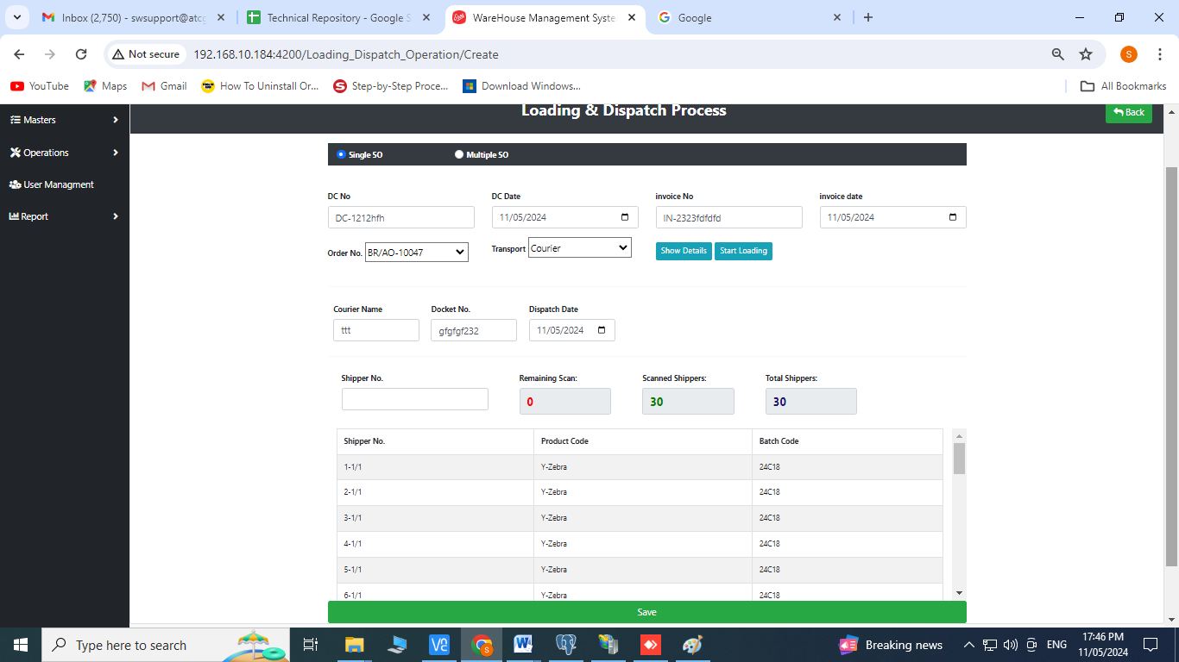

1. **Physical Stock Take:** Click on Physical Stock Take from the operation’s menu

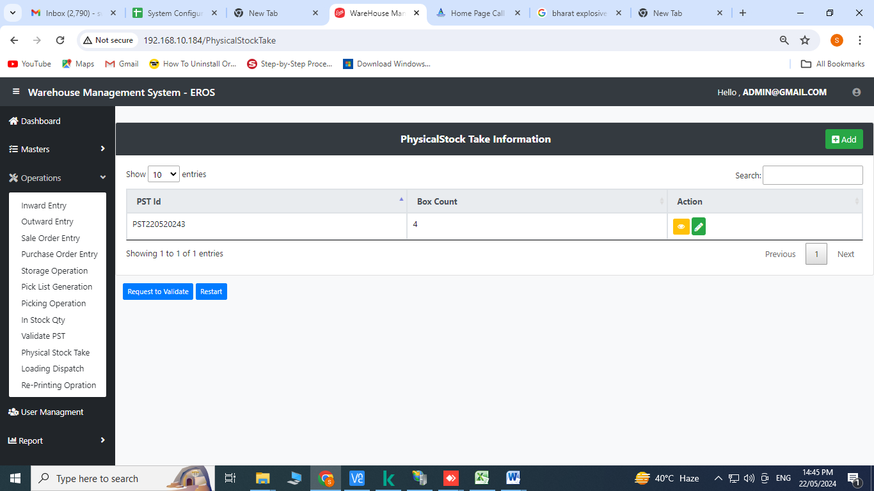

Create Operation:

1. Click on  to add

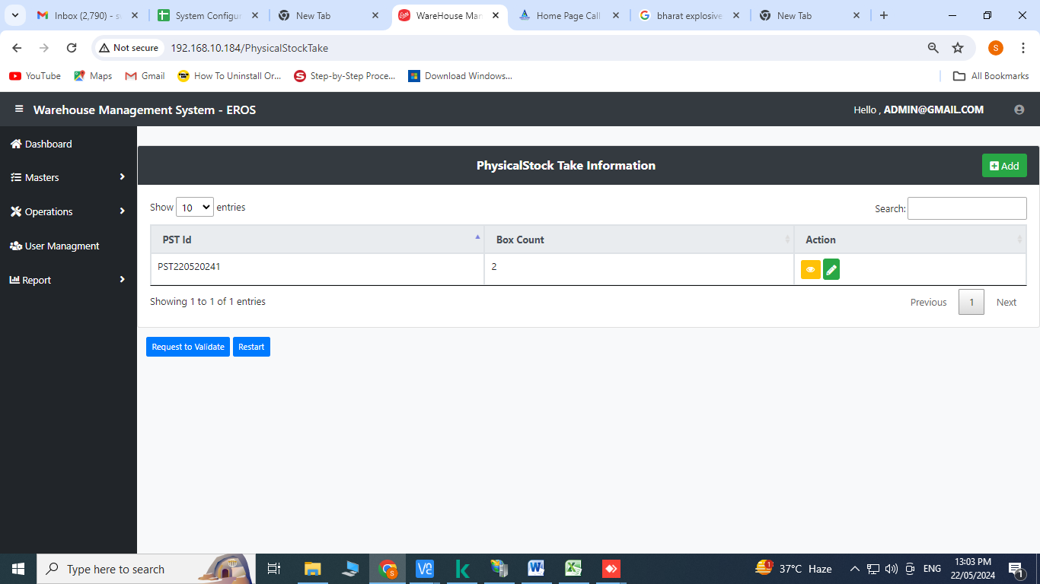

Place the cursor on storage location and scan the barcode

Scan the barcode of product code

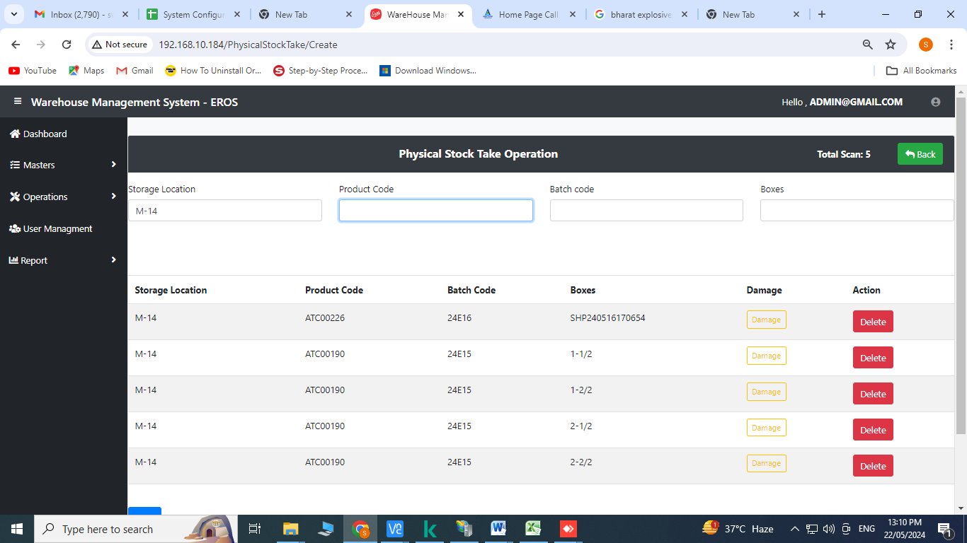

Click on save

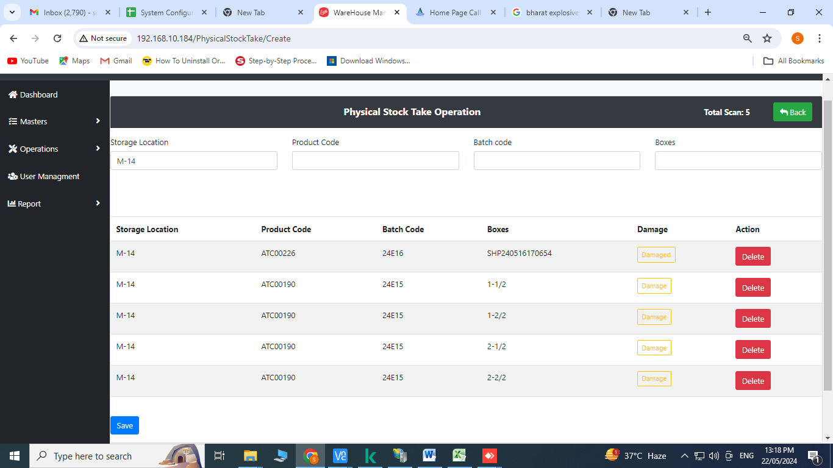

Click on OK

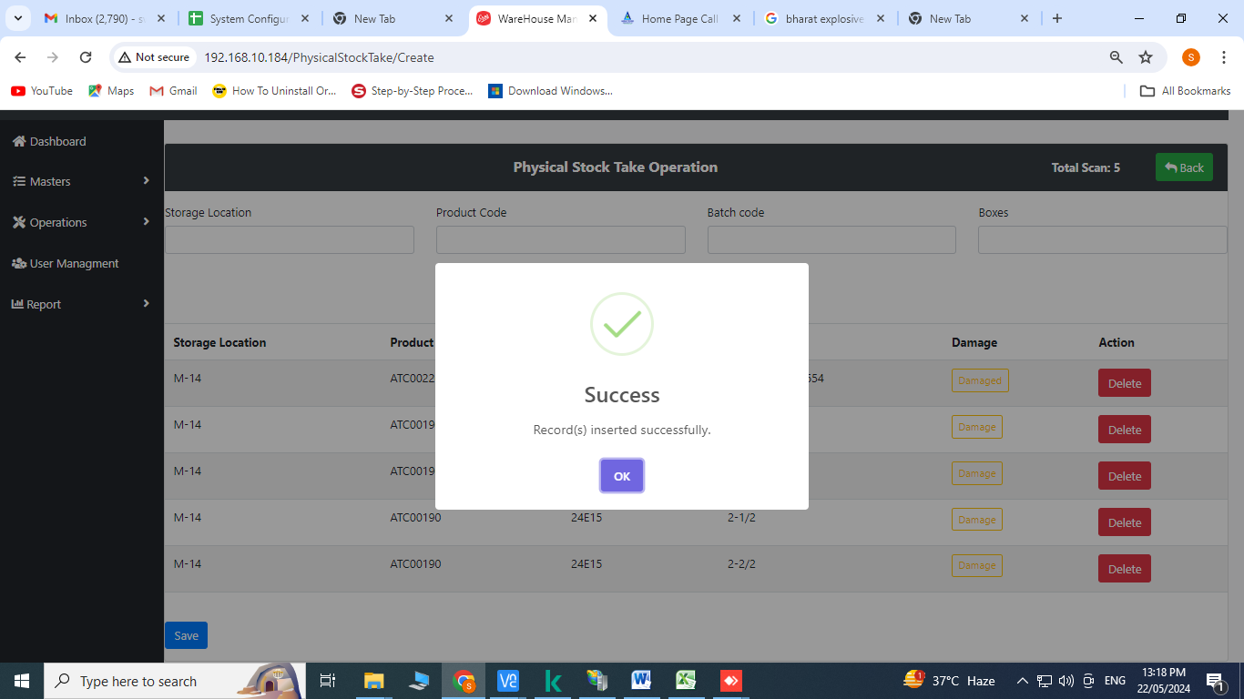

**In case of damage products:**

1. Click on 



1. Click on confirm

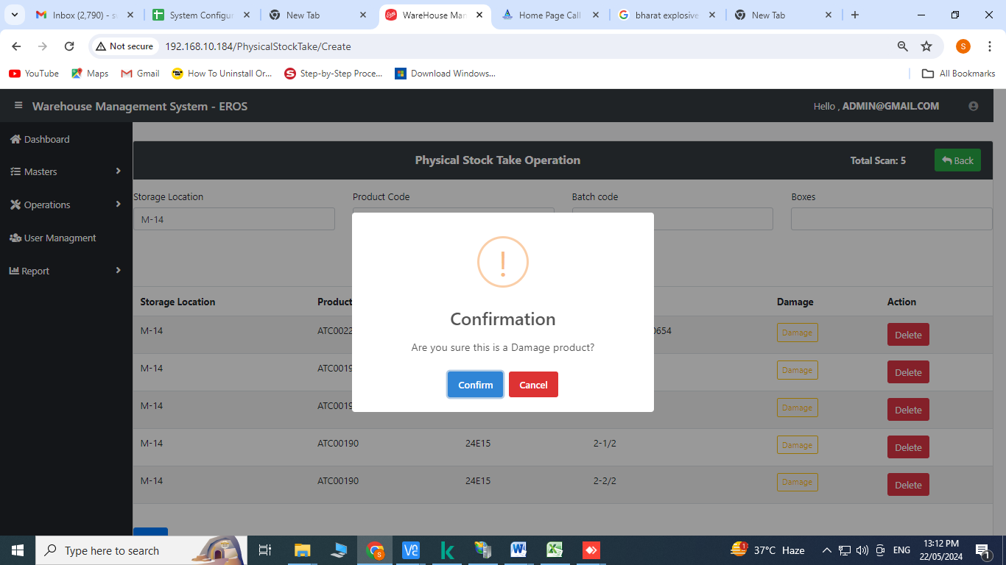

1. Click on OK

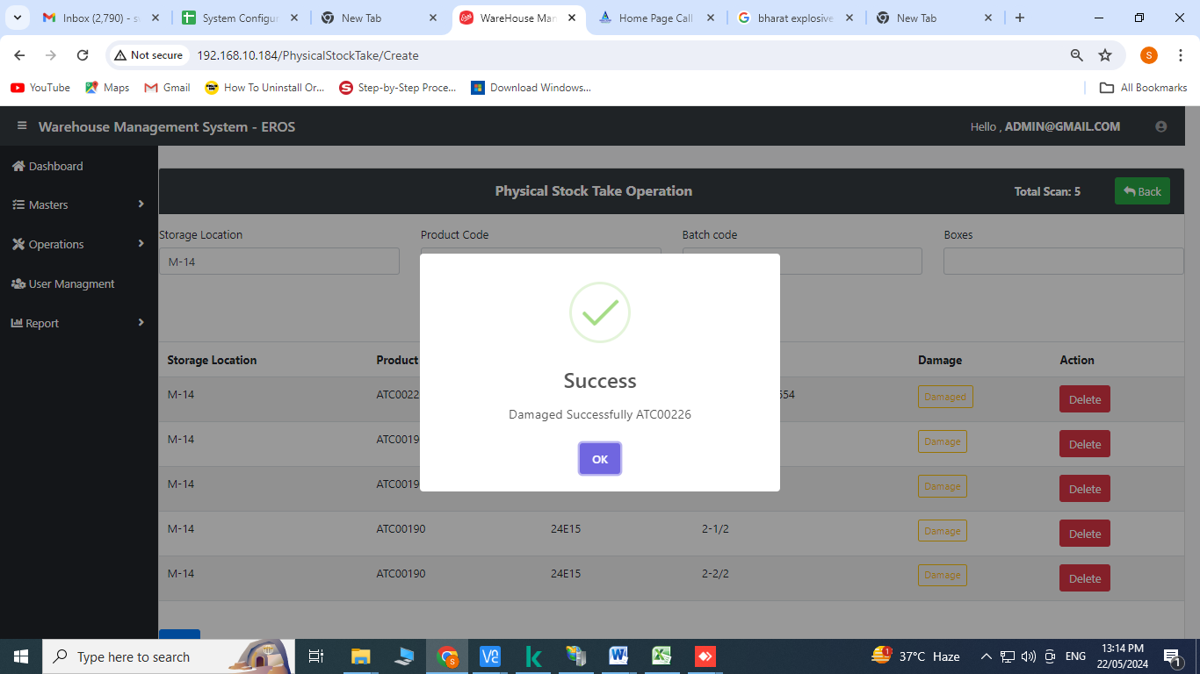

After clicking on OK the process gets completed and the damage button appears to be like 

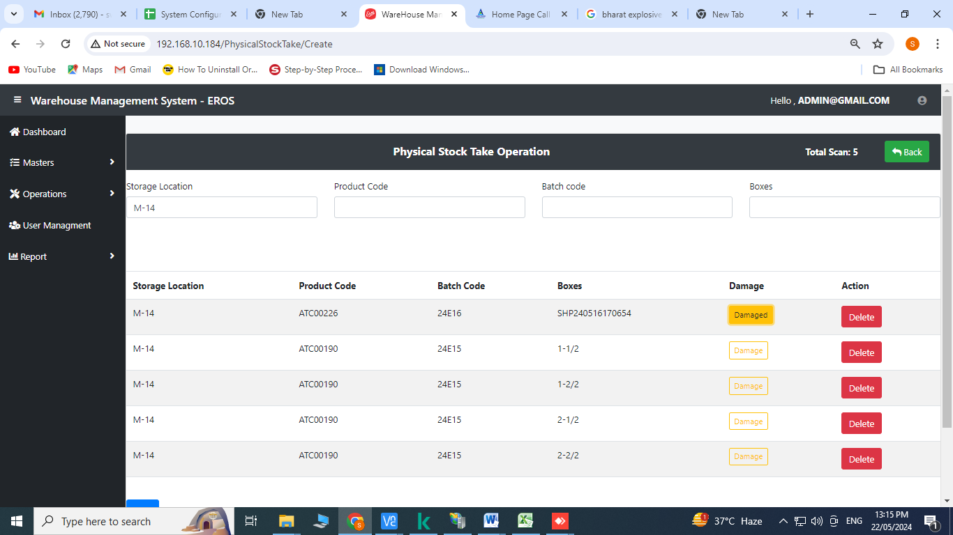

Click on  for adding more products on the same PST ID

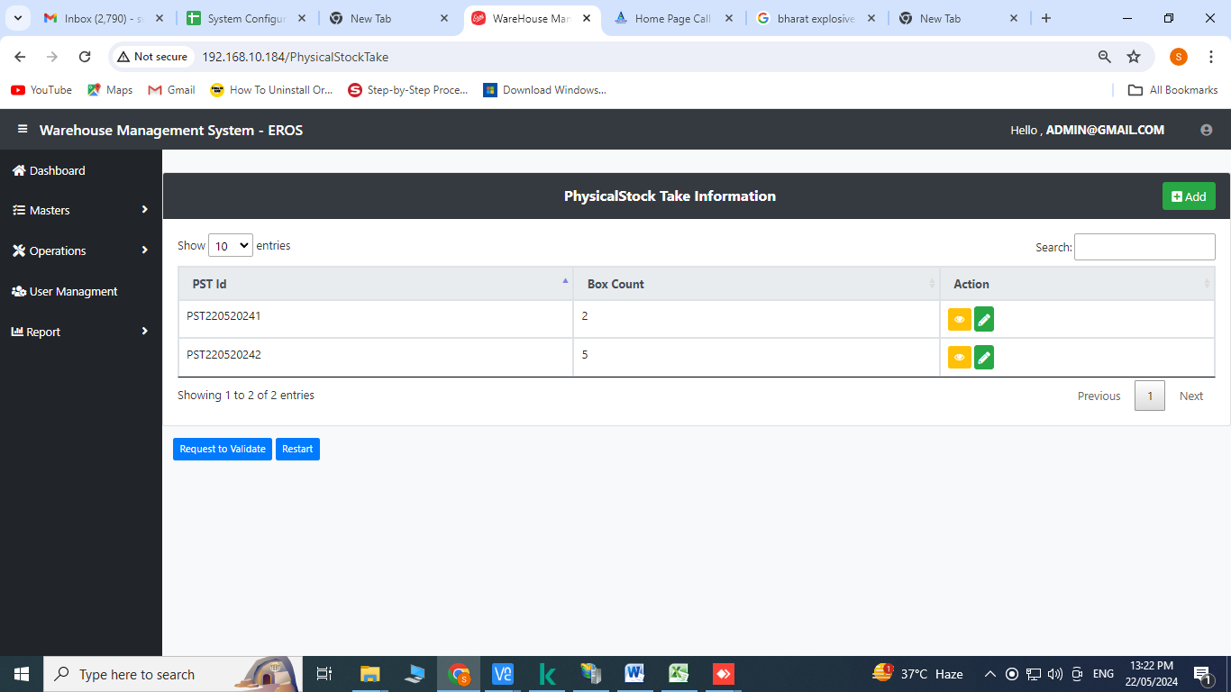

Place the cursor on storage location and scan the barcode

Scan the barcode of product code

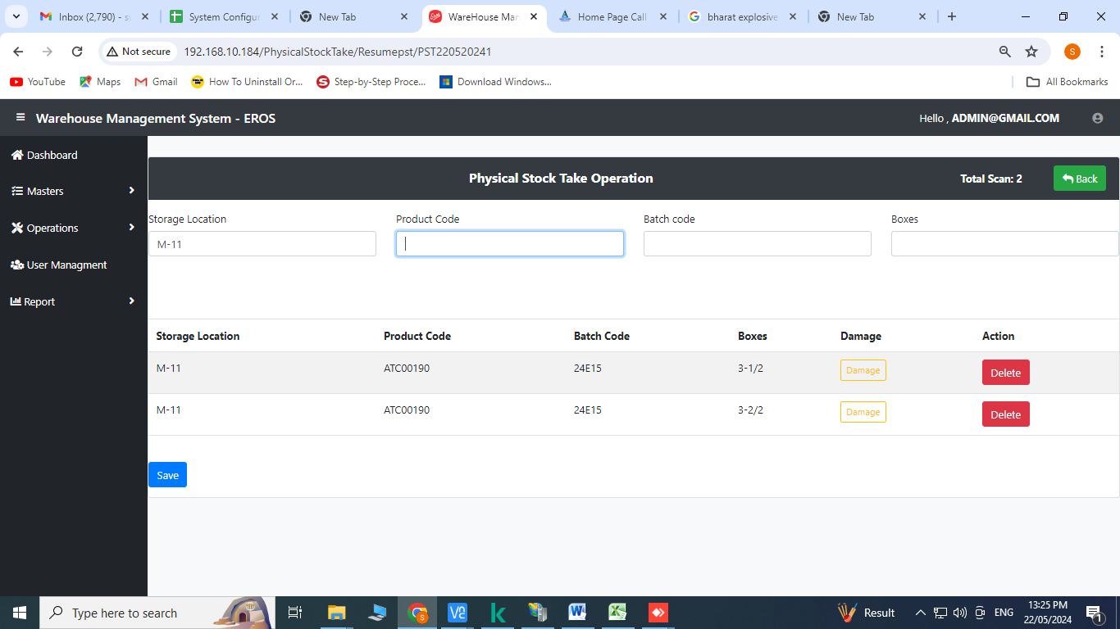

Click on OK

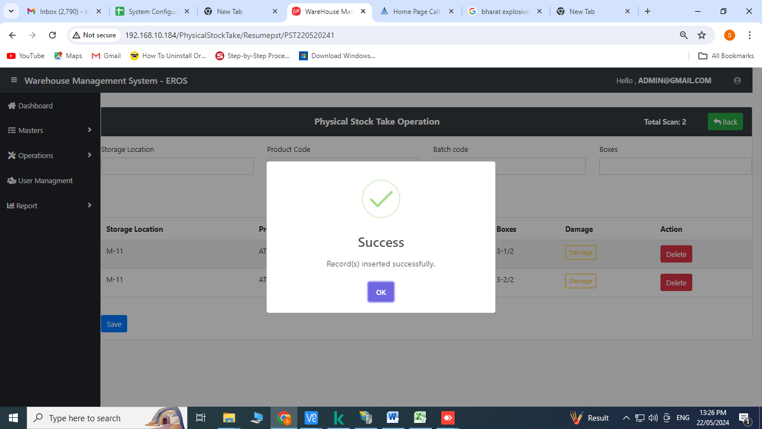

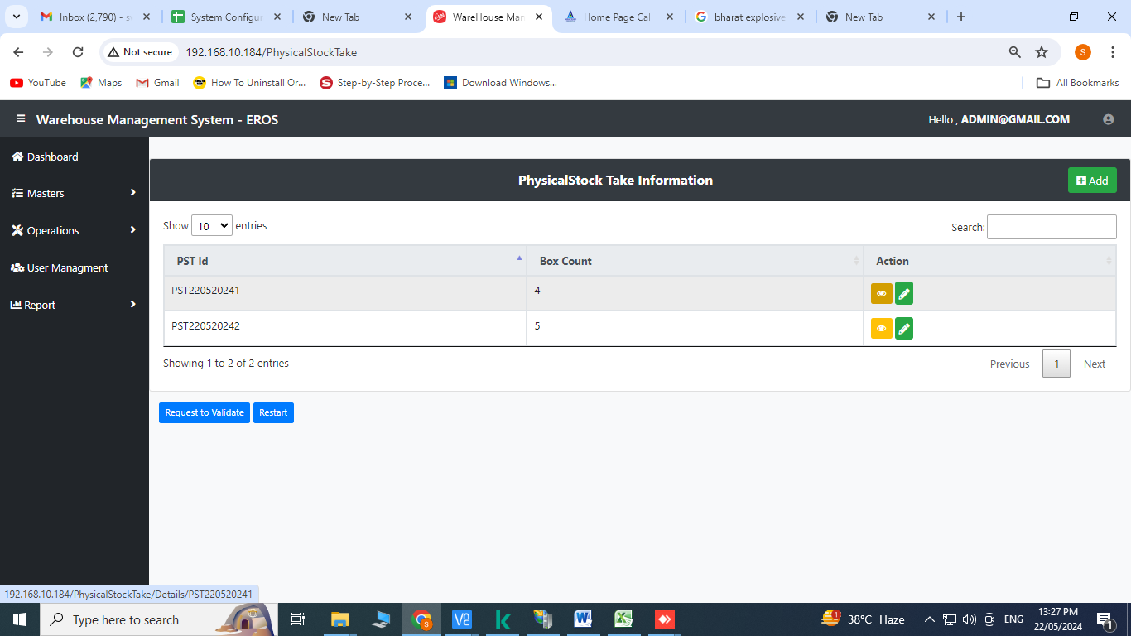

For checking total no. of added products click on 

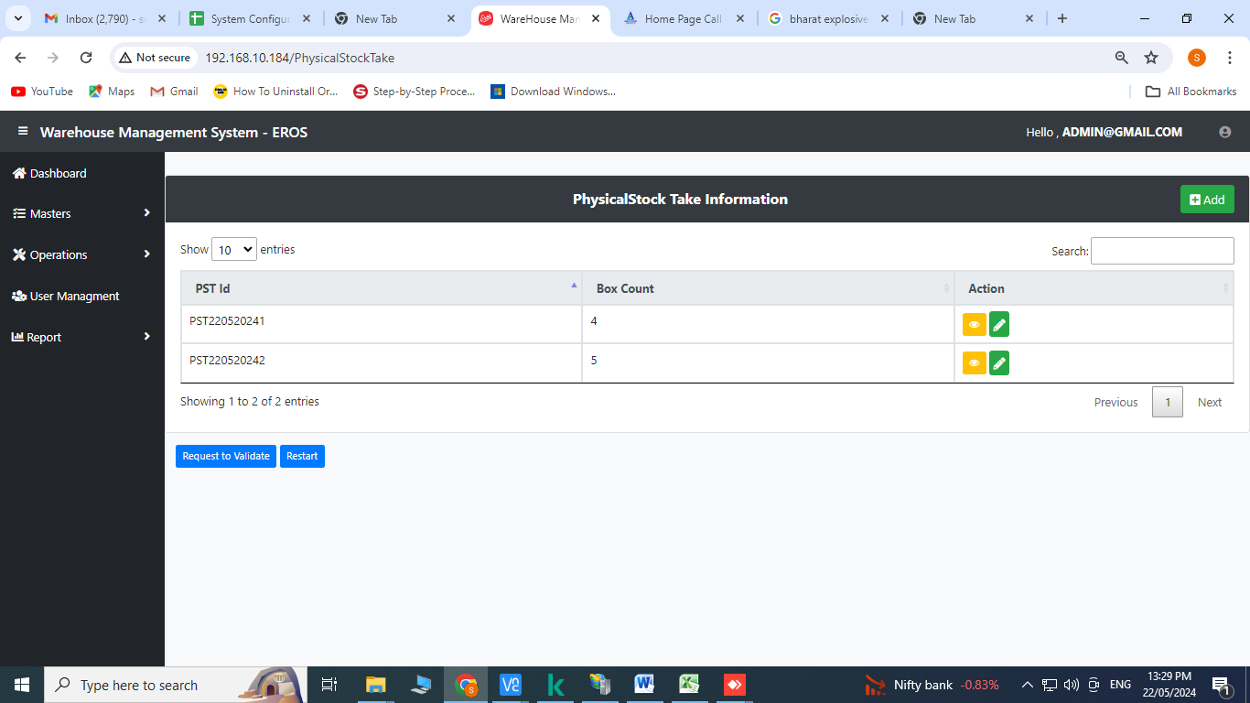

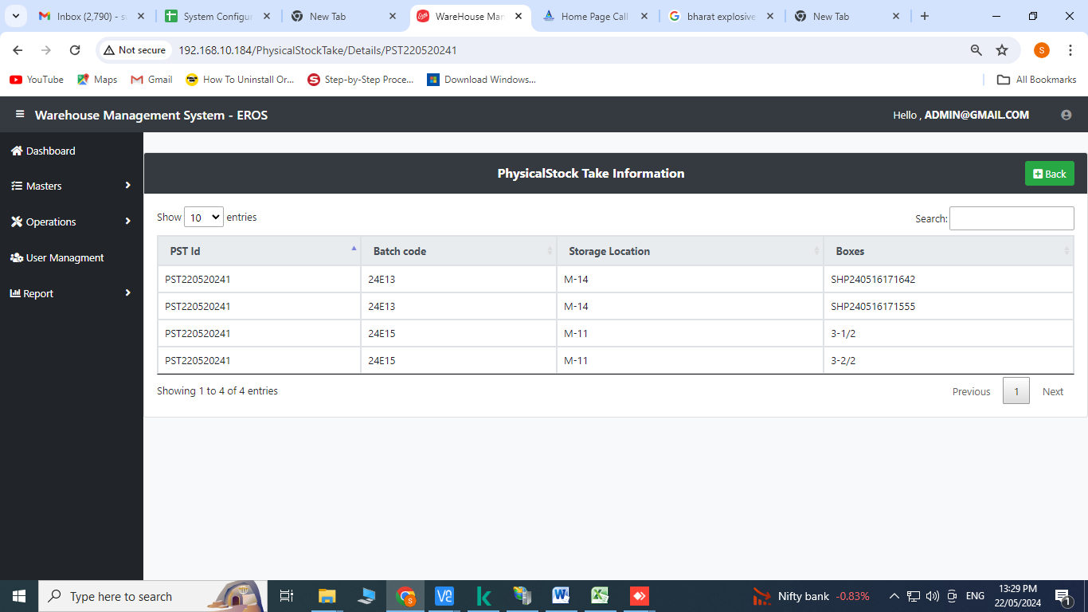

Click on request to validate

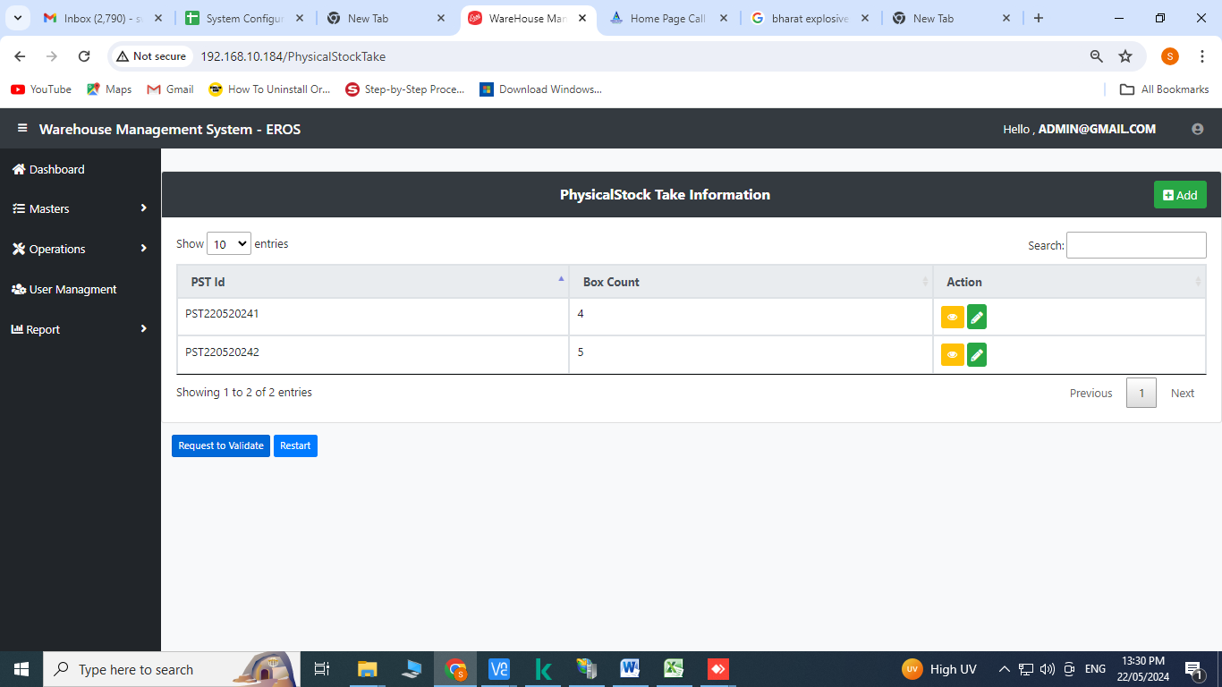

Click on Yes to send the data to HO

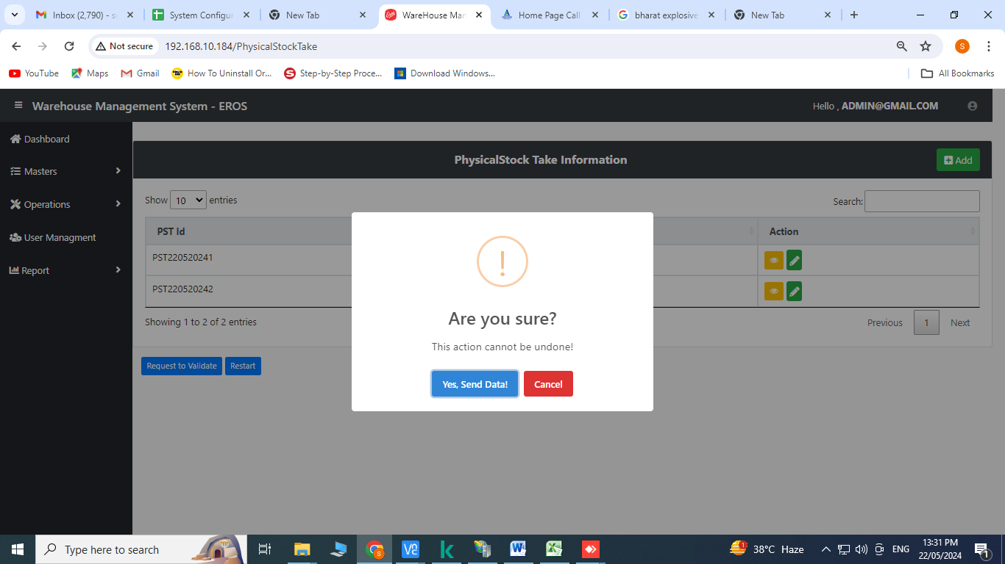

1. **Validate PST:** Click on Validate PST from the operation’s menu

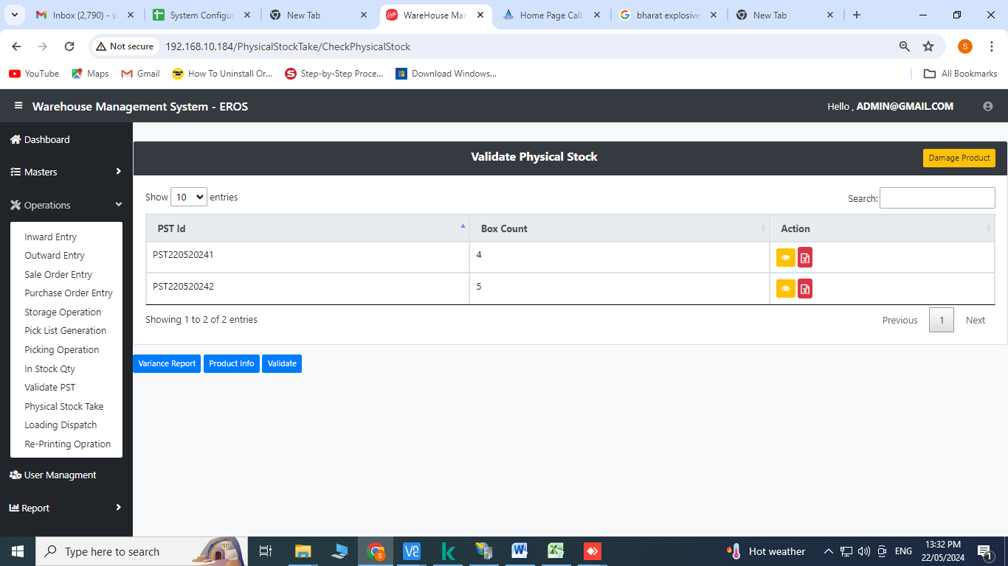

For checking the total no. of products click on 

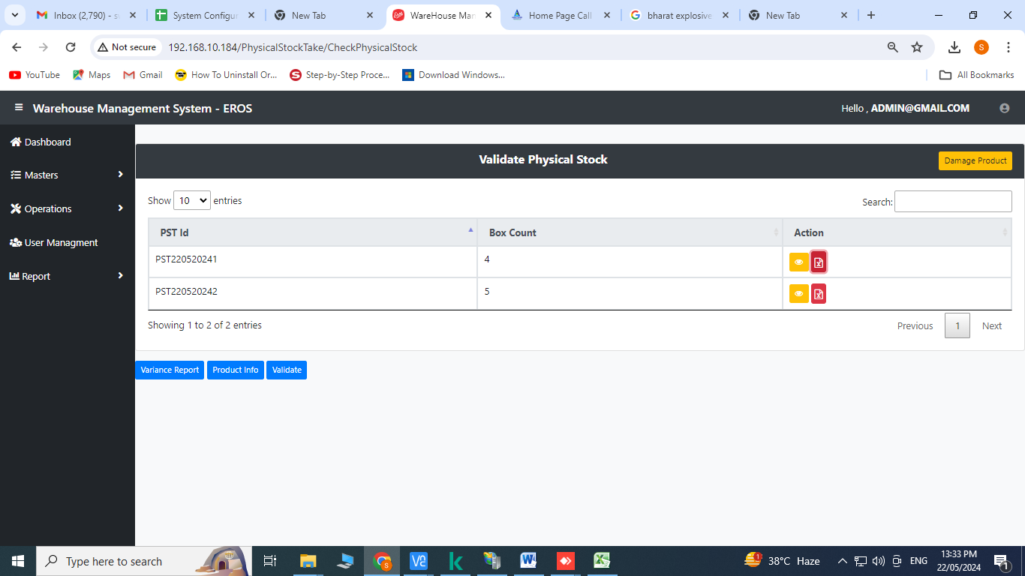

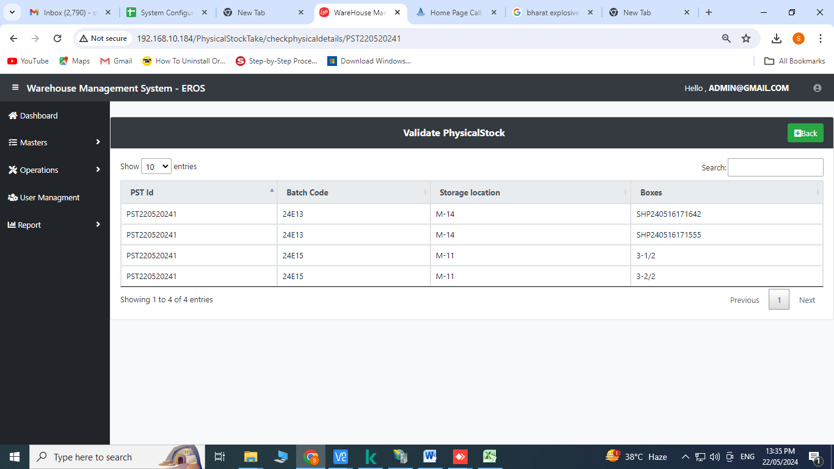

For fetching the data in excel format click on 



**Sample:**

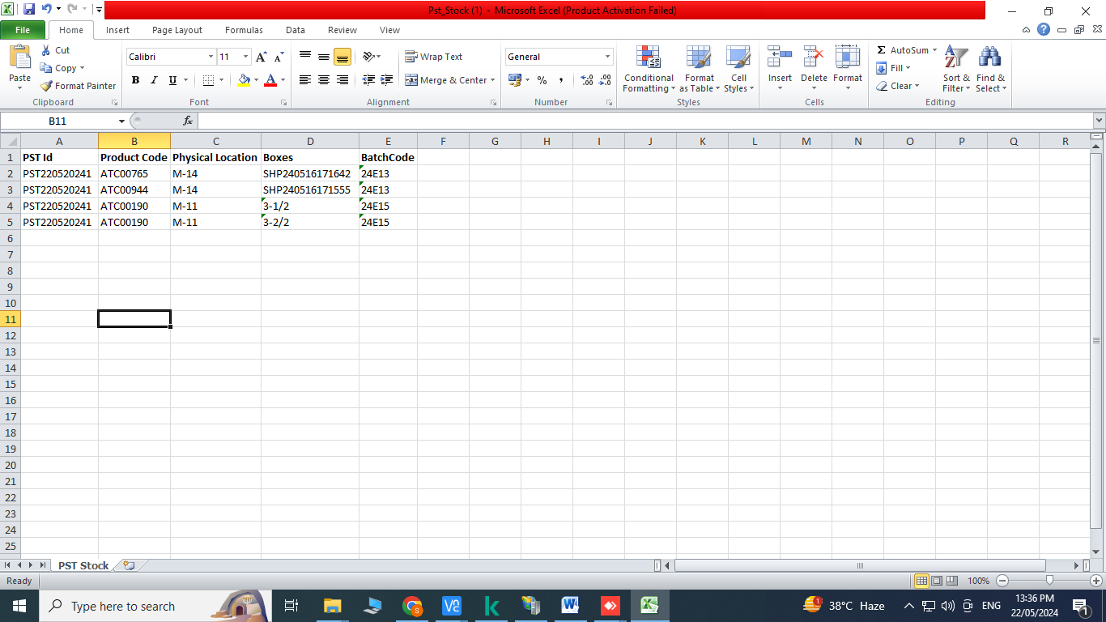

**Variance Report**

Click on variance report

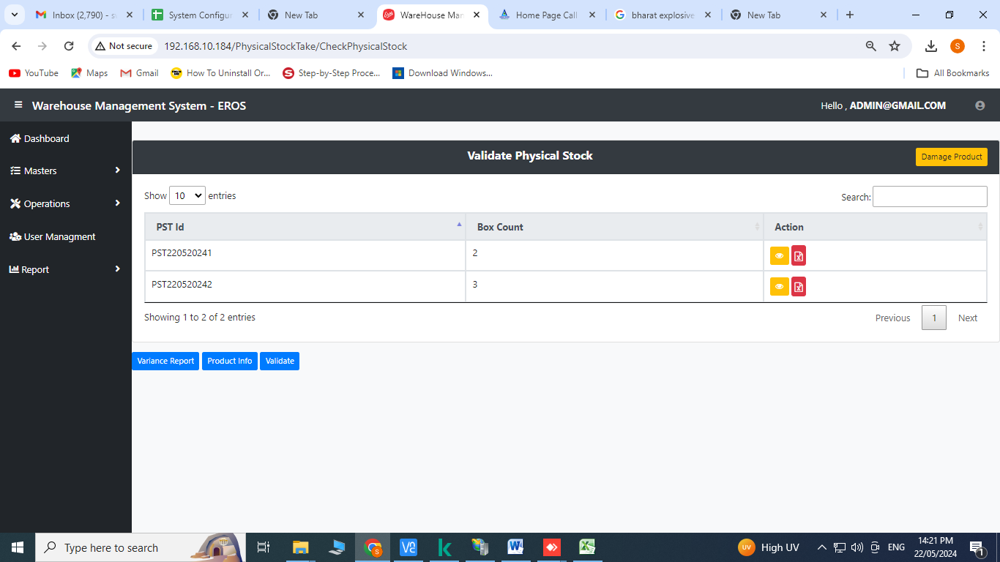

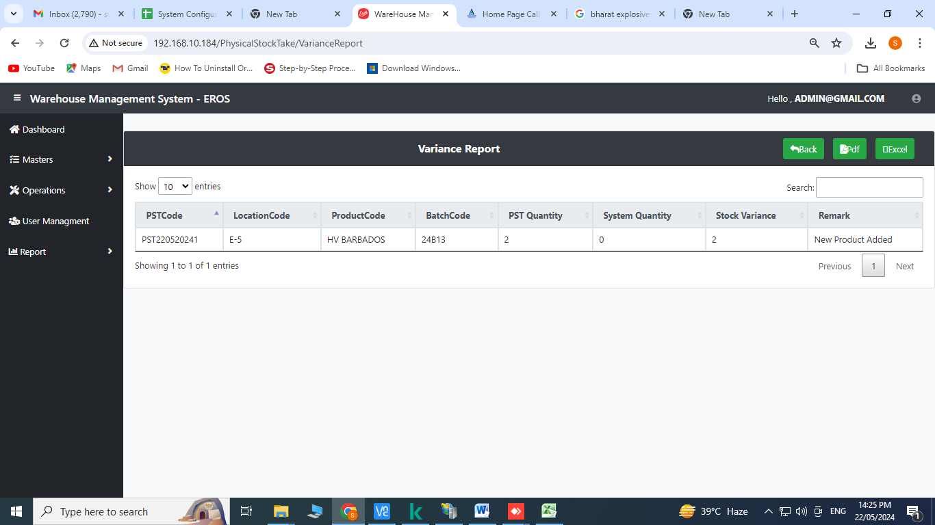

**Product Info**

Click on product info for checking the products

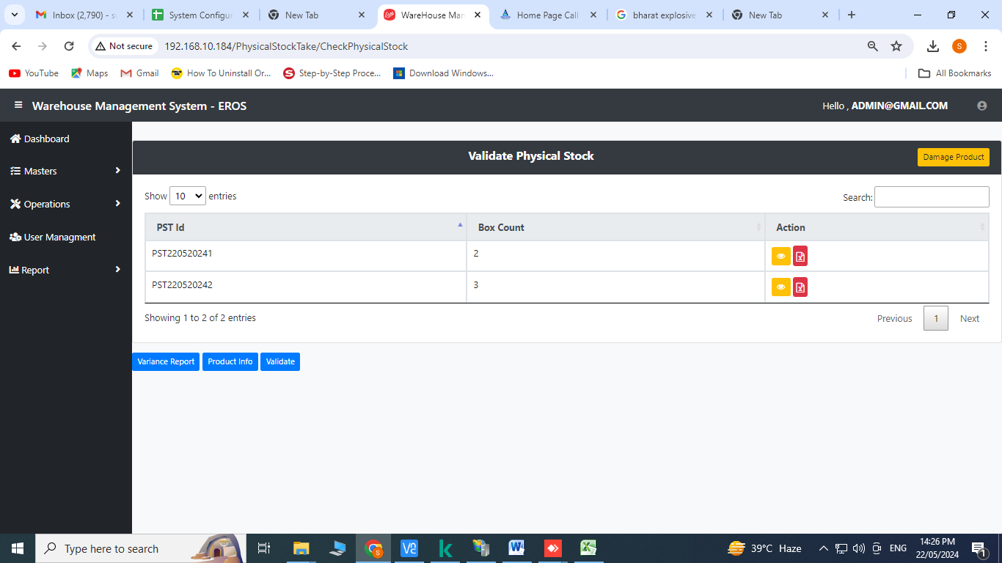

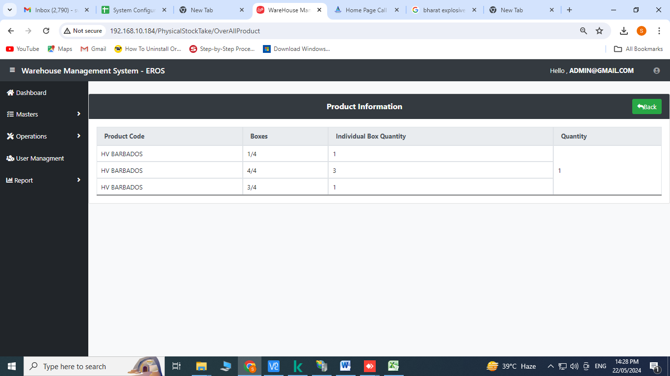

**Validate:**

Click on validate

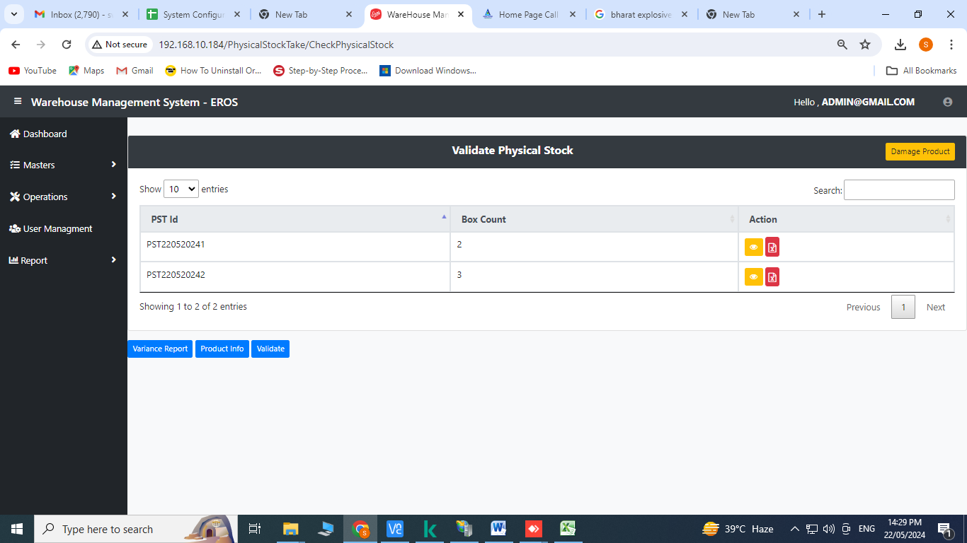

Click on Yes

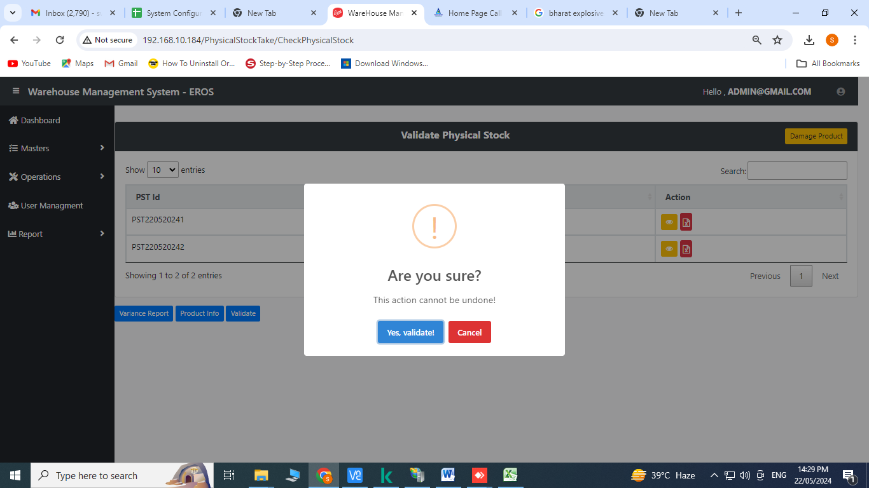

**Reports**

1. **In-Out Report :** Click on In-Out Report

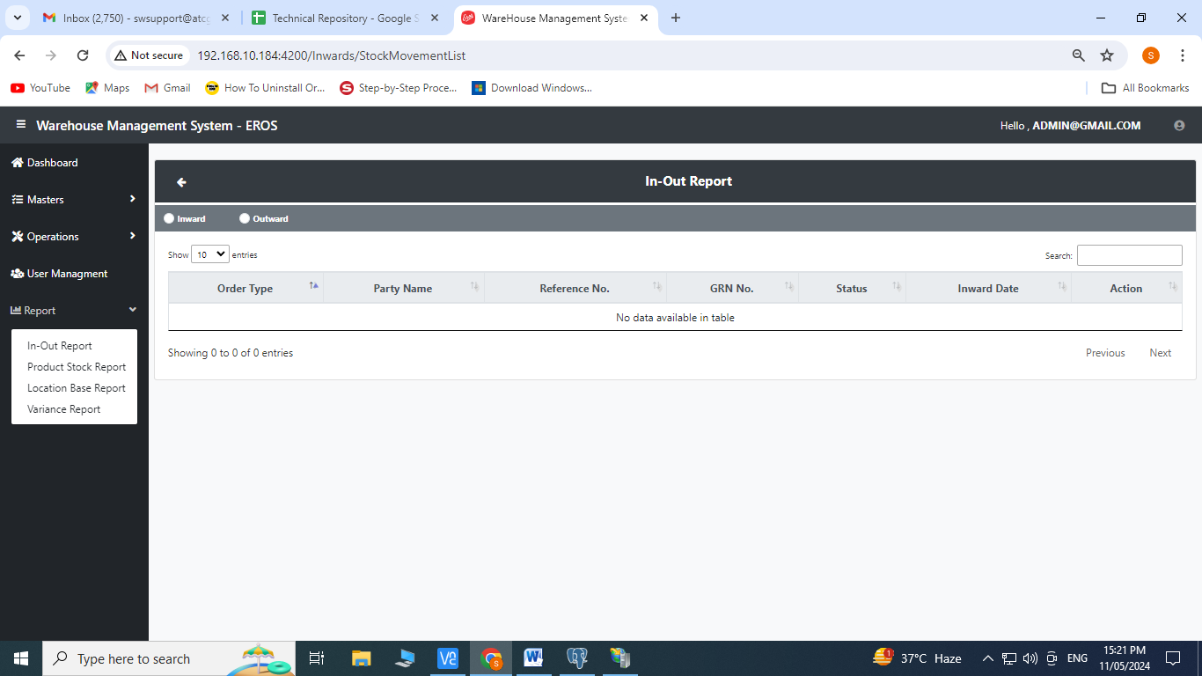

Click on Check box of Inward and Outward for records

Click on 

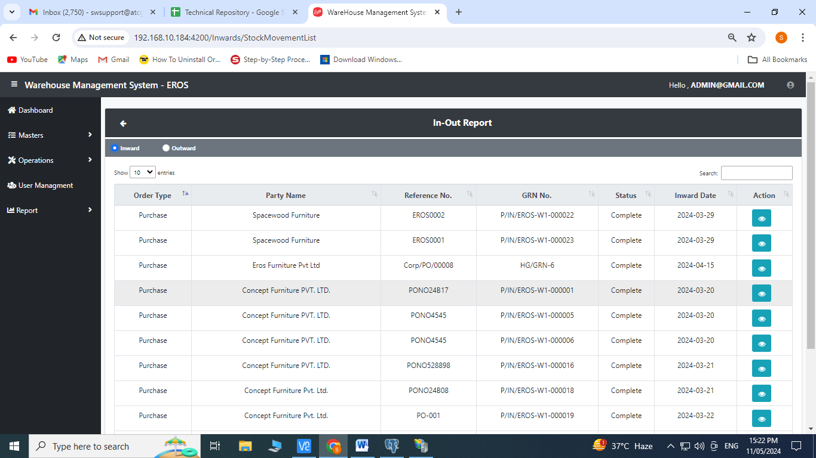

**Product Stock Report :** Click on Product Stock Report

Records can be exported to pdf or excel

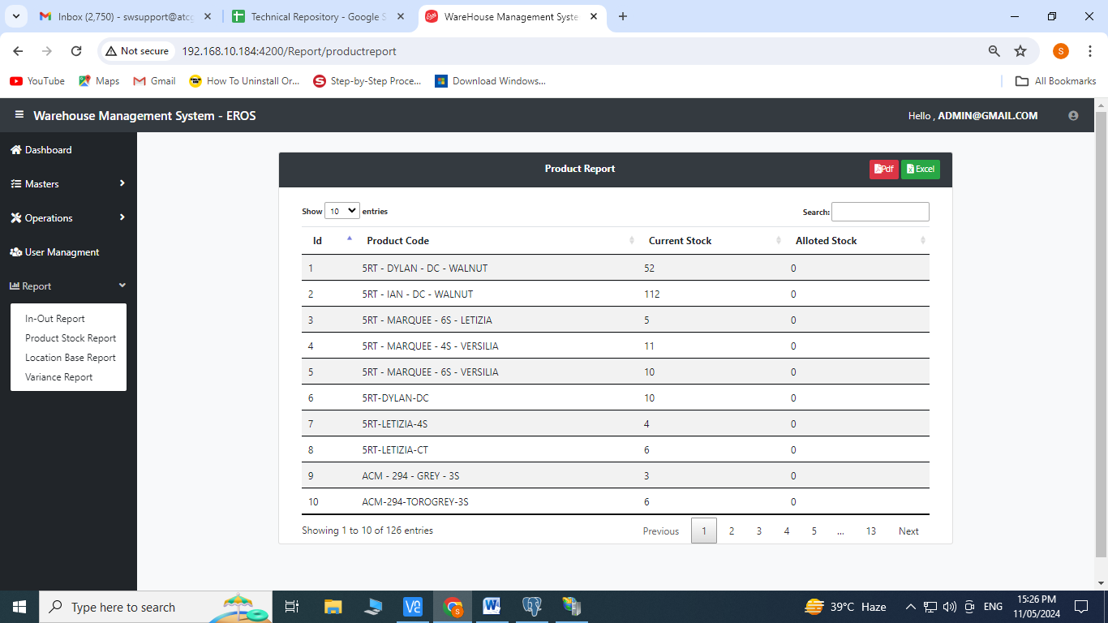

**Location Base Report:** Click on Location Base Report

Records can be exported to pdf or excel

